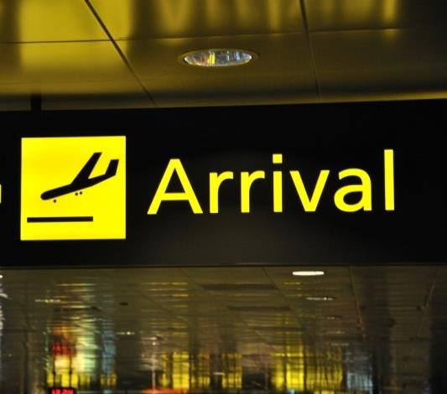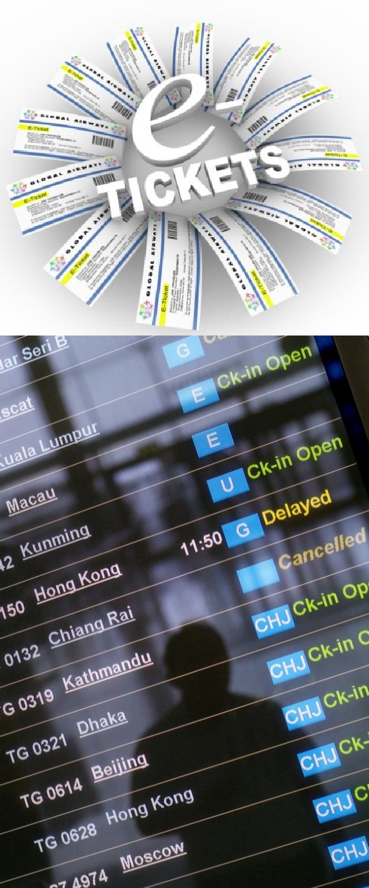Apply advanced airfare rules and
procedures

D2.TTA.CL2.03
Trainee Manual

Apply advanced airfare rules and procedures

D2.TTA.CL2.03

Trainee Manual





Project Base
William Angliss Institute of TAFE
555 La Trobe Street
Melbourne 3000 Victoria
Telephone: | (03) 9606 2111
Facsimile: | (03) 9670 1330
Acknowledgements
Project Director: | Wayne Crosbie
Project Manager | Jim Irwin
Chief Writer: | Alan Hickman
Subject Writer: | Sheena D’Souza and Dianne Whelan
Editor: | Jim Irwin
DTP/Production: | Daniel Chee, Mai Vu, Cindy Curran

The Association of Southeast Asian Nations (ASEAN) was established on 8 August 1967. The Member States of the Association are Brunei Darussalam, Cambodia, Indonesia, Lao PDR, Malaysia, Myanmar, Philippines, Singapore, Thailand and Viet Nam.
The ASEAN Secretariat is based in Jakarta, Indonesia.
General Information on ASEAN appears online at the ASEAN Website: www.asean.org.
All text is produced by William Angliss Institute of TAFE for the ASEAN Project on “Toolbox Development for Tourism Labour Divisions for Travel Agencies and Tour Operations”.
This publication is supported by the Australian Government’s aid program through the ASEAN-Australia Development Cooperation Program Phase II (AADCP II).
Copyright: Association of Southeast Asian Nations (ASEAN) 2015. All rights reserved.
Disclaimer
Every effort has been made to ensure that this publication is free from errors or omissions. However, you should conduct your own enquiries and seek professional advice before relying on any fact, statement or matter contained in this book. The ASEAN Secretariat and William Angliss Institute of TAFE are not responsible for any injury, loss or damage as a result of material included or omitted from this course.
Information in this module is current at the time of publication. Time of publication is indicated in the date stamp at the bottom of each page.
Some images appearing in this resource have been purchased from stock photography suppliers Shutterstock and iStockphoto and other third party copyright owners and as such are non-transferable and non-exclusive. Clip arts, font images and illustrations used are from the Microsoft Office Clip Art and Media Library. Some images have been provided by and are the property of William Angliss Institute.
Additional images have been sourced from Flickr and SXC and are used under Creative Commons licence: http://creativecommons.org/licenses/by/2.0/deed.en

File name: TM_Apply advance airfare rules procedures_291015



Table of contents
Introduction to trainee manual 1
Unit descriptor 3
Assessment matrix 7
Glossary 11
Element 1: Confirm client requirements for all purchases 19
Element 2: Construct mixed class fares 31
Element 3: Construct airfares incorporating add-ons 53
Element 4: Prepare international pre-paid ticket advices 73
Element 5: Construct round-the-world and round trip itineraries 91
Element 6: Construct fares for open jaw journeys 103
Element 7: Apply the pricing unit concept to fares 117
Element 8: Maintain client file 129
Presentation of written work 153
Recommended reading 155
Trainee evaluation sheet 157
Trainee self-assessment checklist 159

© ASEAN 2015
Trainee Manual Apply advanced airfare rules and procedures

© ASEAN 2015
Trainee Manual
Apply advanced airfare rules and procedures

Introduction to trainee manual

To the Trainee
Congratulations on joining this course. This Trainee Manual is one part of a ‘toolbox’ which is a resource provided to trainees, trainers and assessors to help you become competent in various areas of your work.
The ‘toolbox’ consists of three elements:
- A Trainee Manual for you to read and study at home or in class
- A Trainer Guide with Power Point slides to help your Trainer explain the content of the training material and provide class activities to help with practice
- An Assessment Manual which provides your Assessor with oral and written questions and other assessment tasks to establish whether or not you have achieved competency.
The first thing you may notice is that this training program and the information you find in the Trainee Manual seems different to the textbooks you have used previously. This is because the method of instruction and examination is different. The method used is called Competency based training (CBT) and Competency based assessment (CBA). CBT and CBA is the training and assessment system chosen by ASEAN (Association of South-East Asian Nations) to train people to work in the tourism and hospitality industry throughout all the ASEAN member states.
What is the CBT and CBA system and why has it been adopted by ASEAN?
CBT is a way of training that concentrates on what a worker can do or is required to do at work. The aim is of the training is to enable trainees to perform tasks and duties at a standard expected by employers. CBT seeks to develop the skills, knowledge and attitudes (or recognise the ones the trainee already possesses) to achieve the required competency standard. ASEAN has adopted the CBT/CBA training system as it is able to produce the type of worker that industry is looking for and this therefore increases trainees’ chances of obtaining employment.
CBA involves collecting evidence and making a judgement of the extent to which a worker can perform his/her duties at the required competency standard. Where a trainee can already demonstrate a degree of competency, either due to prior training or work experience, a process of ‘Recognition of Prior Learning’ (RPL) is available to trainees to recognise this. Please speak to your trainer about RPL if you think this applies to you.
What is a competency standard?
Competency standards are descriptions of the skills and knowledge required to perform a task or activity at the level of a required standard.
242 competency standards for the tourism and hospitality industries throughout the ASEAN region have been developed to cover all the knowledge, skills and attitudes required to work in the following occupational areas:
- Housekeeping
- Food Production
- Food and Beverage Service
- Front Office

- Travel Agencies
- Tour Operations.
All of these competency standards are available for you to look at. In fact you will find a summary of each one at the beginning of each Trainee Manual under the heading ‘Unit Descriptor’. The unit descriptor describes the content of the unit you will be studying in the Trainee Manual and provides a table of contents which are divided up into ‘Elements’ and ‘Performance Criteria”. An element is a description of one aspect of what has to be achieved in the workplace. The ‘Performance Criteria’ below each element details the level of performance that needs to be demonstrated to be declared competent.
There are other components of the competency standard:
- Unit Title: statement about what is to be done in the workplace
- Unit Number: unique number identifying the particular competency
- Nominal hours: number of classroom or practical hours usually needed to complete the competency. We call them ‘nominal’ hours because they can vary e.g. sometimes it will take an individual less time to complete a unit of competency because he/she has prior knowledge or work experience in that area.
The final heading you will see before you start reading the Trainee Manual is the ‘Assessment Matrix’. Competency based assessment requires trainees to be assessed in at least 2 – 3 different ways, one of which must be practical. This section outlines three ways assessment can be carried out and includes work projects, written questions and oral questions. The matrix is designed to show you which performance criteria will be assessed and how they will be assessed. Your trainer and/or assessor may also use other assessment methods including ‘Observation Checklist’ and ‘Third Party Statement’. An observation checklist is a way of recording how you perform at work and a third party statement is a statement by a supervisor or employer about the degree of competence they believe you have achieved. This can be based on observing your workplace performance, inspecting your work or gaining feedback from fellow workers.
Your trainer and/or assessor may use other methods to assess you such as:
- Journals
- Oral presentations
- Role plays
- Log books
- Group projects
- Practical demonstrations.
Remember your trainer is there to help you succeed and become competent. Please feel free to ask him or her for more explanation of what you have just read and of what is expected from you and best wishes for your future studies and future career in tourism and hospitality.

Unit descriptor

Apply advanced airfare rules and procedures
This unit deals with the skills and knowledge required to Apply advanced airfare rules and procedures in a range of settings within the travel industries workplace context.

Unit Code:
D2.TTA.CL2.03

Nominal Hours:
50

Element 1: Confirm client requirements for all purchases

Performance Criteria
  - Identify and confirm needs and preferences of client

  - Identify and access appropriate resources to enable processing of client requirements

Element 2: Construct mixed class fares

Performance Criteria
  - Identify and confirm availability of mixed class combinations

  - Match choice of mixed class fare to identified needs of client

  - Ensure fare construction complies with operational requirements

  - Calculate mixed fare costs

  - Construct and check accuracy and completeness of air itineraries

Element 3: Construct airfares incorporating add-ons

Performance Criteria
  - Identify and interpret available and applicable add-on flights

  - Ensure fare construction complies with operational requirements

  - Calculate through fare costs including add-ons

  - Construct and check accuracy and completeness of air itineraries

Element 4: Prepare international pre-paid ticket advices

Performance Criteria
  - Determine the needs and preferences of client for pre-paid ticket advice (PTA)

  - Select flight and carrier that best meets client needs

  - Process PTA in accordance with operational requirements

  - Issue or forward PTA

Element 5: Construct round-the-world and round trip itineraries

Performance Criteria
  - Identify and confirm needs and preferences of client

  - Identify and access appropriate resources to enable processing of client requirements

  - Identify and confirm availability of flights to meet client requirements

  - Ensure fare construction complies with operational requirements

  - Calculate fare costs

  - Construct and check accuracy and completeness of air itineraries

Element 6: Construct fares for open jaw journeys

Performance Criteria
  - Identify and confirm needs and preferences of client

  - Identify and access appropriate resources to enable processing of client requirements

  - Identify options that enable open jaw journeys

  - Identify and confirm availability of flights to meet client requirements

  - Ensure fare construction complies with operational requirements

  - Calculate fare costs

  - Construct and check accuracy and completeness of air itineraries

Element 7: Apply the pricing unit concept to fares

Performance Criteria
  - Divide fare journey into individual pricing units

  - Calculate lowest combination of fares for given pricing units

Element 8: Maintain client file

Performance Criteria
  - Record and update needs and preferences of client

  - Record itineraries and airfares quoted

  - Generate and issue documents to clients

  - Record and process changes to bookings

  - Record, up-date and receipt payments made by client

Assessment matrix

Showing mapping of Performance Criteria against Work Projects, Written Questions and Oral Questions
The Assessment Matrix indicates three of the most common assessment activities your Assessor may use to assess your understanding of the content of this manual and your performance - Work Projects, Written Questions and Oral Questions. It also indicates where you can find the subject content related to these assessment activities in the Trainee Manual (i.e. under which element or performance criteria). As explained in the Introduction, however, the assessors are free to choose which assessment activities are most suitable to best capture evidence of competency as they deem appropriate for individual students.

 |  | Work Projects | Written Questions | Oral Questions
Element 1: Confirm client requirements for all purchases
1.1 | Identify and confirm needs and preferences of client | 1.1 | 1,2,3,4 | 1
1.2 | Identify and access appropriate resources to enable processing of client requirements | 1.2a, 1.2b | 5,6,7 | 2
Element 2: Construct mixed class fares
2.1 | Identify and confirm availability of mixed class combinations | 2.1 | 8,9 | 3
2.2 | Match choice of mixed class fare to identified needs of client | 2.2 | 10,11 | 4
2.3 | Ensure fare construction complies with operational requirements | 2.3a, 2.3b | 12,13,14,15 | 5
2.4 | Calculate mixed fare costs | 2.4 | 16,17,18 | 6
2.5 | Construct and check accuracy and completeness of air itineraries | 2.5 | 19,20,21 | 7

 |  | Work Projects | Written Questions | Oral Questions
Element 3: Construct airfares incorporating add-ons
3.1 | Identify and interpret available and applicable add-on flights | 3.1 | 22,23,24,25 | 8
3.2 | Ensure fare construction complies with operational requirements | 3.2a , 3.2b | 12,13,14,15 | 5
3.3 | Calculate through fare costs including add-ons | 3.3 | 26,27,28 | 9
3.4 | Construct and check accuracy and completeness of air itineraries | 3.4 | 19,20,21 | 7
Element 4: Prepare international pre-paid ticket advices
4.1 | Determine the needs and preferences of client for pre-paid ticket advice (PTA) | 4.1 | 29,30,31,32,33 | 10
4.2 | Select flight and carrier that best meets client needs | 4.2 | 34,35,36 | 11
4.3 | Process PTA in accordance with operational requirements | 4.3 | 37,38 | 12
4.4 | Issue or forward PTA | 4.4 | 39,40,41,42,43 | 13
Element 5: Construct round-the-world and round trip itineraries
5.1 | Identify and confirm needs and preferences of client | 5.1 | 1,2,3,4 | 1
5.2 | Identify and access appropriate resources to enable processing of client requirements | 5,2a, 5.2b | 5,6,7 | 2
5.3 | Identify and confirm availability of flights to meet client requirements | 5.3a, 5.3b,  5.3c | 44,45,46 | 14
5.4 | Ensure fare construction complies with operational requirements | 5.4a, 5.4b | 12,13,14,15 | 5
5.5 | Calculate fare costs | 5.5 | 16,17,18 | 6
5.6 | Construct and check accuracy and completeness of air itineraries | 5.6 | 19,20,21 | 7

 |  | Work Projects | Written Questions | Oral Questions
Element 6: Construct fares for open jaw journeys
6.1 | Identify options that enable open jaw journeys | 6.1 | 1,2,3,4 | 1
6.2 | Identify and access appropriate resources to enable processing of client requirements | 6.2a, 6.2b | 5,6,7 | 2
6.3 | Identify options that enable open jaw journeys | 6.3a,6.3b,6.3c | 47,48,49 | 15
6.4 | Identify and confirm availability of flights to meet client requirements | 5.3a, 5.3b,  5.3c | 44,45,46 | 14
6.5 | Ensure fare construction complies with operational requirements | 6.5a, 6.5b | 12,13,14,15 | 5
6.6 | Calculate fare costs | 6.6 | 16,17,18 | 6
6.7 | Construct and check accuracy and completeness of air itineraries | 6.7 | 19,20,21 | 7
Element 7: Apply the pricing unit concept to fares
7.1 | Divide fare journey into individual pricing units | 7.1 | 50,51,52,53 | 15
7.2 | Calculate lowest combination of fares for given pricing units | 7.2 | 54 | 16
Element 8: Maintain client file
8.1 | Record and update needs and preferences of client | 8.1a,8.1b,8.1c | 55,56,57,58 | 17
8.2 | Record itineraries and airfares quoted | 8.2a,8.2b | 59,60,61 | 18
8.3 | Generate and issue documents to clients | 8.3a,8.3b | 62,63,64,65,66 | 19
8.4 | Record and process changes to bookings | 8.4a,8.4b | 67,68 | 20
8.5 | Record, up-date and receipt payments made by client | 8.5a,8.5b | 69,70,71,72 | 21

Glossary

Term | Explanation
Accredited | Endorsed and licensed to sell and issue airline tickets.
Agency | An enterprise that will construct itineraries, calculate airfares and issue documents for their clients. It may be a travel agency, tour operator or travel wholesaler.
Agent | A person working for a travel enterprise and making airline reservations for their clients.
Air documentation | An itinerary and/or e-ticket for air transportation.
Amadeus | Amadeus is a Computer Reservations System owned by the Amadeus IT Group.
Applicable fare | The fare that is calculated after adjustments are made for IATA mileage surcharges and HIP checks.
Approval | Either from an airline or credit provider where permission is given for a transaction to take place.
Automated pricing | When a CRS will automatically recognise a fare and price the airfare and taxes from a booking.
Baggage allowance | The amount of luggage the passenger may carry without additional cost.
Bank selling rates | In the retail currency exchange market, a different buying rate and selling rate will be quoted by money dealers. Most trades are to or from the local currency. The buying rate is the rate at which money dealers will buy foreign currency, and the selling rate is the rate at which they will sell the currency.  https://en.wikipedia.org/wiki/Exchange_rate
BHC | Back Haul Check – to be undertaken when a one way itinerary has a HIP from origin to stopover.
Boarding pass | A document issued when a passenger has provided their flight details and had their details verified. It may be issued at the check-in counter at the airport or some airlines allow this to be completed online. It specifies the passenger’s name, flight number, seat number, frequent flyer membership and departure gate.
Booking class | A letter of the alphabet, selected by an airline to represent a particular airfare. In a CRS, this letter indicates the remaining seat availability on a scheduled flight at a particular fare level.

Term | Explanation
BSP | Billing and Settlement Plan. The centralised system which enables ticket issuance and payments between travel agencies and airlines.
Cancellation | Discontinuation of an arrangement. May be client choice or airline choice.
Carrier | An airline.
Check-in | This is completed at the airport or online. After verifying the passenger details, a boarding pass is issued and luggage is given to the airline to load onto the aircraft.
Child | An airline passenger aged between 2 and 12 years. Discounts may apply depending on the airline and type of fare.
Circle trip | A return journey that starts and finishes in the same city and has two fare components with the different fare levels.
Class of travel | Airline classes of service such as economy, premium economy, business or first class.
CMS | Client Management System – used in a travel organisation/enterprise to record client details, preferences, payments and booking information.
Codeshare | When one carrier operates a flight on behalf of another, using the carrier’s airline designator code.
COM | Open jaw via country of origin check
Commission | A percentage of an airfare that an airline allows the travel agent to keep as earnings from selling the airfare.
Configuration | The seating plan for an aircraft.
Conjunction tickets | If an itinerary includes more than four flights, more than one ticket number is allocated to the itinerary. These ticket numbers will be issued in numeric sequence and at the same time.
Connecting flight | When a passenger travels between their origin and destination via an intermediate point where they disembark from one flight and board another.
Consolidator | Issues tickets on behalf of travel enterprises. A consolidator negotiates preferential commission rates with airlines and then offers these to airlines.
CPM | Country of origin minimum checks.

Term | Explanation
CRS | Central Reservation System (also Computer Reservation System) use by travel enterprises and airlines for airline bookings.
CTM | Circle Trip Minimum check.
Destination | The city where the journey ends (on a one way itinerary). The final stop before returning (or a return itinerary).
Direct flight | A flight which may land between the origin and destination but there is no change in aircraft or flight number.
Disembark | Leave the aircraft after the flight.
DMC | Directional minimum checks.
DPC | Data Processing Centre. The DPC is the central point to which travel agency issued ticket sales are reported.
E-docs | Electronic documentation for land arrangements.
E-ticket | Electronic documentation for airline ticket.
EMA | Excess Mileage Allowance
EMS | Excess Mileage Surcharge
Enterprise | The organisation or agency booking the travel arrangements for clients.
Fare basis | A code that is allocated to each airfare. For promotional airfares, airlines create their own fare basis codes.
Fare construction | Steps and checks that are followed to ensure all IATA rules are met when calculating an airfare.
Fuel surcharges | Charges from airlines to account for increases in the costs of fuel. May be included in the fare or in the tax calculation.
Galileo | Galileo is a CRS and GDS owned by Travelport.
GDS | Global Distribution System – a CRS used as a single point of access for travel agents to make airline, hotel and car hire reservations.

Term | Explanation
GMT | Greenwich Mean Time (GMT) has no offset from Coordinated Universal Time (UTC). This time zone is a standard time zone and is used in: Europe, Africa, North America and Antarctica.  This time zone is often called Greenwich Mean Time. Ref - http://www.timeanddate.com/time/aboututc.html
HIP | Higher Intermediate Point – a check that must be conducted when constructing a regular fare.
Infant | A passenger under the age of two years. Infants generally pay 10% of an adult fare and have limited baggage allowance.
Instant purchase airfare | An airfare that requires immediate payment at the time of booking.
IATA | International Air Transport Association – the peak industry body for most of the world’s airlines. IATA ensures inter- airline cooperation in promoting safe, reliable and secure airline services.
Interline transfer | A transfer from the service of one airline to another airline.
Intermediate point | A city between the origin and destination on an itinerary.
Invoice | Financial statement for arrangements made, describing the amount owing and the terms and conditions.
Issue ticket | After payment is collected from the client the ticketing process can occur.
Itinerary | Details of a passenger’s travel schedule in date order.
Mandatory fields | The information that must be entered into a CRS before a PNR can be created.
Manual pricing | When an airline booking will not auto price, the agent will need to manually manipulate the data to create the airfare.
Mileage | The number of miles travelled on an itinerary.
Mileage system | A series of checks relating to the flown miles on a constructed itinerary.
Minimum connecting time | The minimum amount of time needed at an airport between two flights.
MPM | Maximum Permitted Mileage – the maximum number of miles that can be flown on an itinerary without the fare being surcharged.

Term | Explanation
Nett fare | Different to a published fare whereby the agent earns a percentage of the fare as commission. Nett fares usually have many restrictions and rules. They are provided for selected organisations to buy at cost price and the agent can determine their own sell price.
Non-air documentation | Paper based or electronic documents for any arrangement that is not for air travel.
Non-stop flight | A direct flight which does not land between the origin and destination.
Normal airfare | Refer to ‘Regular airfare’.
No-show | When a passenger holding a confirmed reservation does not check in for a flight and does not cancel.
NUC | Neutral Unit of Construction. A neutral currency developed by IATA for use in international fare construction. NUCs are used to calculate normal/regular airfares.
Online transfer | Transfer from a flight on one airline onto another flight on the same airline.
Open Jaw | A return journey when either:  The passenger is returning to a different city in the same country or region as the origin.  The passenger is flying to a destination city but returning from a different city in the same country or region.
Open ticket | When a passenger has paid for a fully flexible fare, without a confirmed travel date. The booking needs to be made later, subject to.
Origin | The city where the journey starts.
OSC | One way sub-journey check
Passenger Air Tariff | Information published by IATA for the travel industry, providing industry rules and airfare information.
Passport | Official documentation certifying the holder’s identity and citizenship and authorising international travel.
PNR | Passenger Name Record in a CRS.
Pro-forma | A standard document.
Promotional airfare | An airfare that is less expensive than a regular airfare but has restrictions and rules that need to be applied.

Term | Explanation
Pseudo city code | A unique 3-4 character (alpha-numeric) code allocated to an enterprise using a CRS.
Published airfare | An airfare that can be located and priced using a CRS or airline website.
Quotation (Quote) | A list of components and applicable costs for proposed travel arrangements.
Refund | Reimbursements for unused services.
Regular airfare | A full priced airfare that is constructed using the mileage system and following IATA rules. Also called ‘normal’ fares.
Reissue fee | Charged when an alteration is made to a booking which requires a new ticket to be issued.
Reloc | Abbreviation for Record Locator. The airline booking reference which is a code made of a unique combination of 5 or 6 numbers and letters.
Re-routing | Travelling on a different path to what was originally planned.
Revalidation | When an alteration is made to the dates or times of flights but a new ticket does not need to be issued.
ROE | Rate of Exchange – the exchange rate used to convert international airfares calculated in NUC into a real currency.
Round trip | A return journey that starts and finishes in the same city and has two fare components with the same fare level.
Route map | A diagram that applies to an airfare, explaining which airline/s can be flown on the itinerary.
RSC | Return sub-journey check
Sabre | A Computerised Reservation System (CRS).
Schedule / Timetable | Planned list of flight departures and arrivals times and dates of an airline.
Seasonality | When an airfare increases or decreases depending on the date of travel. The price is usually determined by the date of the first international flight. Often referred to as high or low season travel.
Sectors / Segments | Each flight in an airline booking.
Status codes | Codes that appear in a CRS to indicate the status of the flight segments. The status code indicates if the flight is confirmed, requested or waitlisted.

Term | Explanation
Stopover | A break in a passenger journey at an intermediate point for 24 hours or more.
Surface sector | A sector between two intermediate points which is not flown.
System | Abbreviation for the GDS or CRS.
Taxes | Government charges and fees that may apply to an airfare, based on the airports and countries visited on the flown itinerary.
Ticketing | The process of issuing an airline ticket for a CRS booking.
Ticketing time limit (TTL) | The last date that a ticket can be paid for and issued for an itinerary. The date is determined by the airline.
TPM | Ticketed Point Mileage – the number of miles being flown on an itinerary.
Transaction fee | A charge made by the airline or travel agent for services rendered. Also sometimes called a service fee or administration fee.
Transit | A break in a passenger journey to change aircraft, which is less than 24 hours.
Travel Visas | Endorsement on a passport allowing entrance to or exit from a country.
Unaccompanied Minor (UNMR) | A child travelling without an adult who requires supervision and assistance from the airline. Not all airlines allow UNMR passengers and most restrict the child age.
UTC | Coordinated Universal Time (UTC) is the basis for civil time today. This 24-hour time standard is kept using highly precise atomic clocks combined with the Earth's rotation.  This is a standard, not a time zone.  UTC is the time standard commonly used across the world. The world's timing centres have agreed to keep their time scales closely synchronised - or coordinated - therefore the name Coordinated Universal Time.  Ref - http://www.timeanddate.com/time/aboututc.html
Voucher | Documentation issued for land arrangements such as tours, airport transfers, accommodation and car hire.
Waitlist | When the flight is fully booked and the client does not have a confirmed seat. The agent advises the airline that the passenger is waiting for a cancellation.

Element 1:
Confirm client requirements for all purchases

Identify and confirm needs and preferences of client

Introduction
With all travel bookings the agent must begin by confirming the client’s requirements. Each client will have needs and preferences that need to be identified by the agent. Asking questions to identify these requirements will allow the agent to determine if the client requires an itinerary to be constructed and calculated using a regular fare.

Client needs and preferences
The client’s needs and preferences may relate to:
- Packages
- Budget
- Timing and duration
- Destinations
- Carrier
- Quotations and advice supplied to clients
- Airline preferences – this may be based on prior flying experiences or frequent flyer membership
- Single or multiple destinations
- Flexibility with travel dates and times
- Urgency – may need to travel as soon as possible
- Number of passengers travelling
- Reasons for travelling – holiday, business, visiting family
- Class of travel – economy, business or first class
- One way or return travel
- Special requests for meals, seats and assistance from the airline
- Budget – the amount of money they wish to spend
- Passport nationality and need for visas for countries visited
- Other travel arrangements that need to be booked.

Holiday packages
If the client wishes to purchase a holiday package including other travel components such as accommodation, car hire or an organised group tour, this may influence how the booking is made. There are wholesalers and tour operators who specialise in booking packages and will usually book airfares as part of the holiday package. The agent will contact the wholesaler or tour operator on their client’s behalf.

Group bookings
When there are more than nine passengers travelling, reservations are usually made directly through the airline. Airline booking systems often do not allow bookings for larger groups to be made so an agent will contact an airline directly to make the reservation. The airline will confirm seat availability, price and airfare conditions with the agent.

Asking questions to identify client needs and preferences
The client is likely to provide the agent with most of the information that they will require to make their booking. There may however be some questions that the agent needs to ask to confirm that they understand exactly what the client requires. The questions asked will be guided by the client’s needs and the amount of information already provided.
Suggested questions include:
- Where are you interested in travelling to?
- When are you thinking of travelling?
- How long do you wish to be away?
- Which class do you wish to travel in?
- Are your dates flexible?
- Do you have a preference to fly with a particular airline?
- Do you wish to have checked baggage?
- Is meal service an important part of your airline experience?
- What nationality passport are you travelling on?
- How many passengers are travelling?
Each of these questions will help the agent to narrow down the number of airfares that will need to be looked at for the client. The responses to the last two questions may also influence how the booking is made and would require the agent to book through another party, such as an airline, wholesaler or tour operator. These types of bookings will not be covered in this unit but will be explained briefly.

Confirming client needs and preferences
It is recommended that during the initial consultation, when the client’s needs are being determined, the agent should write notes which can then be referred back to rather than trying to rely on memory or having to ask questions again.
Once you have obtained answers to all your questions you should confirm the details back to the client to ensure that you are clear there have been no misunderstandings.
After confirming the client’s needs, the agent can feel confident that they know what they need and can begin looking at options. If client requests are specific, this will minimise the time it will take to construct an itinerary and calculate an airfare. If the requests are not specific, the agent may need to consider a range of options.
Depending on the agent’s confidence and experience, they may immediately start to make recommendations to the client and find the information for them during the consultation. At other times, the agent may need to take some time to search for the relevant information after the consultation with the client has finished. This is why it is important to have good notes of the conversation and a clear understanding of how to proceed.



Identify and access appropriate resources to enable processing of client requirements

Introduction
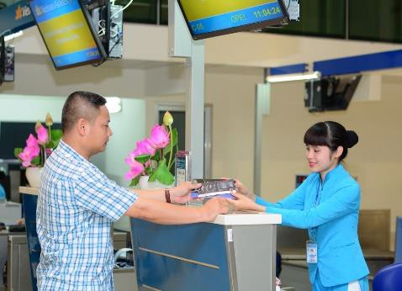Once the agent has confirmed the client’s needs and preferences, they can begin to look for information to construct an itinerary and calculate an airfare that meets the given requirements. In order to do this, the agent will need to identify and access a range of different industry resources and have an understanding of industry concepts in order to interpret the information.

Resources

General resources
To construct and calculate international airfares, it will be necessary to have access to a:
- A computer with internet access
- Calendar
- Calculator
- Pen and paper
- World map
- Airline websites – these websites are a great source of general information on air travel, as well as the airline’s policies. Useful information for the agent and the client will include:
  - Airport information – maps of terminals, facilities
  - Check-in options and facilities
  - Baggage restrictions and fees
  - Special assistance offered for passengers
  - General policy and travel information.

Specialist resources for travel industry staff
Travel industry enterprises will each develop their own policies and procedures for assisting clients to make international airfare bookings. Enterprises which construct regular airfares will have access to:
- A Computer Reservation System (CRS)
- Airline agency help desks (online and/or phone service)
- The Passenger Air Tariff.
We will now look at each of these in detail, including examples.

Computer Reservation System (CRS)
In travel industry enterprises, information relating to airfares is primarily sourced electronically, using a Computer Reservation System (CRS). An enterprise must have access to a CRS in order to book regular airfares for clients.
Three examples of commonly used CRSs are Sabre, Amadeus and Galileo. For consistency when demonstrating examples of CRS processes and information screens, Galileo entries and screens will be used throughout this unit.
A CRS may also be referred to as a GDS, or Global Distribution System, as it allows the user to sell tickets on multiple airlines and for a range of other products including car hire, rail and accommodation. The agent can look up a range of information relating to airfares and airlines, including accurate airfares and taxes, as well as current seat availability. It also allows communication directly with airlines through the creation of bookings. Airfare and airline information that can be accessed through a CRS includes:
- Flight availability
- Airline schedules (timetables)
- Pricing including calculation of taxes
- Airfare rules.
An enterprise uses a unique pseudo city code to access a CRS. The pseudo city code is recorded in each booking, allowing the airline to see which enterprise has created the booking. Each enterprise is only able to access bookings made using their own
pseudo code

It is important to remember that a CRS is
http://www.ihotelligence.com/images/gds.jpg&img

designed for travel industry use only and is not available to the public. An agent using a CRS will require substantial training prior to using the system to access information, make bookings and issue tickets. This unit will only provide an overview of some of the information and processes involved in constructing regular international airfares.

Airline agency help desks
Many airlines offer additional services to agents in order to provide assistance with any queries or problems with bookings. Airline agency help desk staff can also provide advice to the agent when constructing complex itineraries or making amendments to bookings which will require additional fees to be collected. Some airline help desks respond to phone calls and emails.
This service may also be provided online for travel agents. For example, Qantas have a website for agents called Qantas Industry Centre. The website is accessed using an agency login and password and the agent can obtain information on current airfares, changes, policies and procedures.

Airline websites
Not all airlines allow bookings to be made by agents through a CRS. In these instances, the agent can access the airline website in order to construct itineraries for their clients. Most airlines will enable an enterprise to access information via an agency website, using a login and password.
Having an agency login to access an airline website allows an airline to monitor the bookings made by the enterprise. It may also allow the enterprise to earn commission on the airfares booked and sold.
Here is an example of the agency login page on the Jetstar website:

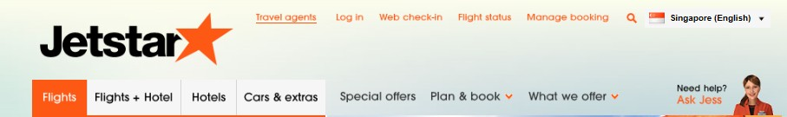
Travel agent Tab

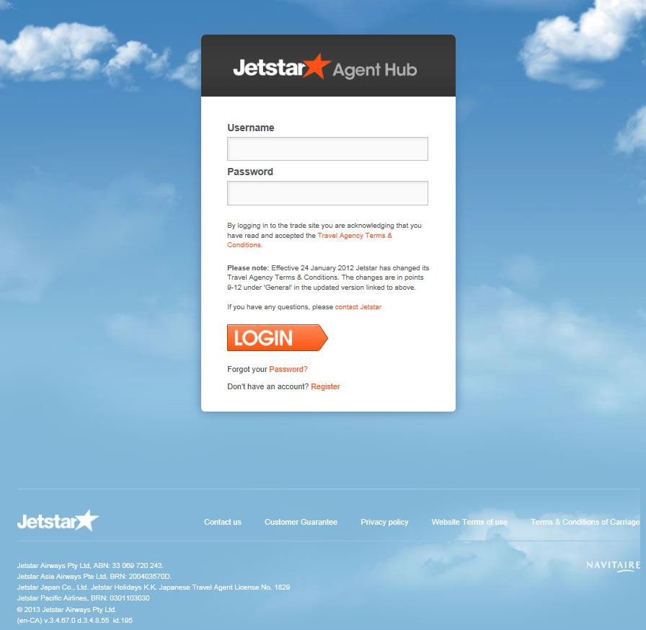
Travel agent login screen

Airline website general information
Airline websites are also a great source of general information on air travel, as well as the airline’s policies. Useful information for the agent and the client will include:
- Airport information – maps of terminals, facilities
- Check-in options and facilities
- Baggage restrictions and fees
- Special assistance offered for passengers
- General policy and travel information.

Passenger Air Tariff (PAT)
The Passenger Air Tariff is published by IATA for the travel industry and contains detailed information on industry information that is required for construct regular international airfares.
In the past, the PAT was distributed to all enterprises constructing regular airfares. The PAT included large volumes of information, some of which needed to be updated quarterly (every three months). In recent years, the PAT is no longer printed and distributed and is now available online. An enterprise must pay a fee to access this information. Fortunately, much of the information contained in the PAT can also be accessed through a CRS.

Industry terminology
Most of the resources described are only used within the tourism and travel industry. There are also specific terms used within the industry that you may not be familiar with. These terms are included in the Glossary at the start of this resource.
The industry also uses a range of codes and concepts that you should be familiar with. Some are specific to the travel industry and others are used in different industries so you may be familiar with them. These codes and concepts include:
- Phonetic alphabet
- Time concepts and principles
- Formats and abbreviations used in a CRS
- IATA codes.

Phonetic alphabet
To avoid confusion with accents and different types of speech and to eliminate spelling mistakes with names and booking details, the phonetic alphabet is routinely used.
The phonetic alphabet is used for communication between staff involved in the airline industry. It is particularly useful when spelling out a client’s name over the telephone or when you need to receive or advise a reservation number. An airline or CRS booking number commonly referred to as a PNR or a Reloc is a unique code made up of six letters and numbers. To avoid confusion, the phonetic alphabet is used when staff involved in air travel need to share this information. This will be discussed in more detail in future topics and these terms also appear in the Glossary.



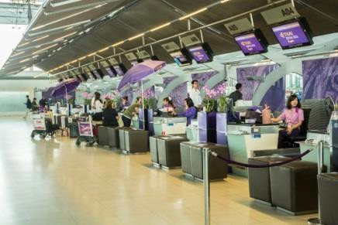Airline schedules and flight routes
Access to schedules (timetables), fares and information relating to the flights operated by the various carriers is available electronically to travel agents via their Computer Reservation System (CRS) and airline websites.

Example of a Thai Airways timetable from their website:

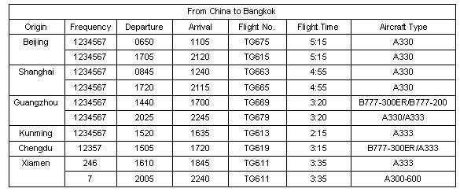

Airline schedules and flight routes may be accessed using a Timetable entry in Galileo.

Galileo entry | Explanation
TT | Timetable
TT01MARSYDSIN | Display all carriers operating direct flights from Sydney to Singapore, departing in March.
TT01OCTBKKVTE/TG | Display Thai Airways scheduled flights from Bangkok to Vientiane, departing in October.

Galileo timetable example – Thai Airways scheduled flights from Bangkok to Yangon in January.

Entry: TT10JANBKKRGN/TG

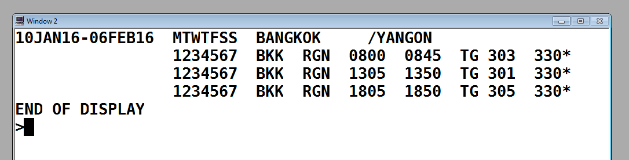

This entry shows that Thai Airways operates three daily flights to Yangon.

Work Projects
It is a requirement of this Unit you complete Work Projects as advised by your Trainer. You must submit documentation, suitable evidence or other relevant proof of completion of the project to your Trainer by the agreed date.

  - List three client needs or preferences to identify what they want

  - a Access an airline website and complete the screens for an international destination.
Save a copy of each screen and print this

1.2b Research the internet for Central reservation System companies and identify where (city, country) they are located and what other services they may provide. List 4, but try to identify others that are not listed in this manual.

Summary
Confirm client requirements for all purchases

Identify and confirm needs and preferences of client
- Client needs and preferences
- Asking questions to identify client needs and preferences
- Confirming client needs and preferences
Identify and access appropriate resources to enable processing of client requirements
- Resources
- General resources
- Specialist resources for travel industry staff
- Computer Reservation System (CRS)
- Airline agency help desks
- Airline websites
- Airline website general information
- Passenger Air Tariff (PAT)
- Industry terminology
- Phonetic alphabet
- Airline schedules and flight routes

Element 2:
Construct mixed class fares

Identify and confirm availability of mixed class combinations

Introduction
A mixed class ticket is an individually modified airfare that allows travellers to fly in different airline classes on different flights. For example: travellers could fly to Asia in Economy Class, then fly from Asia to Europe on the longer flight in Business Class.
Mixed class is available via a combination of any Economy, Premium Economy, Business or First Class airfare.

Carriers who offer mixed class ticket(s)
Mixed class tickets incorporate different class travel for different sectors of a flight booking. Full service carriers operate aircraft that are configured with multiple classes of travel on board. This may be economy, premium economy, business and first class seating. Your client may wish to travel premium economy in one direction and economy on the return flight however this may not be possible if the carrier does not offer this service.
Economy, premium economy, business and first class are referred to as the classes of travel. On an aircraft offering all four classes, most of the aircraft provides seating for economy class passengers, which is located towards the rear of the aircraft. First class is generally at the front, followed by business class and then premium economy in front of economy class. This information is general and there are many ways to access the configuration of an aircraft. It is also important to be aware that the services provided for each class of travel will be different and will also vary for each airline. This will include baggage allowance, check-in procedures, airport lounge access and on board meals and entertainment. This information should be researched and advised to the client.
Each class of travel will have a range of airfares (prices) available for sale by the travel enterprise. For example, this means that everyone travelling in business class is not paying the same price as the airline allocates some seats at lower airfares, which will have rules and conditions that the passenger needs to be aware of. The higher priced fares in business class will be sold to passengers who want more flexibility with the rules and conditions of the airfare, or may be purchased simply because all of the lower priced fares have been sold.
The term ‘class’ has different meanings in relation to airfare construction. Later in this topic you will be introduced to the term ‘booking class’ which is related to, but different from, class of travel. For regular airfares, only one booking class is used to represent each class of travel.

The agent should choose the carrier and flight time that the client prefers. If the client wishes to fly business class, the agent is checking seat availability in J or C class, Y class for economy and F for First class. The screen below shows the many booking classes available on a particular flight.

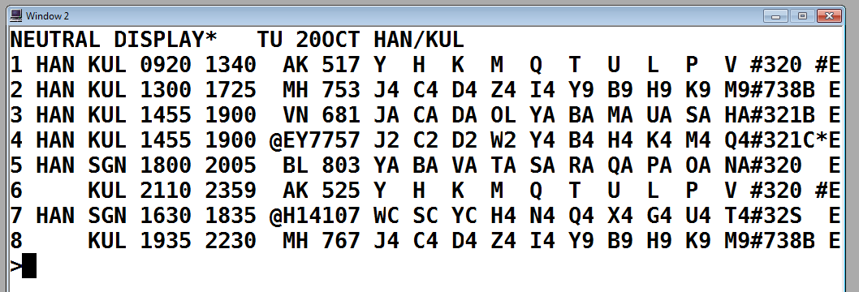

Route Options with mixed class combinations Route maps
Airlines develop route maps to explain the options on how a fare can be constructed. The route map may be very basic for shorter flight and itineraries, or more complex for longer routes.
For example, a route map for Thai Airways for a fare from Bangkok to Dubai, may only allow a direct Thai Airways service to be flown. A route map for the same fare (Bangkok to Dubai) on Singapore Airlines would show that the routing is a flight from Bangkok to Singapore and then another flight from Singapore to Dubai.
A route map can also show additional or secondary carriers that may be flown as part of the itinerary. For example, Garuda Airlines publish fares from Jakarta to Adelaide in Australia, and allow the use of Virgin Australia services for domestic flights in Australia.

Route map example:

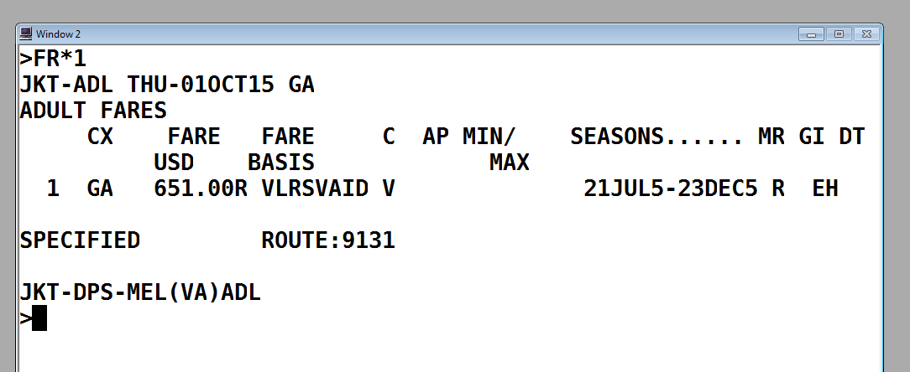

Route maps can be accessed from a Fare Display in the CRS. The fare display screens will be explained later in this topic. A useful explanation of how to interpret route maps can be found on the Qantas website: www.qantas.com.au/agents/dyn/qf/fares/routeMapsRead

Match choice of mixed class fare to identified needs of client

Introduction
Matching the choice of mixed class fare needs to be illustrated in the client’s itinerary. The constructed fare will depend on the client requirements that have been identified and the airlines to be booked. The method used will also depend on operational requirements of the enterprise that the agent is working for and the CRS or airline website being used.

Mileage and routing fares
Regular international airfares are constructed using the mileage system, which has been developed by IATA. This involves determining the number of miles that are being flown on each sector of the itinerary and comparing this to a maximum number of miles that can be flown at a particular fare level.
Most promotional fares are not constructed using the mileage system and are called routing fares, meaning they are based on the flight routing allowed by the carrier, rather than the number of miles flown. Routing fares displayed in a CRS will allow the agent to also access the applicable route map and fare rules. It is important to communicate this information with your client when determining their mixed class fare to avoid any miscommunication.

Itinerary types
When creating an itinerary for a client, you will need to determine what type of fare you need to access in order to calculate the cost of their itinerary. The general types of itineraries are:
- One way
- Return
- Multi city (which would include Round the world itineraries).
When using a CRS to access fare information, it is possible to specify whether one way or return fares are required.
There are also different ways of describing itineraries which will depend on the number of sectors and airlines being flown. The following itinerary examples, using Galileo screen examples, will introduce terminology relating to itinerary types.

Itinerary examples:

Codeshare flights
This itinerary contains codeshare flights which have Qantas flight numbers but are operated by Emirates (Segments 1 and 4). You will note that the Qantas flight numbers contain four digits. This is a way of identifying codeshare services although this is also clearly advised on this booked itinerary.
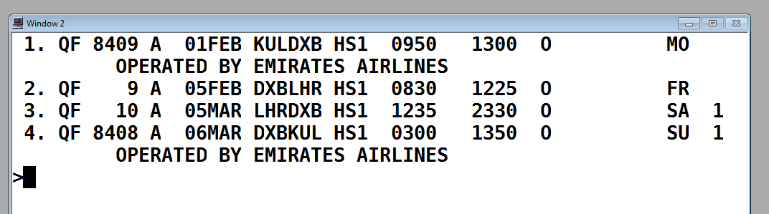When reading this itinerary, you will note the final destination is London Heathrow and on the outbound
component, the passenger is having a stopover in Dubai for 4 nights. On the inbound component, the passenger will only transit through Dubai.

Online and interline transfers
The itinerary below is a return journey from Bangkok to San Francisco, flying with Thai Airways and Singapore Airlines.

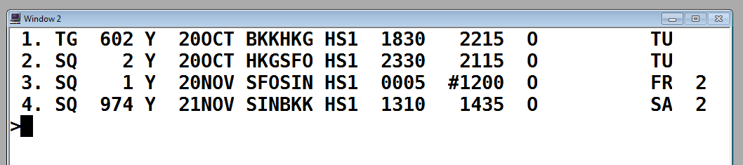

On the outbound component, the passenger will transit through Hong Kong.

On the inbound component, the passenger will transit through Singapore. Note that flight SQ1 arrives into Singapore at #1200, meaning 12.00pm the next day – 21 November.
The passenger will arrive into Hong Kong on Thai Airways and depart on Singapore Airlines. This is called an interline transfer.
The passenger will return from San Francisco to Singapore and change aircraft, continuing to fly with Singapore Airlines. This is called an online transfer.



Regular airfare rules

Fare rules are the terms and conditions for the fare which are developed by the airlines or IATA. IATA has developed headings and paragraphs to categorise airfare rules and these can be accessed using a CRS. Promotional airfares have airfare rules that must be accessed by the agent and explained to the client. This is explained in the unit Construct and ticket promotional international airfares.
Regular fares are fully flexible. This means that they can be changed at any time and if unused, are fully refundable. It also means that there are no payment deadlines and the agent can hold the booking for the client to consider. The only restriction is that payment is required (and the ticket must be issued) prior to departure.
Regular airfares are also not ‘seasonal’, meaning that the fares will be the same every day of the year, with no high or low season price fluctuations.
Despite this considerable flexibility, there are some restrictions that apply. The agent must ensure:
- All required checks are completed when constructing the airfare
- The itinerary meets the requirements of the Global Indicator for the airfare they are accessing and calculating
- The client is aware that although changes are permitted free of charge, the changes are subject to seat availability on the requested flight
- Business and first class passengers are aware that not all aircraft have multiple classes of service. In the event that the itinerary is changed and the passenger is now on a flight without business or first class seats, they will not be compensated
- Clients are aware that although the airlines do not charge any penalties for amendments or cancellation, the enterprise may impose service fees for providing assistance to clients to make these changes.

Booking classes
A booking class is a letter of the alphabet that is allocated to a fare. When calculating promotional airfares, airlines allocate a booking class to represent each of their different airfares. Regular airfares have IATA allocated booking classes that are called primary codes. The IATA allocated primary codes for regular fares are F=First Class, J or C=Business Class and Y=Economy class.

Availability in Galileo
When an availability screen is displayed in the CRS, the information is displayed in order beginning with first class, then business class, premium economy and economy class. All booking classes on flights can be seen in each availability screen, assuming the operating aircraft offers all classes of service. For example, if there is no F shown on a line in the display, there will not be a first class service offered on that flight.
When reading an availability screen, the airline will only show a maximum of nine seats for each booking class. This does not mean that there are only nine seats available, and there could in fact be many more. The airline controls this information and can change their allocation at any time to control the number of seats available at each price level.

The best way to understand how to interpret availability information is by looking at examples of Galileo screens.
The following screen shows the seats available on a Qantas flight from Los Angeles to Melbourne. This screen is called an Availability screen and the entries will be included later on how to display this information.

FRI 26JUL LOS ANGELES /MELBOURNE *QANTAS
1 LAX MEL 26/2330*0820 QF 94 F9 A9 J9 C9 D4 I3 W9 R6 T0 Y8 B7 H8 K3 M0 L0 VC SC NC QC OC

The screen above shows that on Qantas flight QF94, there are four classes of travel and the number of seats available for each:

Class of travel | Booking classes | Number of seats | Other information
First class | F and A | 9 seats for each | 9 means 9 or more
Business class | J and C | 9 seats for each | 9 means 9 or more
 | D | 4 seats
 | I | 3 seats
Premium economy | W | 9 seats
 | R | 6 seats
 | T | 0 | No seats left
Economy class  (some examples only) | Y | 8 seats
 | K | 3 seats
 | M and L | 0 | No seats left
 | V, S, N, Q and O | C | No seats and waitlist closed
In this unit we are interested in regular airfares only (F, J/C and Y), however it is useful to understand the reason for so many letters (booking classes) appearing in an Availability screen.

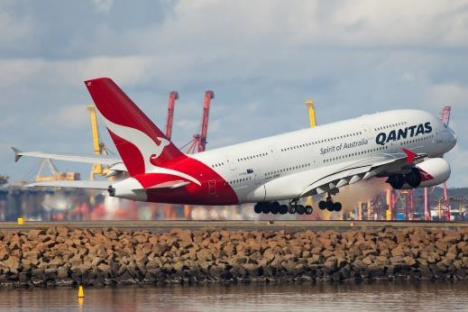

Accessing airfares in Galileo
When using a CRS, there are entries that an agent can use to access information on the airfares that they are considering. The standardised IATA codes and abbreviations are used.
Galileo entries will now be introduced in this topic to demonstrate how information is accessed.
Entries and screen shots will be introduced and described throughout this unit to demonstrate how to:
- Access and interpret fare displays
- Access and interpret mileage information
- Conduct IATA fare construction checks
- Check seat availability for the client itinerary
- Create itineraries and bookings.

Galileo Fare Displays One way airfares Example 1:
Below is an example, using a screen shot from Galileo which is displayed after inputting the following entry:

FDHANMEL20OCT-OW/YY: NUC
Here is a breakdown of the information entered:
- FD Fare Display
- HAN from Hanoi
- MEL to Melbourne
- 20OCT Departing 20th of October (this part of the entry is optional)
- -OW One Way fares only
- YY Display IATA fares for all airlines
- NUC Display the fares in NUCs.
This is an entry that the agent will use to ask Galileo to only display the regular, one way fares from Hanoi to Melbourne, based on a departing Hanoi on the 20th of October. The date does not have to be included in the entry as fares are the same every day of the year.
The information displayed in Galileo is as follows:

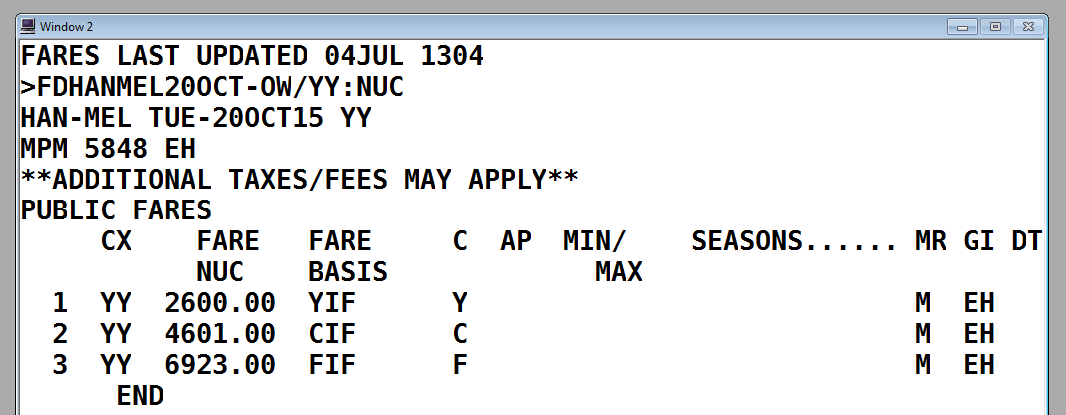

Towards the top of the screen you will see that it says
**ADDITIONAL TAXES/FEES MAY APPLY**. This is a
reminder that the information display is the published IATA fare and does not include taxes and surcharges which cannot be calculated until later when the itinerary is constructed.
Here is an explanation of how to interpret this information, reading across each column displayed:
- The fare on Line 1 is economy class, Line 2 is business class and Line 3 is the first class airfare
- The ‘CX’ above this column is an abbreviation for carrier. The letter YY appears on each Line as this is what was requested and confirms that the fares are applicable to all IATA carriers
- FARE / NUC - The fares are displayed in price order and in NUC. For example, the fare on Line 1 is NUC2600.00
- FARE BASIS - The code in this column indicates the primary booking class for each class of travel, followed by the letters ‘IF’, meaning ‘IATA fare’
- C indicates the booking class. This letter is the primary code for the class of travel. This information relates to seat availability and will be discussed later
- AP refers to Advance Purchase. If the airfare must be booked a certain number of days before departure, a number will appear in this column. For all regular fares, the column is blank, indicating that there are no advance purchase restrictions
- MIN/MAX refers to Minimum and Maximum stay requirements. For all regular fares, this column is blank, indicating that there are no minimum or maximum stay restrictions
- SEASONS refers to seasonality and when the passenger can use the fare. For all regular fares, this column is blank, indicating that there are no seasonal date restrictions
- MR - Mileage system or Routing fare – the method being used to construct the fare. All regular fares will show the letter M in this column, indicating that the mileage system is used when calculating the fare
- GI - Global Indicator – EH indicating that the applicable Global Indicator is Eastern Hemisphere.

Other information on Fare Display screens

MPM 668 EH
- Maximum Permitted Mileage. If the fare between Hanoi and Melbourne is to be constructed using the mileage system, the passenger cannot travel more than 668 miles on the journey without being surcharged
- EH – Eastern Hemisphere (the only applicable Global Indicator).

Ensure fare construction complies with operational requirements

Introduction
Interpreting airfare information involves becoming familiar with many codes, concepts and operational requirements. This topic will introduce you to a range of IATA codes and airfare information including fare types, rules, taxes and Galileo formats. Examples will be used to demonstrate IATA fare construction steps and checks.

IATA Traffic Conference Areas
An important component of international airfare construction is to consider the whole journey that the passenger wishes to undertake. This includes the airlines flown and the direction of travel across the globe, particularly across the world’s oceans. For fare construction purposes, IATA has divided the world into three Traffic Conference areas, numbered TC1, TC2 and TC3. The three areas are shown on the map below:

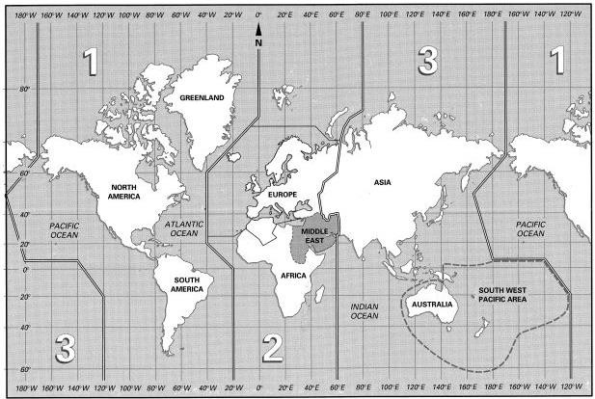

These TC areas have been further divided into ‘sub-areas’ which are summarised as follows:
TC 1 has been divided into 3 sub-areas:
- North Atlantic (or North America)
- Mid Atlantic
- South Atlantic.

TC 2 is divided into the following sub-areas:
- Europe
- Middle East
- Africa, comprising the regions of Central, Western, Eastern and Southern.
TC 3, comprising the following regions:
- South East Asia, including Russian Federation
- South Asian Subcontinent
- Japan & Korea
- South West Pacific.
You may also come across the terms "Western Hemisphere” and "Eastern Hemisphere".
The world is split into two (uneven) halves:
- Western Hemisphere: All of Area 1, that is, north, central and south America
- Eastern Hemisphere: All of Areas 2 and 3, that is, Europe, Africa, Asia and Australia.

Global Indicators (GI)
IATA has also developed Global Indicators (GIs) to describe different directions for travelling on international journeys. Global Indicators represent the direction of the route taken between the origin and destination cities on the passenger itinerary. A Global Indicator is represented by a two letter code. It generally shows which TC Areas are being travelled through and which oceans are being crossed.
Some examples relating to travel from South East Asia have been included below.

EH Eastern Hemisphere
When all travel is within TC Area 3
- Singapore to Kuala Lumpur to Bangkok

Or
Travel between Area 3 and Area 2 via Eastern Hemisphere (there are some exceptions when travel is to Russia or if travel is via Japan or South Korea).
- Bangkok to Dubai to London

TS Trans-Siberian
Travel between Area 3 and Area 2, including a sector having nonstop service between Europe and Japan/Korea
- Bangkok to Tokyo to London
- Singapore to Seoul to Paris

PA Pacific
Travel between Area 3 and Area 1 via Pacific Ocean
- Hanoi to Taipei to Los Angeles.

AP Atlantic Pacific
Travel between Area 3 and Area 2 via the Atlantic and the Pacific oceans (via Area 1)
- Sydney to Los Angeles to London

Importance of Global Indicators
Understanding GIs is a very important part of regular airfare construction as they will often determine which fare to charge.
Imagine a passenger wants to travel from Sydney to London. There are three directions that the passenger could travel. The journey may travel via Asia and Europe (EH), via the Trans- Siberian route including a sector from Japan or South Korea to Europe (TS) or via North America (AP). It is a much longer journey to travel via North America so the fare with the GI for the AP routing would also be higher.
The screen below is a Galileo display showing economy class, regular fares from Sydney to London. The important part of this screen to notice is on the right hand side, showing that the three different prices are for three different Global Indicators (GI) with AP being the most expensive. This screen is called a Fare Display. Similar screens will be introduced throughout this topic.

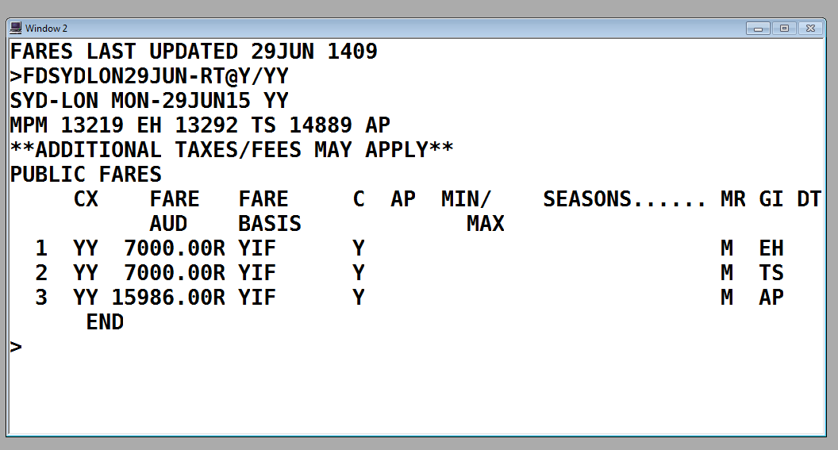

Terminology

Glossary
The Glossary at the beginning of this unit contains many of the terms used when constructing regular international airfares. The most relevant terms are listed here and many of these will be explained further during this unit. It is suggested that you refer to the Glossary now to become more familiar with these terms.

Terms relating to regular airfare construction
- Maximum Permitted Mileage (MPM)
- Ticketed Point Mileage (TPM)
- Excess Mileage Allowance (EMA)
- Excess Mileage Surcharge (EMS)
- Higher Intermediate Point (HIP)
- Back Haul Check (BHC)

- Circle Trip Minimum check (CTM)
- Directional minimum checks (DMC)
- Country of origin minimum checks (CPM)
- Open jaw via country of origin check (COM)
- One way sub-journey check (OSC)
- Return sub-journey check (RSC)
- Re-routing
- Booking class.

Terms relating to itineraries:
- Circle trip
- Codeshare
- Connecting flight
- Destination
- Direct flight
- Interline transfer
- Intermediate point
- Non-stop flight
- Online transfer
- Origin
- Round trip
- Stopover
- Transit.

Terms relating to pricing an itinerary:
- Neutral Unit of Construction (NUC) - (discussed in detail in 3.1)
- Rate of Exchange (ROE) - (discussed in detail in 3.1)
- Taxes
- Bank Selling Rates.

Calculate mixed fare costs

Introduction
It is important to establish what is involved in the mixed fare costs to meet the client’s needs during the initial sales consultation. The client’s needs and preferences will determine the potential carriers that should be recommended and how this information can be sourced. Calculating mixed fare cost can include:
- Referring to relevant carrier schedules or timetables and tariff information
- Referring to specials available and packages that apply
- Factoring in applicable discounts, where appropriate.

Fare types
There are many different ways of categorising types of mixed airfare costs and many of them will be explained in this section.

Regular (normal) fares
Regular fares are created by IATA and are also referred to as ‘normal’ fares. They are the most expensive airfares and can be used for travel on any IATA approved airline. Regular fares are often referred to as ‘full’ fares as they are fully flexible in that, subject to availability, they can be changed at any time and if unused, are fully refundable.
These fares are generally used for corporate travellers who require total flexibility and wish to travel on multiple airlines on complex itineraries.
Regular fares are constructed using the mileage system and a range of steps and checks must be completed when calculating an airfare. You will be introduced to these steps throughout this unit, using examples from the Galileo CRS.

Promotional fares
Although IATA publishes a range of promotional airfares, the most commonly used promotional international airfares are developed by each airline. The airline determines the cost of the airfare and also the fare rules and conditions. Each airline will have a range of different airfares. The lowest priced airfares generally have the most restrictions while the higher priced airfares are generally more flexible.
The airline can change their airfares at any time however they generally give advance notice to any travel enterprises that sell their tickets. There are many fares that are quite stable and can be sold year round. There are other fares that are only in the market place for a short time. For example, when the airline is having a sale, some new fares may be created only for sale for a short time.
The construction of promotional international fares is not covered in this unit as this unit relates to constructing regular international fares. For more information on promotional fares, please complete the unit titled Construct and ticket promotional international airfares.

Published fares
Most promotional airfares are published, meaning the airlines advise the actual cost of the airfare. This price can be found in the CRS and when a booking is made correctly in the CRS, the airline recognises the airfare and confirms the itinerary is accurate and the fare can be applied. When the CRS confirms the published fare price, it can also calculate applicable taxes and surcharges.
When using published fares, the airline determines how much commission the agent will earn from selling the fare. For example, the agent may earn 5% of the published fare. Agents do not earn commission on taxes. Some airlines no longer pay any commission to agents so the enterprise will charge service fees for making bookings for clients.

Concession fares
The published price of a regular airfare is an adult airfare (excluding taxes and surcharges).

Child fares
A child is a passenger who is over 2 and under 12 years of age and is travelling with an adult. A regular fare can be discounted for a child and is 75% of the adult fare.

Infant fares
An infant is a passenger who is not yet 2 years of age and is travelling with an adult and will not occupy a seat. The infant will sit on the adult’s lap. For smaller infants, the bulk head seat and a bassinet can be requested from the airline. An infant will pay 10% of a regular, adult fare.

Unaccompanied minors
An unaccompanied minor is a child travelling without an adult who requires supervision and assistance from the airline. Not all airlines allow unaccompanied minors to travel and will also restrict the minimum age allowed. It is important to contact the airline directly when booking an unaccompanied minor as there will be further information they require.

Mileage and routing fares
Regular international airfares are constructed using the mileage system, which has been developed by IATA. This involves determining the number of miles that are being flown on the itinerary and comparing this to a maximum number of miles that can be flown at a particular fare level.
Most promotional fares are not constructed using the mileage system and are called routing fares, meaning they are based on the flight routing allowed by the carrier, rather than the number of miles flown. Routing fares displayed in a CRS will allow the agent to also access the applicable route map and fare rules. This information is covered in the unit Construct and ticket promotional international airfares.

Accessing airfares and rules
A travel enterprise can access airfare pricing and rules through the system that they are using to book the airfare. For example, if an agent is using an airline website, this website will provide information on the cost of the airfare and also the conditions that apply.
Consolidators, which are used by non-accredited travel enterprises for airline ticketing, may also provide information on airfare pricing and rules. This is usually provided as a general service for travel enterprises. This will vary for each consolidator.
When using a CRS, there are entries that an agent can use to access information on the airfares that they are considering.



Construct and check accuracy and completeness of air itineraries

Introduction
Before issuing an air ticket, it is important to ensure that all of the details of the clients’ air itineraries are accurate.
This includes the passenger’s details and also the itinerary, pricing and conditions.
It is important that the client has read and understood the airfare conditions before the payment is processed and tickets are issued.

Air Itineraries
Air Itineraries may include:
- Name and number of passengers
- Day and date of travel
- From and to destinations
- Flight number and carrier, including seat allocation, where applicable
- Departure and arrival times
- Fare, taxes, fees and charges, including sub-totals and total
- Amount paid and amount due, if applicable
- Verification of connections and times, where applicable.
Dates and times
Ensure the client clearly understands the itinerary including the day of the week, date and month that they are travelling. This is particularly important if the passenger is leaving in the middle of the night. A 1.00am departure on a Saturday morning will mean that the passenger needs to check in at the airport on a Friday night. Do not assume that your client understands this and take the time to explain this in detail. This also applies to their return flight from their destination and any stopovers.
It is also recommended that if the passenger has stopovers on their itinerary that you ensure they clearly understand their arrival and departure dates and times and the number of nights that they are staying. Changes in time zones can cause the customer confusion and it is important to help them understand their itinerary.

Itinerary changes
For bookings made in a CRS, the airline automatically advises the agent if time changes have occurred. Sometimes these changes are very minor and other times they can be quite significant, with changes to flight times, flight numbers and dates of travel. The agent must ensure that the client is made aware of these changes and confirm with the airline that these changes have been explained and accepted by the client. There is a process to do this in each CRS.
When checking time changes, the agent should consider date and sector continuity. Generally the CRS will always ensure that flights remain in a logical time sequence but it is particularly important that the agent check the time between connecting flights. If the passenger is travelling through intermediate points, they must ensure that they meet the minimum connecting time requirements of the airlines; otherwise the airlines will not take any responsibility if flights are delayed and passengers miss connecting flights.

Airfare and tax changes
Ensure that the airfare has not changed since the time the price was advised to the client. Airfares do occasionally change or are withdrawn. In most cases, agents are advised before this occurs but, as there are so many airlines operating, it is not always possible for agents to be aware of such changes. Taxes also change regularly and need to be requoted at the time of ticketing. There are quick and easy entries in each CRS to reconfirm the fare and taxes prior to issuing a ticket.

Airfare conditions and ticketing time limit

Each airfare has a ticketing time limit. Many airfares require payment at the time of booking but in a CRS, there are many fares that can be booked without requiring payment immediately. The date that payment is required is called the ticketing time limit (TTL). Some airlines will require a specific date, particularly if it is a sale fare that ends soon. Some fares will require payment within a number of days of the booking being created, for example 72 hours. Other fares will require payment in advance of the departure date. For example, the fare must be paid one month prior to departure.
It is the agent’s responsibility to ensure that the booked airfare is paid for and ticketed prior to the TTL. If the TTL has passed, the booking is no longer valid and flights are cancelled. A new PNR will need to be created with flights rebooked, subject to availability.

Online bookings
Where the booking has been made online, via an airline website or via an airline travel agent website (e.g. Zuji, Webjet etc.), the agent will issue the ticket at the time of booking and will therefore not have a second opportunity to get it right. All the checks therefore must be done at the time of the booking and prior to purchasing and paying for the ticket.

Issuing an invoice before payment
Ideally an invoice should be issued and given to the client prior to the travel arrangements being paid for. This ensures that the client has had an opportunity to read through all of their booking details to ensure accuracy of their details and also understanding of the airfare costs and conditions.
Issuing an invoice prior to payment is not always possible, particularly with internet bookings or instant purchase airfares, which require immediate payment. It is still the agent’s responsibility to ensure the client’s understanding and accuracy of the booking details.
Regardless of the type of airfare or travel arrangements booked, it is important to issue an invoice so that the client has a record of the travel arrangements that they have booked and paid for. Invoices would include details on travel arrangements, pricing, service or transaction fees, airfare conditions and payment details. Preparing an invoice is covered in detail in 8.3

Enterprise policies and procedures
Throughout this topic it has been explained that policies and procedures may vary between different enterprises. Each agency will make decisions on their own policies and will advise their staff on how they want them to operate. This includes providing instructions, checklists, pro-formas and systems to be used when processing documents. This will ensure consistency throughout the enterprise. If you are intending to start your own travel enterprise, these are decisions that you will need to make as you establish your business and these will need to be advised to your staff.

Work Projects
It is a requirement of this Unit you complete Work Projects as advised by your Trainer. You must submit documentation, suitable evidence or other relevant proof of completion of the project to your Trainer by the agreed date.
  - Identify the following classes for a CRS

J

C

Y

F

  - Explain what is meant by a codeshare flight

  - a What is the correct Global Indicator for each of these itineraries?

AKL HKG SHA

LON NYC HNL BNE

JNB PER SYD

FRA LAX MEX

BNE KUL TYO AMS

ATH LON NYC LAX

SYD TYO SIN VIE

MEL LAX BUE

SIN KUL DXB ATH

  - b Construct a round world fare with a stop in each country in TC1, TC2 and TC 3. Identify the intermediate point and provide costing in US dollars. Identify the carriers being used and their cost.

  - Briefly identify the following fare types: Regular (normal) fares

Published fares

Infant fares

Child fares

Concession fares

  - A passenger is departing Sunday 0010 to an international destination. What day and time will they be required to check-in?

Summary

Construct mixed class fares

Identify and confirm availability of mixed class combinations
- Carriers who offer mixed class ticket(s)
- Route Options with mixed class combinations
- Route maps
Match choice of mixed class fare to identified needs of client
- Mileage and routing fares
- Itinerary types
- Regular airfare rules
- Booking classes
- Accessing airfares in Galileo
- One way airfares
- Galileo Fare Displays
Ensure fare construction complies with operational requirements
- IATA Traffic Conference Areas
- Global Indicators (GI)
- Importance of Global Indicators
- Terminology
- Terms relating to regular airfare construction
- Terms relating to itineraries:
- Terms relating to pricing an itinerary
Calculate mixed fare costs
- Fare types
- Regular (normal) fares
- Promotional fares
- Published fares
- Concession fares
- Child fares
- Infant fares
- Unaccompanied minors
- Mileage and routing fares
Construct and check accuracy and completeness of air itineraries
- Air Itineraries
- Dates and times
- Itinerary changes
- Airfare and tax changes
- Airfare conditions and ticketing time limit
- Online bookings
- Issuing an invoice before payment
- Enterprise policies and procedures

Element 3:
Construct airfares incorporating add- ons

Identify and interpret available and applicable add-on flights

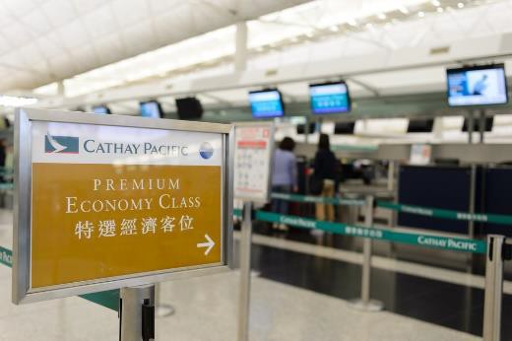Introduction
Before being able to confirm the reservation for your client you will need to establish if there will be any add-on flights to include on the itinerary and if preferred options are available.

Add-on flights
Available and applicable add-on flights may relate to:
- Add-on tables
- Specific flights
- Availability
- Nominated carriers
- Specified routes/destinations
- Integration with full packages
- Compatibility with nominated class
- Prohibition on separate sale
- Confirming currency of guidelines that apply to add-ons with carriers
- Individual terms and conditions of carriers
Understanding all the various airline and city codes that are used within a GDS will assist you in making reservations for your passengers. For example: within the Galileo system just like with all the other GDS operating worldwide, individual airline and city codes can be found with a few simple key stokes, so don’t worry that you have to remember every one. It is recommended to remember by heart the most common city and airline codes that are used within your agency.
The airline availability display in the system will show all the available seats and corresponding fares. It is important to understand that each letter of the alphabet showing in the availability display represents a particular fare type.
For example, the following is a replication of how an availability screen may look for a request of Singapore to Hong Kong on the 25th July.

AN25JULSINHKG
1 3K 691 Y4 W4 V4 T4 S4 R4 Q4 SIN 1 HKG 2 0640 1025 3.45 O4 N4 M4 L4 K4 H4
2 SQ 860 F4 P4 A4 Z4 C4 J0 D4 SIN 3 HKG 1 0830 1215 S9 Y9 B9 E9 Q9 N9 V0 T0 M9 H9 W0 L9 K9
If we look at the 2nd line of availability the Singapore Airlines flight SQ 860, all the different letters of the alphabet represent the different airfares available for sale. The letters F, P and A are all first class airfares, each one with different rules. It shows that there are 4 seats showing available in each of these 3 classes of travel. Letters Z, C, J and D represent the business class cabin in the aircraft. As with first class, each letter represents a different business class fare. The cost of each one will be different just as the rules pertaining to the fare will change. Note that the ‘J’ seats are showing as 0 – that is: none available. All the letters from ‘S” onwards represent economy class fares, each with different rules.
You may notice that most of these economy fare seats show 9 seats available. It is common practice within all the GDS worldwide to show a maximum of 9 seats for sale at one time.
This does not mean that there is only 9 seats left; it represents is the maximum number of passengers that can be booked within one reservation. Should the number ever fall below 9 then it is representative of the actual number of seats left at that fare.
As a general rule of thumb, the first letter represents the most expensive and most flexible fare, as the letters move across the page they become less expensive and far less flexible.

Currencies

Neutral Units of Construction - NUCs
When constructing regular international airfares, a neutral currency is used. It is referenced as NUC - Neutral Unit of Construction (or Neutral Unit of Currency).This neutral currency has been developed by IATA, specifically for use in international airfare construction.
All regular airfares are published in NUC and can be
accessed in a CRS through a Fare Display entry. When constructing an airfare for an itinerary, there are a series of checks that must be conducted. Some of these checks result in a higher airfare needing to be charged. This is referred to as the applicable fare. It is only after determining the applicable airfare that the NUC amount is converted into a real currency using an exchange rate called ROE – Rate of Exchange.

Rates of Exchange (ROE)
The Rates of Exchange are determined by IATA and stored in the CRS. The ROEs are updated quarterly on 01JAN, 01APR, 01JUL and 01OCT, or more frequently if there are significant currency changes during that time.

After constructing an airfare, the agent can do a simple calculation in their CRS to convert NUCs into a real currency. The currency is generally the currency for the first city (country) on the itinerary, or the currency of the country in which the enterprise and CRS are located. For example, a fare from Singapore will be displayed in Singapore dollars. In order to convert NUC to a real currency using the ROE, the agent needs to know the code for the currency. The Galileo entry to convert NUCs using the ROE will be introduced later in this unit.

Currency codes
Each currency code also has an internationally recognised three letter code. Generally, the code will appear in a CRS or on an airline website, before the airfare price to indicate which currency is being quoted.
Some countries choose to use US Dollars (USD) for international airfare calculations due to instability and fluctuations in the local currency.
This table contains the currency name and code for many South East Asian countries.

Country | Currency name | Currency code
China | Yuan or Renminbi | CNY
France | Euro | EUR
Hong Kong | Dollar | HKD
Sweden | Kroner | SEK
Malaysia | Malaysian Ringgit | MYR
Morocco | Dirham | MAD
Philippines | Peso | PHP
Singapore | Singapore Dollar | SGD
Thailand | Baht | THB
United States | Dollar | USD
Great Britain | Pound | GBP

Airfares and rules
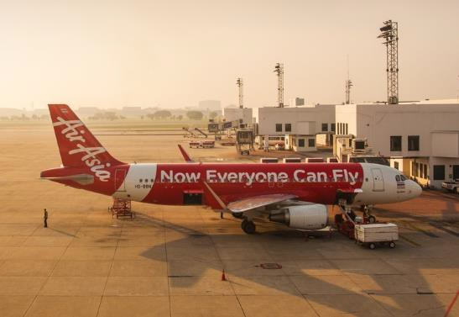A travel enterprise can access airfare pricing and rules through the system that they are using to book the airfare. For example, if an agent is using an airline website, this website will provide information on the cost of the airfare and also the conditions that apply.
Consolidators, which are used by non-accredited travel enterprises for airline ticketing, may also provide information on airfare pricing and rules.
This is usually provided as a general service for travel enterprises. This will vary for each consolidator.
When using a CRS, there are entries that an agent can use to access information on the airfares that they are considering. Galileo entries will now be introduced in this topic to demonstrate how information is accessed.
Entries and screen shots will be introduced and described throughout this topic to demonstrate how to access:
- Fare displays (pricing and some fare rules)
- Fare notes (to read airfare rules in detail)
- Availability screens to see if seats are available for the client.

Fare Basis codes
A fare basis is a code that an airline allocates to each airfare. As stated earlier, in each class of travel, the airline offers a range of prices for sale by the travel enterprise. Each price is allocated a fare basis starting with a different letter of the alphabet. This is best demonstrated by providing an example.
Fare Display Galileo Fare Display Example 1:
Below is an example, using a screen shot from Galileo to display after inputting the following entry:

FDSINJKT01FEB-RT/GA
Here is a breakdown of the information entered:
- FD Fare Display
- SIN Singapore
- JKT Jakarta
- 01FEB Departing 1st of February
- RT Return fares only
- GA Garuda Airlines.

This is an entry that the agent will use to ask Galileo to only display the return fares from Singapore to Jakarta, flying with Garuda Airlines, based on a departing Singapore on the 18th of December.
The information displayed in Galileo is as follows:

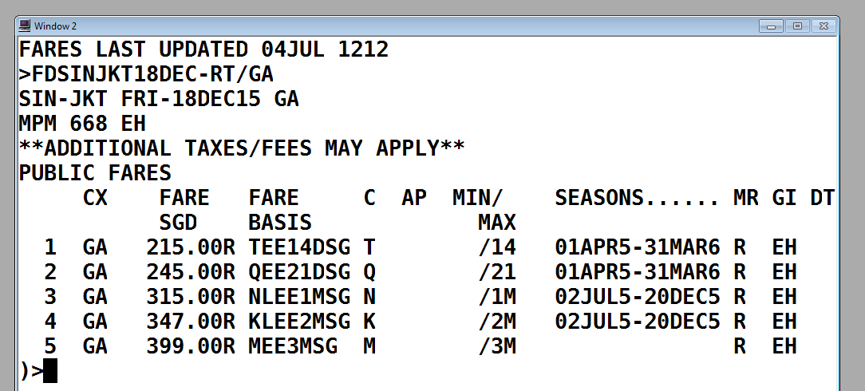
At the top of the screen you will see that it says **ADDITIONAL TAXES/FEES MAY APPLY**. This is a reminder that the information display is the published fare by the airline and does not include taxes and surcharges which cannot be calculated until later when the itinerary is constructed.
Here is an explanation of how to interpret this information, reading across each column displayed:
- Numbers 1-5 are the five cheapest fares in order of price, with the lowest at the top
- Garuda is the carrier for all five fares (as was requested). The ‘CX’ above this column is an abbreviation for carrier
- The fares are displayed in price order and in Singapore Dollars (SGD). The letter ‘R’ after the price indicates that these are return fares (as requested). The fare on Line 1 is SGD215.00
- The Fare Basis is the unique code for each fare
- The letter in the next column (titled ‘C’) is the booking class. This information relates to seat availability and will be discussed later. You will note that the letter in this column (the booking class) is the same as the first letter of the fare basis. This is always the case for all airlines
- AP refers to Advance Purchase. If the airfare must be booked a certain number of days before departure, a number will appear in this column. For all fares displayed, the column is blank, indicating that there are no advance purchase restrictions

- MIN/MAX refers to Minimum and Maximum stay requirements. In each column, there is information after the / symbol, but not before. This indicates that these fares do not have a minimum stay restriction but do have a maximum stay restriction. On line 1, the /14, means a maximum stay of 14 days is allowed before the passenger must return to Singapore. The fare on line 3 states ‘1M’ as the maximum stay, meaning one month is the maximum stay allowed on this fare.
This information demonstrates the importance of knowing when your client wishes to travel and how long they are travelling for before returning. For example, if the client was travelling to Jakarta for six weeks, the fares on lines 1, 2 and 3 could not be used.
Note that the maximum stay information is incorporated into the Fare Basis
- Although some of the fare rules are displayed on this page, more rules can be accessed with further entries and this will be discussed later.



Ensure fare construction complies with operational requirements
Refer to 2.3.

Calculate through fare costs including add-ons

Introduction
Once the agent has confirmed the client’s bookings they can begin to construct an itinerary and calculate costs that meet their requirements.

Accessing airfares in Galileo
When using a CRS, there are entries that an agent can use to access information on the airfares that they are considering. The standardised IATA codes and abbreviations are used.
Galileo entries will now be introduced in this topic to demonstrate how information is accessed.
Entries and screen shots will be introduced and described throughout this unit to demonstrate how to:
- 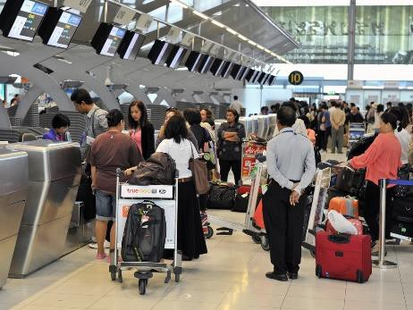Access and interpret fare displays
- Access and interpret mileage information
- Conduct IATA fare construction checks
- Check seat availability for the client itinerary
- Create itineraries and bookings.

Galileo Fare Displays One way airfares Example 1:
Below is an example, using a screen shot from Galileo which is displayed after inputting the following entry:

FDHANMEL20OCT-OW/YY: NUC
Here is a breakdown of the information entered:
- FD Fare Display
- HAN from Hanoi
- MEL to Melbourne
- 20OCT Departing 20th of October (this part of the entry is optional)
- -OW One Way fares only
- YY Display IATA fares for all airlines
- NUC Display the fares in NUCs.

This is an entry that the agent will use to ask Galileo to only display the regular, one way fares from Hanoi to Melbourne, based on a departing Hanoi on the 20th of October. The date does not have to be included in the entry as fares are the same every day of the year.
The information displayed in Galileo is as follows:

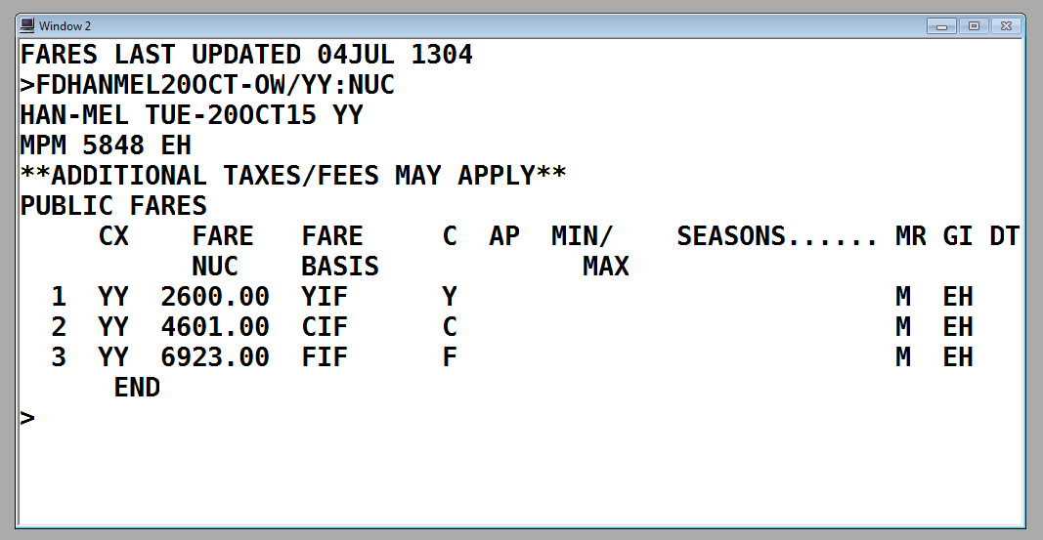
Towards the top of the screen you will see that it says **ADDITIONAL TAXES/FEES MAY APPLY**. This is a reminder that the information display is the published IATA fare and does not include taxes and surcharges which cannot be calculated until later when the itinerary is constructed.
Here is an explanation of how to interpret this information, reading across each column displayed:
- The fare on Line 1 is economy class, Line 2 is business class and Line 3 is the first class airfare
- The ‘CX’ above this column is an abbreviation for carrier. The letter YY appears on each Line as this is what was requested and confirms that the fares are applicable to all IATA carriers
- FARE / NUC - The fares are displayed in price order and in NUC. For example, the fare on Line 1 is NUC2600.00
- FARE BASIS - The code in this column indicates the primary booking class for each class of travel, followed by the letters ‘IF’, meaning ‘IATA fare’
- C indicates the booking class. This letter is the primary code for the class of travel. This information relates to seat availability and will be discussed later
- AP refers to Advance Purchase. If the airfare must be booked a certain number of days before departure, a number will appear in this column. For all regular fares, the column is blank, indicating that there are no advance purchase restrictions
- MIN/MAX refers to Minimum and Maximum stay requirements. For all regular fares, this column is blank, indicating that there are no minimum or maximum stay restrictions
- SEASONS refers to seasonality and when the passenger can use the fare. For all regular fares, this column is blank, indicating that there are no seasonal date restrictions
- MR - Mileage system or Routing fare – the method being used to construct the fare. All regular fares will show the letter M in this column, indicating that the mileage system is used when calculating the fare
- GI - Global Indicator – EH indicating that the applicable Global Indicator is Eastern Hemisphere.

Other information on Fare Display screens

MPM 668 EH
- Maximum Permitted Mileage. If the fare between Hanoi and Melbourne is to be constructed using the mileage system, the passenger cannot travel more than 668 miles on the journey without being surcharged
- EH – Eastern Hemisphere (the only applicable Global Indicator).

Example 2:
This is the entry to display regular, one way fares from Singapore to London, departing on 20th October.

FD20OCTSINLON-OW/YY: NUC

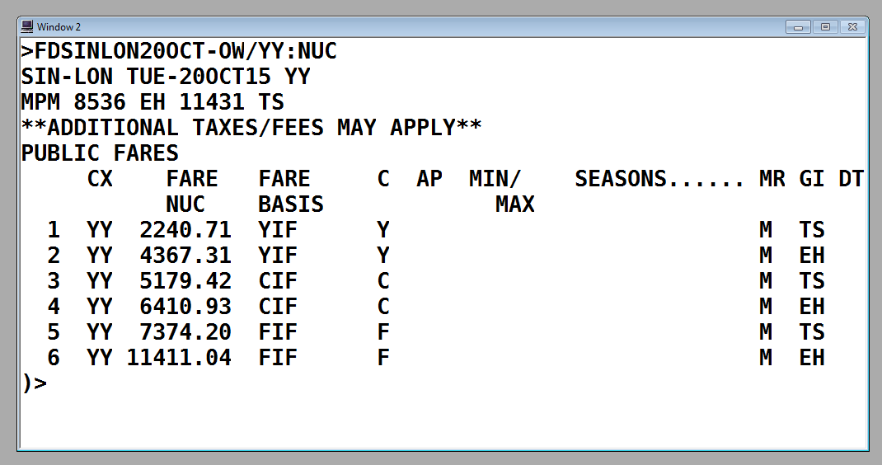
This screen is similar to the first example with fares from Hanoi to Melbourne; however this screen contains additional information because there are two possible Global Indicators (GI) allowed for travel between Singapore and London. The two GIs are EH and TS. Refer to Topic 2.1 to revise the different Global Indicators.
Note that there are six fares display as each class of travel has a different fare for each GI. Also note that there are two separate MPMs (Maximum permitted mileage) for each Global Indicator.
In order for the agent to know which Global Indicator to use, the agent must consider which direction the client is traveling from Singapore to London. For example, if the client is flying from Singapore to Dubai and then on to London the Global Indicator is EH, but if the client is flying from Singapore to Seoul and then on to London the Global Indicator is TS.

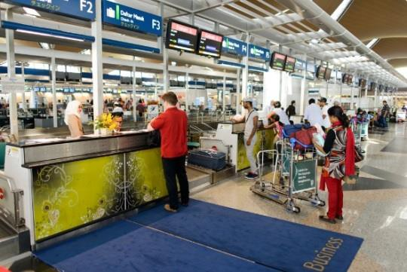

Here is a summary of this information for a passenger flying business class.

Itinerary | Global Indicator | Business class fare in NUC | MPM
SIN DXB LON | EH | 5179.42 | EH 8536
SIN TYO LON | TS | 6410.93 | TS 11431
Note that the fare via the TS indicator is much higher but also has a much higher Maximum Permitted Mileage.

Return airfares
The examples above are based on one way airfares. The process is very similar for return airfares however there are a few further considerations.
Firstly, a one way fare has one component – from origin to destination. A return airfare has two components – an outbound component from origin to destination and then an inbound component from the destination back to the origin. When constructing an airfare for a return itinerary, the agent must firstly choose the destination point. Sometimes this isn’t very clear as it is the furthest place from the origin and other times it may be a bit difficult to determine.
For example, if the client wishes to fly Singapore to Dubai to London, returning via Dubai to Singapore, the itinerary would appear like this:

SIN DXB LON DXB SIN
London is clearly the destination as it is the point of turnaround and furthest city from the origin.
However, in this example, the destination could either be London or Paris.

SIN DXB LON PAR DXB SIN
The agent has a choice and could do any of the following:
- Select the city with the highest fare
- Select the city that is furthest away
- Construct the fare twice to see which construction has the lowest airfare for the client.
Although there are different ways to do this, IATA have checks that must be completed which will assist the agent to construct the correct fare. This will be considered later.

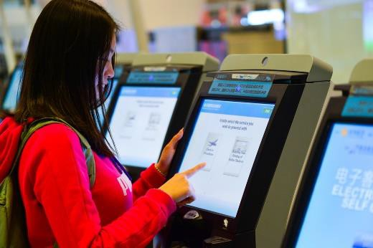

If London was selected as the destination (or breakpoint), the fare display entry would be:

FD09JULSINLON-RT/YY: NUC

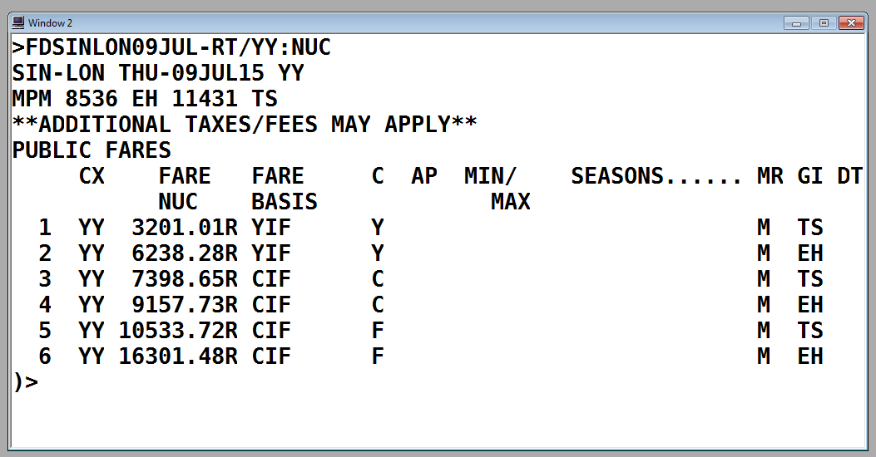
This screen is very similar to the previous example which was a fare display for the same cities but requesting Galileo display one way fares.
You will note the following:
- The letter R appears at the end of the NUC price to indicate this is a return fare
- The return fares are higher than the one way fares but are not double the one way fares. It is usually better value to buy a return airfare than a one way fare
- The Global Indicators are the same
- The MPM (Maximum Permitted Mileage) is the same, not double. This is because the MPM is applied to each fare component.

Types of return airfares
Return airfares have two components – outbound and inbound. A return fare can be classified as being a round trip or a circle trip.
When a return journey has an itinerary that starts and finishes in the same city, and both the outbound and inbound component are the same price, this is called a round trip.
When a return journey has an itinerary that starts and finishes in the same city, and the outbound and inbound component are different prices, this is called a circle trip.
This will be explained further in this topic. It is important to understand the difference as an additional IATA check is required for some circle trip itineraries.

Mileage information

Maximum Permitted Mileage
When reading a Fare Display, the Maximum Permitted Mileage (MPM) is displayed to indicate the maximum number of miles that can be flown between the origin and destination cities. This MPM must be compared to the number of miles being flown on the itinerary. A CRS can calculate the mileage very simply but it is important for the agent to be able to interpret the information provided. In order to do this, the agent must be aware of the following mileage terms and concepts:
- MPM – Maximum Permitted Mileage
- TPM – Tickets Point Mileage
- EMS – Excess Mileage Surcharge
- EMA – Excess Mileage Allowance.

Ticketed Point Mileage

Galileo Entry
To calculate the flown mileage on an itinerary, the cities can be entered into Galileo (using IATA codes), preceded by the code FL (Flown Mileage).
For example, to check the mileage to fly from Hanoi to Kuala Lumpur and then to Melbourne, the entry:

FLHANKULMEL
The response is:

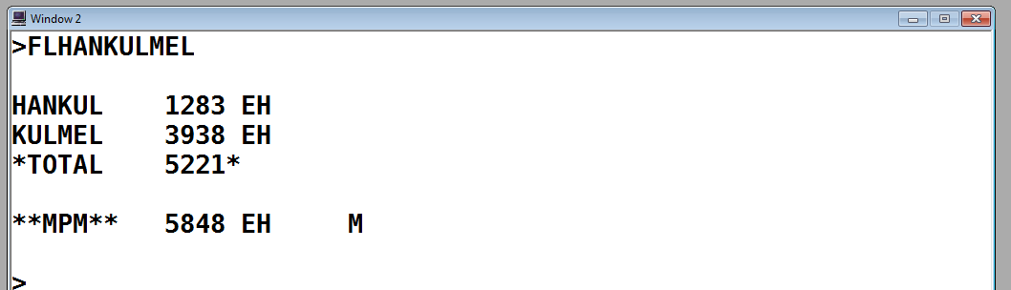
This screen indicates that the distance between Hanoi and Kuala Lumpur is 1,283 miles and the distance between Kuala Lumpur and Melbourne is 3,938 miles. The total is the two numbers added together and the Ticketed Point Mileage (total) is 5,221 miles.
Underneath, Galileo is indicating that the Maximum Permitted Mileage is 5,848 miles. The MPM was also shown in the Fare Display (see previous Example 1).
The TPM is less than the MPM, indicating that the itinerary is ‘in on miles’. The letter M in this display is indicating that the flown itinerary is below the MPM.

Return Airfare example
To check the TPM for a return airfare, requires two FL entries; one for each component. For this itinerary, the breakpoint (destination) selected is London.

SIN DXB LON PAR DXB SIN
The two entries will be:

Outbound: FLSINDXBLON

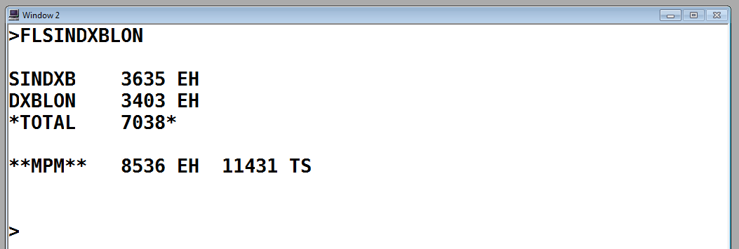

Inbound: FLLONPARDXBSIN

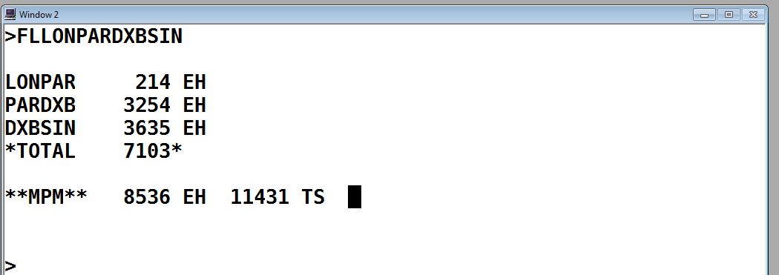
Both the outbound and inbound components are ‘in on miles’.



Excess Mileage Allowance
There will be itineraries where the TPM is higher than the MPM. In this case, in some circumstances there may be a deduction known as an Excess Mileage Allowance (EMA) which can be applied. IATA has determined which itineraries are entitled to this allowance and will deduct miles from the total TPM if the itinerary is eligible for an EMA.
The EMA example we will consider applies for travel within Area 3 only. When an itinerary only involves travel within TC Area 3 and travel is via Delhi and Mumbai, IATA allows an EMA (if required). This is also the case for an itinerary within TC Area 3 which includes travel via both Karachi and Islamabad.
This is best described using an example. In this Galileo screen, the TPM is calculated for a journey from Vientiane to Bangkok to Delhi to Mumbai.

FLVTEBKKDELBOM

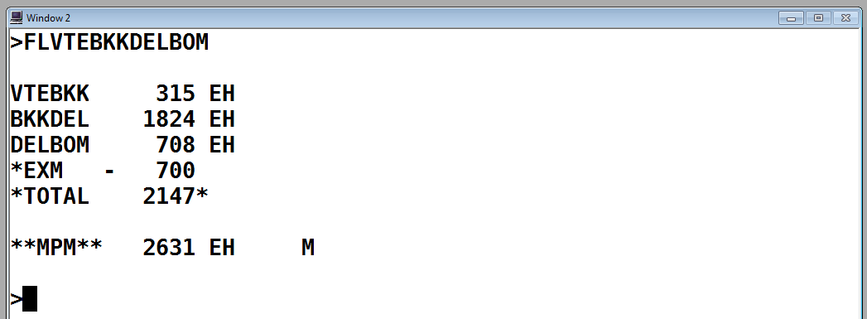

In the screen above, Galileo has calculated the flown mileage on the itinerary (TPM) and then deducted 700 miles from the TPM as the passenger is entitled to this EMA as they are flying via Delhi to Mumbai on their itinerary.
There are very few flight routings that are entitled to a deduction but as they still exist, it is important that an agent is aware of the EMA and how to interpret this from a Galileo screen.

Excess Mileage Surcharge
In the following example, the itinerary is much longer. This is a more realistic example of an itinerary that might be constructed using a regular airfare. The flown itinerary is Jakarta to Manila to Singapore to Dubai to Paris. Encoded, the itinerary is written as:

JKT MNL SIN DXB PAR
The Global Indicator for this itinerary is EH.
The following screen displays the TPM and MPM:

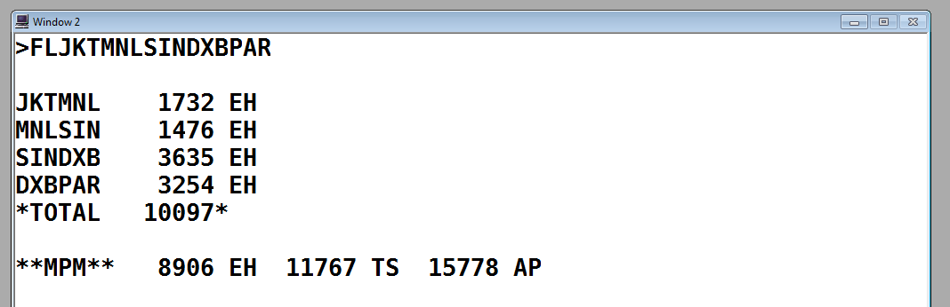

Note that the TPM is 10,097. Galileo has displayed a range of different Global Indicators and their applicable MPMs. Galileo is able to indicate the possible GIs for this itinerary but is not able to determine which one applies to the itinerary outlines in the FL entry. The agent needs to select the correct GI and MPM.

TPM 10,097 miles MPM 8,906 miles - EH
In this example, the TPM is higher than the MPM. This means that the regular fare from Jakarta to Paris cannot be charged and will need to be surcharged as the client needs to fly additional miles. Galileo is able to advise that the MPM has been exceeded but cannot calculate the applicable surcharge when there are multiple Global Indicators. The fare will need to be surcharged an additional 5%, 10%, 15%, 20% or 25%, depending on the number of extra miles being flown. The calculation of the required surcharge needs to be done manually be the agent.

Calculating a mileage surcharge
Using a calculator, enter the TPM divided by the MPM.

10097 ÷ 8906 = 1.1337
Use this table to calculate the surcharge.

If the number on your calculator is between: | Surcharge the fare by | CRS / IATA format | Multiply the fare by:
1.0001 - 1.0500 | 5% | 5M | X 1.05
1.0501 - 1.1000 | 10% | 10M | X 1.10
1.1001 - 1.1500 | 15% | 15M | X 1.15
1.1501 - 1.2000 | 20% | 20M | X 1.20
1.2001 - 1.2500 | 25% | 25M | X 1.25
1.2501 - higher | Unsurchargeable – too much mileage flown
This means that the published, regular fare from Jakarta to Paris (for this itinerary: JKT MNL SIN DXB PAR) will need to be surcharged by 15%.
We will not continue with this example at this stage as there are still further checks that need to be completed. The fare is not surcharged until after these checks have been completed as the fare may increase.

Unsurchargeable itinerary example
The itinerary is Singapore to Auckland to Brisbane – SIN AKL BNE.

FLSINAKLBNE

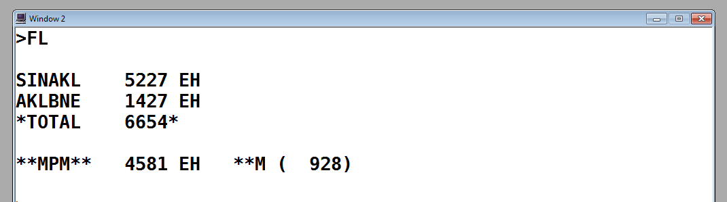

Note that EH is the only possible Global Indicator for this itinerary and the MPM is 4,581 miles. The TPM is 6,654 miles, which is higher than the MPM.
Using a calculator, enter the TPM divided by the MPM.

6654 ÷ 4581 = 1.4525
Referring to the Mileage Surcharge table above, you will see that as the number is greater than 1.2501, the fare is unsurchargeable. This means that a regular airfare cannot be used to construct one fare for an itinerary from Singapore to Auckland to Brisbane.
This does not mean that the client is not able to fly this itinerary; it just means that the agent is not able to use one regular airfare from the origin to destination and will need to consider different ways to construct this airfare. For example, the agent could access two different one way fares – one from Singapore to Auckland and then another from Auckland to Brisbane. This is considered advanced regular airfare construction and is not covered in this unit.

Construct and check accuracy and completeness of air itineraries
Refer to 2.5.



Work Projects
It is a requirement of this Unit you complete Work Projects as advised by your Trainer. You must submit documentation, suitable evidence or other relevant proof of completion of the project to your Trainer by the agreed date.

  - Complete the following list for currency codes.

Country | Currency name | Currency code
 |  | AUD
 |  | CHF
 |  | JPY
Brazil
Canada
Chile
 | Pataka
 | Tala
 | Rouble or Ruble

  - a What is the correct Global Indicator for each of these itineraries?

AKL HKG SHA

LON NYC HNL BNE

JNB PER SYD

FRA LAX MEX

BNE KUL TYO AMS

ATH LON NYC LAX

SYD TYO SIN VIE

MEL LAX BUE

SIN KUL DXB ATH

  - b Construct a round world fare with a stop in each country in TC1, TC2 and TC 3. Identify the intermediate point and provide costing in US dollars. Identify the carriers being used and their cost.

  - Explain excess mileage allowance. How will you know when it applies?

  - Create a circle trip airfare showing calculations for excess mileage.

Summary
Construct airfares incorporating add-ons

Identify and interpret available and applicable add-on flights
- Add-on flights
- Currencies
- Neutral Units of Construction - NUCs
- Rates of Exchange (ROE)
- Currency codes
- Airfares and rules
Ensure fare construction complies with operational requirements
- Refer to 2.3
Calculate through fare costs including add-ons
- Accessing airfares in Galileo
- Galileo Fare Displays
- One way airfares
- Return airfares
- Types of return airfares
- Mileage information
- Maximum Permitted Mileage
- Ticketed Point Mileage
- Excess Mileage Allowance
- Excess Mileage Surcharge
- Unsurchargeable itinerary example
Construct and check accuracy and completeness of air itineraries
- Refer to 2.5

Element 4:
Prepare international pre-paid ticket advices

Determine the needs and preferences of client for pre-paid ticket advice (PTA)

Introduction
There are a variety of documents that are required to be completed for international pre-paid ticket advices (PTA). These may include letters of confirmation, tickets, invoices, itinerary and vouchers. Some clients will ask that their documents be sent by post or courier, others will prefer to receive them electronically, others will prefer to collect in person.
Element one discussed client needs and preferences and some of that information has been repeated here for consideration with pre-paid ticket advice

Client needs and preferences
The client’s needs and preferences may relate to:
- Airline preferences – this may be based on prior flying experiences or frequent flyer membership
- Single or multiple destinations
- Flexibility with travel dates and times
- Urgency – may need to travel as soon as possible
- Number of passengers travelling
- Reasons for travelling – holiday, business, visiting family
- Class of travel – economy, business or first class
- One way or return travel
- Special requests for meals, seats and assistance from the airline
- Budget – the amount of money they wish to spend
- Passport nationality and need for visas for countries visited
- Other travel arrangements that need to be booked.

Asking questions to identify needs
The client is likely to provide the agent with most of the information that they will require to make their booking. There may however be some questions that the agent needs to ask to confirm that they understand exactly what the client requires. The questions used will be guided by the client’s needs and the amount of information previously given.
Suggested questions include:
- Where are you interested in travelling to?
- When are you thinking of travelling?
- How long do you wish to be away?
- Which class do you wish to travel in?
- Are your dates flexible?
- Do you have a preference to fly with a particular airline?
- Do you wish to have checked baggage?
- Is meal service an important part of your airline experience?
- What nationality passport are you travelling on?
- How many passengers are travelling?

Invoices
Often an invoice detailing the total charges of the client’s booking will accompany the letter of confirmation. Again these details would have been discussed during the consultation and booking process however a printed invoice provides a permanent record of the details of the costs involved in the reservation.

Tickets, vouchers and final itinerary
As a guide, industry standard is no later than 2 weeks prior to passenger departure date. That said, it is worth considering dispatching E-tickets documents as they are issued or received. Provided that you are not waiting for other documentation e.g. cruise or tour vouchers, there is no reason to hold the E-tickets in your office and not send them to the passenger. As a general rule, passenger documents, if retained in the office, are stored in a secure place, usually in a safe.
The advent of the requirement to show photo-ID when checking in for domestic travel, now, to some extent, precludes the fraudulent use of a ticket.
Many clients, particularly those who are travelling for leisure, will come into the office to collect their E-tickets and any other documentation such as vouchers etc.
If you decide to mail the documents then please allow sufficient time for delivery and ensure they are sent using a service where the documents can be tracked, such a registered mail.
Some E-tickets such as those issued via an agents website or an airline website can be emailed to the passenger if they elect this option.
If you have made a booking in your office using a CRS/GDS you may be able to scan and email the ticket to the client. The hard copy original ticket should then also be sent through express or registered post.

Delivery options commonly used
- E-mail
- Post Express Mail
- Registered Mail
- Delivery via a courier service.
Regular mail is not generally used, as there is no way to track documents if they fail to arrive.
Copies of all documentation, both soft copy and hard copy, received and dispatched, should be retained in the office for reference. How and where these are kept, will be office specific. You will usually receive or produce a combination of one or more of the following:
- Electronic documents sent by supplier/operator
- Hard copy documents sent by supplier/operator
- ‘In-house’ produced, electronic documents
- ‘In-house’ produced hard copy documents.
Back-end office applications may automatically save any ‘in-house’ produced documentation against the passenger file number.
A detailed itinerary which presents all the travel arrangements booked, whether pre-paid or not, should be provided, in date and product/service continuity, for the passenger/s. A should be retained for the file.
As discussed the documentation provided to the customer is, often, simply pieces of paper. They are usually the only tangible item/s received which represent the exchange of monies paid for product and service. Presentation of the documentation is important and should look professional. Where possible, in packaging and presenting the documentation use:
- Agency branded voucher covers
- Agency branded itinerary covers
- Stationery with agency logo
- Wallets if available
- Baggage labels
- Extra information
- Business card
- Insurance policy (if purchased) together with applicable emergency contact information. Provide the final documentation to the passenger by one of the following means:
- Face to face
- Email – PDF or similar files
- Registered mail
- Post Express
- Courier or personal delivery.

Where possible, in particular with leisure travel, it is advisable to meet face to face with the customers when providing their final documentation to them. Where documentation is being produced on behalf of another consultant they will indicate how the documents will be delivered to the customer.
When deciding how best to dispatch documentation, consider:
- When the passengers are departing
- Where they live
- Public holidays
- Contents
- Service levels associated with the various delivery options.
Documentation which includes documents which are accountable and which can be utilised, without verification of passenger identification, passports or travellers cheques should always be sent via a traceable delivery service such as registered mail.

Select flight and carrier that best meets client needs

Introduction
It is important to establish during the sales consultation the parameters of the passenger’s needs. If they need flexibility in their ticket then it is important you meet those requirements and not try to sell them a fare with restrictions attached.

Client information
There are a few pieces of information you require to construct a good itinerary for your client at the best available airfare. This includes client needs and preferences which have already been discussed in previous sections of this manual.
This information will assist you in deciding which airline carrier best suits your clients’ needs and to some degree that will dictate which source you will use to access the schedules.

Selecting carriers
Selecting a flight and carrier may include:
- Confirming availability
- Understanding relevant carrier policies and procedures, including limitations and restrictions
- Matching timing requirements to flight availability
- Seat availability
- Meeting connecting flights
- Package limitations, where applicable.

When discussing airfare costs with your passenger you must make a thorough check of the fare rules to ensure you advise your client correctly of the fare conditions.
Strong competition in the air travel marketplace means that as well as the standard fare types, special airfares and deals become available from time to time. These specials and deals usually have clear book and pay conditions, limited availability and often sell out quickly. The airlines will generally provide advance notice of specials to their travel agent network however there are instances where this does not happen. Travel agents need to keep up to date in terms of what is happening in the marketplace
Once a reservation has been made on behalf of a passenger the CRS provides the opportunity to be able to quote the relevant airfare and corresponding booking conditions that align with that airfare.

When selling certain tickets you may need to make these reservations directly with the airline via their website. When processing a booking this way, you will need to use the passengers own credit card for payment and not your agency one. In most instances the credit card holder must actually be one of the travelling parties.
The fare (or combination of fares) is class and availability dependant.
In order to check the seat availability, you must decide what class you need to book for your client based on:
- Passenger flexibility in terms of dates and times
- Degree of flexibility required in terms of changes and/or amendments
- Passenger budget
- Airline preference.
The following is an excerpt of fare rules and taxes from the Vietnam Airlines website.

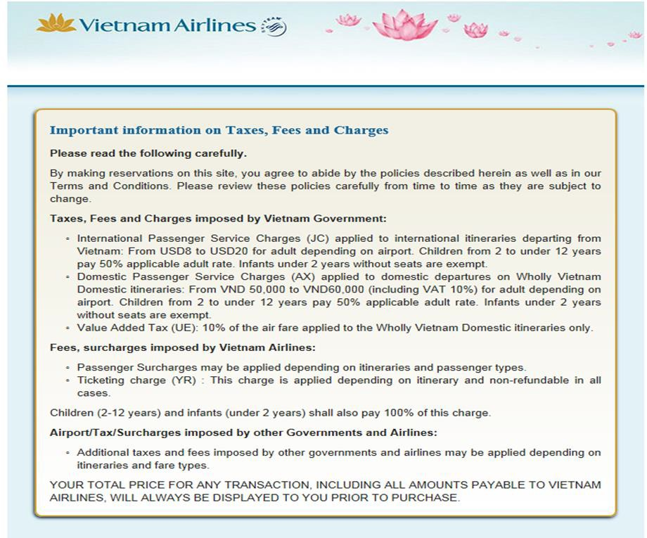

Airline schedules

Access to airline schedules, airfares and information in relation to the flights operated by the various airlines is available electronically to travel agents via:
- A CRS/GDS
- A Travel Agent Website
- An Airline website.
In most instances you will use your CRS/GDS to access schedules, construct the itineraries, source airfares and make bookings. There may however be instances when, because of ticket restrictions or commercial arrangements, you will:
- Access an Airline Travel Agent Website to check schedules and fares and to make the booking e.g. British Airways and Emirates
- Access Airline general public website e.g. Qantas to check schedules and fares and to make the booking.

Limitations of indirect travel
A rule that covers the limitations of indirect travel relates to how many times a city can be travelled through within a fare component.
The rule states that a fare component must not include more than:
- One departure from the point of origin; or
- One arrival at the point of destination; or
- One stopover at any one intermediate point.
This means that the following one way itineraries cannot be constructed as a through one way fare from origin to destination:
SYD ADL SYD KUL LON BNE BKK LON DUB LON MEL SIN BKK SIN LON
Please note:
- The use of the word ‘stopover’ in the third limitation - it is possible to stopover and transit through the same intermediate point within a fare component
- The following itinerary is permitted: BNE SIN LON SIN BNE
- Singapore appears twice as an intermediate point but within different fare components – outbound and inbound.

Selecting the carrier with the cheapest fare
If you are using a CRS/GDS to process the booking, and considering all of the above, you can proceed to make the booking using the system specific entries. Once you have checked the availability and secured the seat in the applicable class, complete the booking including quoting the fare and taxes for the booking. Again there are CRS/GDS system specific entries that you will use.
If your client requests the cheapest fare:
- Use your CRS/GDS to do a ‘fare shop’ for the date and segment required. The following screen shot is for a one way flight Denpasar to Jakarta from the Galileo CRS

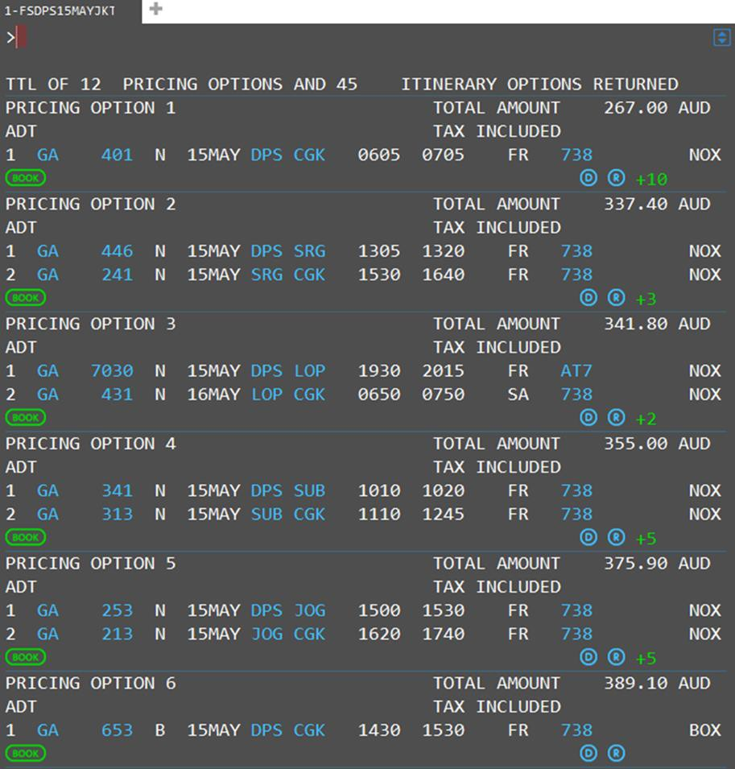

- Select the cheapest fare and note the class to be booked and display the rules associated with that fare
- Check the fare rules and conditions to ensure that you can use that fare
- Sell the ticket by selecting the ‘Book’ icon and complete the booking by entering all CRS mandatory fields.
- Collect the money or charge to a credit card
- Issue the ticket and provide the e-ticket and receipt to client.

Baggage allowances
Baggage allowances should be understood and communicated to the client at the time of quoting. There are two types of baggage that passengers are permitted to take with them on their journey. These are called checked baggage and carry-on baggage. Checked baggage is given to the airline at the airport and is carried in the hold of the aircraft. Carry-on baggage, often referred to as hand luggage, is carried onto the aircraft by the passenger.
The weight and size of baggage that a passenger can take on a flight varies for each airline and the class of travel. Some low cost carriers charge passengers for carrying any baggage while full service airlines have a free baggage allowance included in the fare.
It is important to be aware of both size and weight restrictions and the penalties that will apply for carrying excess baggage. This information is easily accessed from airline websites. Airlines will also have policies relating to the carriage of larger items of luggage including sporting equipment and musical instruments.
This information is from the Thai Airways website and relates to their general checked baggage policy:

Dangerous goods and restrictions
All airlines will also impose restrictions on dangerous goods that cannot be packed into baggage. Dangerous goods include explosives, flammable liquids, alarms, weapons, and so on. There are also restrictions on the amount and size of liquids, aerosols and gels that can be included in carry-on baggage on international flights.

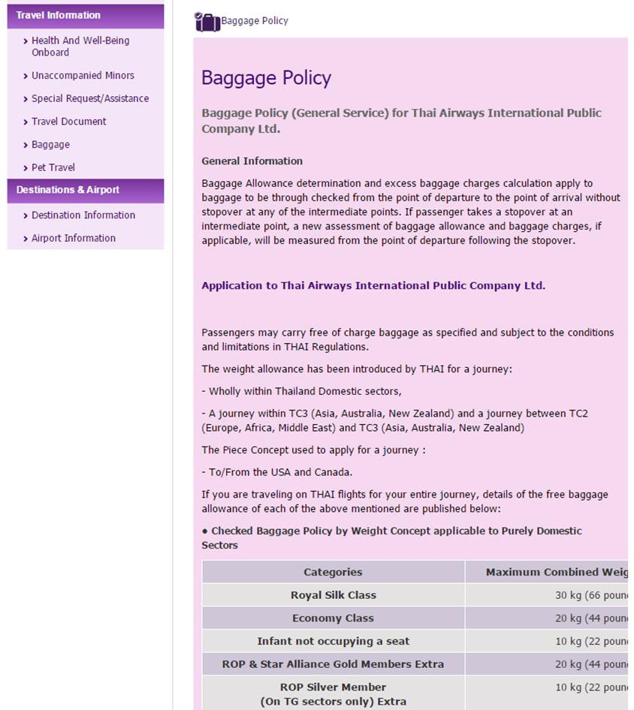

Process PTA in accordance with operational requirements

Introduction
The method used when processing PTA (pre-paid ticket advice) in accordance with operational requirements will also depend on the enterprise that the agent is working for and the CRS or airline website being used.

PTA Process
The PTA process may include:
- Following relevant guidelines, policies and procedures
- Confirming applicable timeline requirements for booking
- Verifying agency details with carrier
- Including services covered by PTA’s, including excess baggage, unaccompanied children, oxygen use
- Obtaining fare quote
- Applying service charge
- Raising Miscellaneous Charge Order (MCO).

Since 2008 paper tickets were finally phased out and replaced with electronic ticketing, so this process is now much simpler. All ticket transactions are now reported through the agent GDS to the Data Processing Centre and V-MPDs can be issued.

Miscellaneous charge orders (MCO
Miscellaneous charge orders (MCO) have now been replaced with a virtual MPD
A multi-purpose document (MPD) is used by the agent to make payment to airlines for non-air services such as excess baggage, ground transportation and accommodation. The document is now called a Virtual MPD (abbreviated to V-MPD) which is issued by the agent

Quotations supplied to clients
If you are using a CRS or Agent Airline website to construct an air itinerary and to provide a fare quote for a client, the data or information provided will always be up to date at the time that the quote is sourced and there is provision to print an itinerary which includes the price of the airfare and the taxes. It does not however include the fare rules and conditions in relation to the airfare and you should be careful to provide these to your passenger.
The breakdown of fares and taxes are detailed during the book and/or quote process but before the payment details are required to be input.
Remember airfares are a moving target, are subject to availability and can and do change.
While airlines such as Singapore usually retain the fare levels for particular classes, other airlines such as Jetstar often change the various fare levels in order to improve loadings on a particular service or in response to what is happening in the general market place.

The golden rule therefore, in terms of providing up to date airfare quotes to your client, is to check your CRS or airline website each and every time you are required to provide a quote. This is in fact a very quick process and you will quickly learn to do this as a matter of habit. You must never guess.
Some passengers of course may only be interested in the total cost per person including any taxes.
Requests for quotes and bookings will generally be received via:
- The telephone
- An email
- In person.
If you are providing a quote over the telephone or to the client sitting across from you, you must make notes! These notes should be recorded against a quotation reference number, have the dated recorded and should include:
- The name and contact detail of the person requesting the quote
- The itinerary - detailing the sectors, dates, times, airline and class (if specified).
- The price quoted (per person) airfare and taxes separately (they can and do change) and your service fee, if applicable, separately.
- The current availability and/or status of the sectors, products or services
- The validity of the quote and any deadlines – book, pay or ticket
- The condition of sale. Fare rules, changes. refunds and so on
- The applicable cancellation and/or amendment fees applicable to the airfare quoted
- Advise that the name on the ticket must match exactly the photo identification of the person travelling. No nick names e.g. Nick Jones instead of Nicholas Jones
- State the office policy in relation to payment i.e. cash or credit card only
- Any merchant fees associated with the use of credit cards. These notes will form the basis of your written or verbal quote.
If you are providing a quote via email the content of your reply to the email enquiry will in fact
serve as your file notes.
It is recommend that when providing quotes to clients via email that you ask for a telephone contact number (if not provided) for both the person requesting the quote and the passenger, if they are different people.
Requests for quotes via email can be time consuming. Often clients are simply shopping around and send multiple emails to a range of travel agents requesting quotes. The policy, in relation to the handling of these email requests for quotes, is agency specific and you should check with your manager regarding the guidelines.
Where reference numbers are not automatically generated for quotes and there is no office protocol for referencing quotes, it is advisable to devise a system of your own.
E.g. DD/MM/YY + client family name + your initials

Adjusting and updating fare quotations
Once a quote has been provided to a client, you may be required to re- quote, for a range of reasons some of which are:
- The quote has expired
- The fare has expired or has been withdrawn
- The taxes have increased
- There is no availability
- Flights are added or deleted from the itinerary
- Passengers are added or deleted from the itinerary
- The passenger wishes to make a booking.

Remember that all quotes provided, verbal or written, are subject to availability of flights, in the class of travel required, for the dates and times required and are therefore subject to change. Taxes in particular can and do change. There is no way to guarantee any quote unless you quote, book and ticket at the same time.
Where you are converting a quote to a booking, you may be required to update a quote due lack of availability and so on.
The guidelines for re-quoting an itinerary are no different to those used when providing a quote for the first time. Do not assume that the client will know that the same fare rules, conditions and so on apply. You need to detail this as part of providing a new quote. In particular make sure that the quote is dated.
Many travel agents use a pro-forma document which contains all the standard paragraphs in relation to quotes or booking conditions and has provision to simply fill in the specifics.

Regular airfare rules
Airfare rules were discussed in detail at 2.2 however the following points are worth reviewing when considering airfare quotes.
The agent must ensure:
- All required checks are completed when constructing the airfare
- The itinerary meets the requirements of the Global Indicator for the airfare they are accessing and calculating
- The client is aware that although changes are permitted free of charge, the changes are subject to seat availability on the requested flight
- Business and first class passengers are aware that not all aircraft have multiple classes of service. In the event that the itinerary is changed and the passenger is now on a flight without business or first class seats, they will not be compensated
- Clients are aware that although the airlines do not charge any penalties for amendments or cancellation, the enterprise may impose service fees for providing assistance to clients to make these changes.

Mileage information

Maximum Permitted Mileage
This has been covered in detail in 3.3 however it is worth reviewing the following term and concepts as they relate to processing pre-paid ticket advice.
When reading a Fare Display, the Maximum Permitted Mileage (MPM) is displayed to indicate the maximum number of miles that can be flown between the origin and destination cities.
This MPM must be compared to the number of miles being flown on the itinerary. A CRS can calculate the mileage very simply but it is important for the agent to be able to interpret the information provided. In order to do this, the agent must be aware of the following mileage terms and concepts:
- MPM – Maximum Permitted Mileage
- TPM – Tickets Point Mileage
- EMS – Excess Mileage Surcharge
- EMA – Excess Mileage Allowance.

Baggage

There are 2 types of baggage that passengers are permitted to take with them on their journey. These are “checked” and “carry on” baggage.
Weight and size allowances vary from airline to airline however as a general rule for travel the economy allowance is 20 kilos for checked baggage and 7 kilos for carry-on baggage. The size of the carry-on baggage is also regulated. It must be able to fit under the seat or in an overhead locker.
Children under 2 years (who are travelling free of charge) are not entitled to a free baggage allowance.
Where a ‘piece’ system is in place, no one piece of baggage can exceed 32 kilos in weight. There are also size limitations imposed where baggage allowance is expressed in pieces.
Where passengers are travelling business class or are a member of the airline’s frequent flyers club, additional baggage allowances are extended. They are carrier specific and this should be checked with the applicable airline.

Issue or forward PTA

Introduction
Once full payment has been received from clients, their tickets can be issued. There are different ways of doing this. When bookings are made through the CRS, the process for issuing tickets will vary depending on whether or not the enterprise is accredited. As well as understanding the ticketing processes and options, there is also general ticketing information that should be understood by all travel agents.

Issuing a PTA invoice
Regardless of the type of airfare or travel arrangements booked, it is important to issue an invoice so that the client has a record of the travel arrangements that they have booked and paid for. An invoice gives the client the opportunity to check their personal and travel itinerary details are correct and that they understand the fare rules and conditions.

Accredited enterprises
To issue airline tickets, an agency must be accredited by IATA (International Air Transportation Association) and also have authority from each airline that they wish to ticket. An IATA accredited travel enterprise can issue tickets on approved airlines through their CRS. When the agency is accredited, ticket numbers are electronically provided through the Billing Settlement Plan (BSP).

Billing Settlement Plan
The Billing Settlement Plan is a centralised system which allows travel agents to issue tickets on IATA approved airlines. When an agent tickets a confirmed flight booking, a ticket number is allocated for each person in the booking. Each ticket has a monetary value which includes the airfare and the taxes. Agents only earn commission on the airfare component of a ticket.
Each evening, information from the enterprise’s CRS reports to the BSP the tickets that have been issued throughout the day. The information reported includes the airlines, ticket numbers and the monetary value of each ticket. This information is collated into a report which is issued to the agency each week. This report (BSP statement) lists the money owing for all of the tickets sold and is itemised by airline and date of issue.
The BSP offers a simplified system allowing agents to make one weekly payment for airline tickets issued through their CRS, rather than making payments for each airline and each ticket separately. The BSP statement is accessed through an agent, online system called BSP-Link and ticket details can be viewed in date order with tickets in sequential order, by airline or by passenger surname.

Ticket Modifiers
Each CRS has a series of entries that must be entered to allocate a ticket number to each passenger in the booking. When issuing a ticket, the agent must include the carrier, the percentage commission earned from the carrier and the form of payment from the client (cash or credit card paid to the airline). These pieces of information are called Modifiers.
- Galileo entry: TKPCSQZ5FS
Explanation:
- TKP Print tickets
- CSQ Carrier – Singapore Airlines
- Z5 Commission – 5%
- F Form of payment
- S Cash.

Issuing tickets – Cash payment
When including the form of payment as ‘Cash’, this means that the agency will pay for the airfare. This means that on the weekly statement from BSP, the agency will be billed by the airline for this ticket.
Example: Airfare is SGD2000 with taxes SGD157.40 Commission is 5%
Agent will pay 2000 less 5% = SGD1900 plus SGD157.40 to Singapore Airlines.
The enterprise keeps SGD100 as commission on the airfare.
BSP arrange the payment to the airlines on the enterprise’s behalf and will include the cost of this airfare on the weekly statement sent to the enterprise.

Issuing tickets – Credit card payment
The other option is payment using the client’s credit card. There is an entry in each CRS to firstly ensure there are sufficient funds on the card. There is then a further entry to advise the credit card number and expiry date directly to the airline to charge the card and issued the ticket. This means that on the weekly statement from BSP, the agency will receive commission from the airline for this ticket.
Galileo entry: TKPCPRZ6F5555666677778888*0316
- TKP Print tickets
- CPR Carrier – Philippine Airlines
- Z6 Commission – 6%
- F Form of payment
- 5555666677778888 Credit card number
- 0316 Credit card expiry date – March 2016.

Example: Airfare is USD1000 plus taxes USD 99.50 Commission is 6%
Agent will receive 6% of USD1000 as commission = USD60
The airline is receiving the payment directly from the client’s credit card. Philippine Airlines will pay the agent’s commission through the weekly BSP statement. This means that instead of paying for the ticket, the agent will receive the commission (USD60) from the airline.

Ticket numbers
A used ticket number has 11 digits. An issued ticket has 14 numbers and the first three numbers assigned will represent the three digit designator code of the airline that is being flown. When multiple airlines are being flown, the agent must choose which airline to issue the ticket to. It is usually the first or the most used carrier on the itinerary. As explained previously, the agent is not responsible for paying each airline for each airfare individually; this is dealt with through the BSP.
The ticket number/s are automatically generated and recorded in the booking. The associated paperwork that is generated by this process is minimal and is only for audit purposes, BSP remittance and agent records.

Non-accredited enterprises
It is also possible for non-accredited enterprises to issue tickets through their CRS by using the services of a consolidator. When booking airfares in a CRS, the process is the same for both accredited and non-accredited enterprises. The difference is in how the ticket is issued and how the enterprise pays for the tickets.



Work Projects
It is a requirement of this Unit you complete Work Projects as advised by your Trainer. You must submit documentation, suitable evidence or other relevant proof of completion of the project to your Trainer by the agreed date.

  - When providing final documentation to a client, by what method can this be done?

  - Search the internet, find and print an airline schedule for a regular route from:

    - Airline 1 - Melbourne to Singapore
    - Airline 2- New York to London
    - Airline 3 - Berlin to Shanghai

  - Print the baggage limitations for the airlines in the above listed task

4.4. List three items which need to be considered when issuing or forwarding PTA

Summary
Prepare international pre-paid ticket advices

Needs and preferences of a client need to be met for a pre-paid ticked advice (PTA)
- Client needs and preferences
- Asking questions to identify needs
- Invoices
- Tickets, vouchers and final itinerary
- Delivery options commonly used
Items when selecting flight and carrier for your clients
- Client information
- Selecting carriers
- Airline schedules
- Limitations of indirect travel
- Selecting the carrier with the cheapest fare
- Baggage allowances
Items which the PTA may include:
- PTA Process
- Miscellaneous charge orders (MCO
- Quotations supplied to clients
- Adjusting and updating fare quotations
- Regular airfare rules
- Mileage information
- Baggage
Items which need to be considered when issuing or forwarding PTA
- Issuing a PTA invoice
- Accredited enterprises
- Billing Settlement Plan
- Ticket Modifiers
- Non-accredited enterprises

Element 5:
Construct round-the-world and round trip itineraries

Identify and confirm needs and preferences of client
Refer to 1.1.

Identify and access appropriate resources to enable processing of client requirements
Refer to 1.2.

Identify and confirm availability of flights to meet client requirements

Introduction
Once the agent has confirmed the client’s needs and preferences, they can begin to look for information to construct an itinerary and calculate an airfare that meets their requirements.

Availability of flights may relate to:
- Time of travel
- Connections
- Seat availability
- Stop-over’s
- Time spent at destinations.

Airline Time Principles
To ensure that the time of departure and time of arrival is always clear to both the passenger and the travel agent, the 24 hour clock is used. It is essential you understand the 24 hour clock so that you can accurately reserve flights and advise your clients correctly on arrival and departure times and so on.

The 24 hour clock
The 24 hour clock is used in the travel industry throughout the world. The times in your CRS are represented by the 24 hour clock and both domestic and international tickets are issued using the 24 hour clock. It is represented with 4 digits.

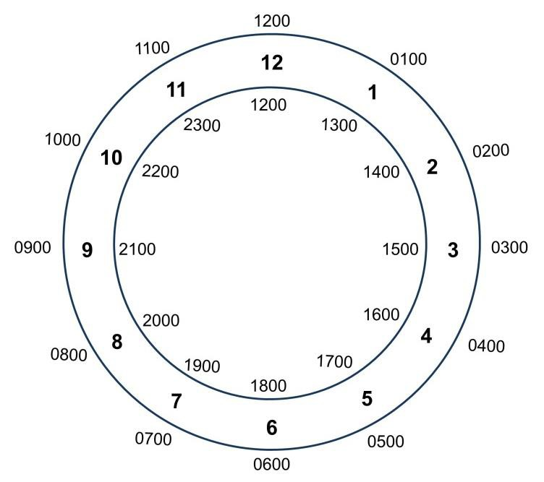
The 24 hour clock
1 minute after midnight | 0001
30 minutes after midnight | 0030
1 hour after midnight or 1am | 0100
1 hour before midnight | 2300
30 minutes before midnight | 2330
1 minute before midnight or 1159pm | 2359
1 minute after noon | 1201
30 minutes after noon | 1230
1 hour after noon or 1pm | 1300
1 minute before noon | 1159
30 minutes before noon | 1130
1 hour before noon or 11am | 1100

Equally important is an understanding of the UTC/GMT (refer to glossary for detailed definition) and various time zones within your own part of the world.

Time Zones
The Greenwich Meridian, also known as the prime meridian or International Meridian, is the "starting point" for dividing the Earth's surface into time zones. Each time zone is 15 degrees of longitude wide (with local variations) and the local time is one hour earlier than the zone immediately to the east on the map
The number of standard time zones is debatable and discussed among various sources, particularly with regards to the International Date Line.
Reference: http://www.timeanddate.com/time/time-zones.html. This website has a great deal of useful information and is worth exploring.
A basic explanation is that time zones to the west of UTC are behind UTC and times to the east of UTC are ahead of UTC.
E.g. If the time is 1200 noon in London (as Greenwich coincides with the position of London) it will be morning in the USA.
If the time is noon in London, then it will be the afternoon in parts of Asia.

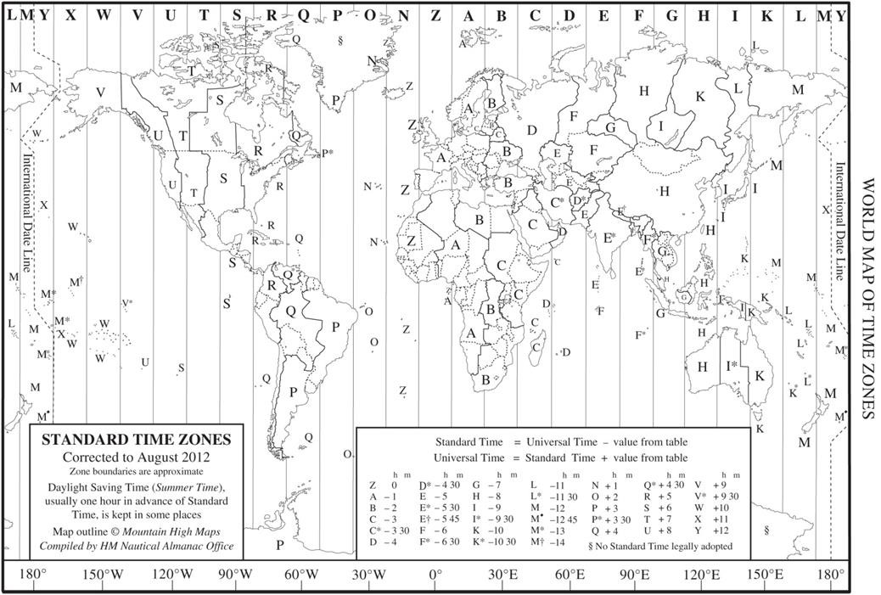

Departure and arrival times
Airline timetables will always be stated in local time for arrival and departure; therefore you will need to consult the CRS to confirm the duration of the flight, or the timetable if it details that information. Never estimate the flight duration from the arrival and departure times as you must take into account the times zones the flight may cross. Times must be converted back to UTC/GMT time before flight durations can be calculated.

Minimum connecting time between flights
Minimum connecting time is the minimum time you must allow for a passenger to complete a transfer from one flight to another. This time will vary depending if the client needs to change carriers, terminals or even airports. You will learn in your CRS training how to confirm the minimum time allowance and what requirements there are. It is your responsibility to ensure that your passenger has sufficient connecting time between their flights.

Airports
Airlines operate flights from various airports and terminals. Some airports have all their terminals (domestic and international) in the same location. In some cities there may be various airline specific terminals within an airport precinct. For example in Malaysia there are two airports utilising three terminals.
The old international airport is terminal three. There are several names used for this airport (Sultan Abdul Aziz Shah Airport, Subang [International] Airport and Skypark Terminal) however it was officially renamed Subang Skyway terminal
The new international airport at Sepang is divided into two terminals.
KLIA1 home to Malaysia Airlines and used by other national and international carriers and KLIA2 is home to Air Asia
There is 65kilometeres between the two KLIA airports at Sepang and Skyway terminal at Subang taking around 45 minutes travel time.
In America JFK has six terminals which continue to change as redevelopment continues. http://www.airport-jfk.com/images/JFK_terminal_map.jpg
The terminals are connected by the AirTrain system and access roads
In the United Kingdom Heathrow has 4 terminals. Terminals 2 and 3 are a short walk from each other. Terminals 4 and 5 are served by free trains and buses
Sydney, Australia has three terminals. Terminal 1 is the international terminal and is located separately. Terminals 1&2 are domestic
So as you can see it is important passengers are informed where they need to be how to transfer and suggested time allowances.

Check-in facilities
Depending on the airline there are currently 3 ways to check-in for a domestic flight.
- Counter Check-in – the default check-in procedure
- Online Check-in – available with some airlines
- Self-Serve Check-in – available with some airlines.

Counter check-in
The recommended time for check-in for most domestic flights is now 60 minutes prior to departure; however, passengers must be aware of delays that can be encountered during holiday periods. Over peak holiday period such Christmas and Chinese New Year check-in delays can be lengthy and it is best to advise your client to allow for this and arrive earlier. Some airlines have a very strict policy regarding late arrivals and passengers arriving within 30 minutes of the scheduled flight departure time may be denied boarding by the airline.
Passengers are required to have photo identification with them when travelling.
After completing the check-in process all passengers receive a boarding pass which details their seat number, departure gate, frequent flyer information and name etc. This boarding pass must be presented when boarding the aircraft. In the case of frequent flyer programs, it is advisable that passengers retain their boarding passes until their mileage points are shown on their statement. Boarding passes are the only proof that passengers travelled on that leg of their journey.

Online check-in
Some airlines offer online check-in facilities for their passengers via their website. This allows passengers to check-in and print their boarding pass before arriving at the airport. Individual airlines will indicate on their website the timeframes online check-in is available. It is NOT available where the passenger requires special handling e.g. wheelchair assistance.

Seat requests
When the low revenue special fares are purchased, special seating is not available. For business class travel and some of the higher revenue airfares, special seat requests can be made.
Where this facility is available choices are:
- Window
- Aisle
- Specific seat number.

On some carriers special seating is available upon payment of an additional amount, typically around USD25.00 per person per flight. With some of the low cost airlines, seat selection is available at the time of booking. In other instances pre-seating may not be available until check-in which can be either online or at the airport.

Special Care Passengers

Infants/babies
A limited amount of baby food and baby needs are available on the aircraft, however it is advisable that passengers carry with them what they anticipate needing during their flight. It is compulsory to note any infants travelling in the booking.

Unaccompanied minors
An unaccompanied minor must be checked in at the airport by their mother, father or guardian. They must be collected at their destination by one of the above people also. All details such as name and address of the parents or guardians must be supplied upon making a reservation. Permission to travel as an unaccompanied minor varies from carrier to carrier along with ages etc. It is best to check this information thoroughly when making a reservation of this type.

Elderly or incapacitated passengers
There are various services available to passengers with differing needs in terms of wheelchair assistance. Airline staff can assist with full support from check-in through to boarding or just boarding if required. Requests for this service must be made at the time of making the reservation and is the responsibility of the travel consultant.

Day and month abbreviations
Day and month abbreviations are used by airlines, within Global Distribution System and Central Reservation System timetables and are standard throughout the industry.
Date abbreviations are shown as 2 numeric digits e.g. the 6th March is shown as 06MAR and not as 6/3. This is a necessity in ticket construction

Frequency abbreviations |  | Month abbreviations
Alphabetical | Numerical | January | Jan
Monday = M or MON | 1 | February | Feb
Tuesday = T or TUE | 2 | March | Mar
Wednesday = W or WED | 3 | April | Apr
Thursday = T or THU | 4 | May | May
Friday = F or FRI | 5 | June | Jun
Saturday = S or SAT | 6 | July | Jul
Sunday = S or SUN | 7 | August | Aug

Frequency abbreviations |  | Month abbreviations
Daily = DLY |  | September | Sep
Except = EX | X | October | Oct
 |  | November | Nov
 |  | December | Dec
Frequently used abbreviations

Code | Meaning | Code | Meaning
AGT | Agent | INF | infant
ARR | Arrive or Arrival | LMTC | Left message to call
CHD | Child | PAX | Passenger
CTC | Contact telephone | PSGR | Passenger
DEP | Depart or Departure | PNR | Passenger Name Record
ETA | Estimated time of arrival | UM | Unaccompanied minor
ETD | Estimated time of departure | UTC | Unable to contact
FLT | Flight

Ensure fare construction complies with operational requirements
Refer to 2.3.

Calculate fare costs
Refer to 2.4.

Construct and check accuracy and completeness of air itineraries
Refer to 2.5.

Work Projects
It is a requirement of this Unit you complete Work Projects as advised by your Trainer. You must submit documentation, suitable evidence or other relevant proof of completion of the project to your Trainer by the agreed date.

  - List three client needs or preferences to identify what they want

  - a Access an airline website and complete the screens for an international destination.
Save a copy of each screen and print this

  - b Research the internet for Central reservation System companies and identify where (city, country) they are located and what other services they may provide. List 4, but try to identify others that are not listed in this manual

  - a Using the world map of time zones identify what time it is in the following countries Midday London, UK Rio de Janeiro, Brazil
11am Perth Australia Tokyo, Japan

4pm Mexico City, Mexico Auckland New Zealand

2am Cape Town, South Africa Moscow, Russia

  - b Using the internet research three major international airports and identify the following:
    - The airport name, city and country
    - Mode of transfer between terminals
    - Number of terminals – domestic and international
    - Distance from city centre

In addition to this research identify the three busiest airports in the world as well as the number of passenger travelling through these airports per year.

  - c Identify the following abbreviations:

    - ARR
    - ETA
    - PAX
    - PNR
    - UM

  - a What is the correct Global Indicator for each of these itineraries?

AKL HKG SHA

LON NYC HNL BNE

JNB PER SYD

FRA LAX MEX

BNE KUL TYO AMS

ATH LON NYC LAX

SYD TYO SIN VIE

MEL LAX BUE

SIN KUL DXB ATH

  - b Construct a round world fare with a stop in each country in TC1, TC2 and TC 3. Identify the intermediate point and provide costing in US dollars. Identify the carriers being used and their cost.

  - Briefly identify the following fare types: Regular (normal) fares

Published fares

Infant fares

Child fares

Concession fares

  - A passenger is departing Sunday 0010 to an international destination. What day and time will they be required to check–in?

Summary
Construct round-the-world and round trip itineraries

Identify and confirm needs and preferences of client
- Refer to 1.1
Identify and access appropriate resources to enable processing of client requirements
- Refer to 1.2
Identify and confirm availability of flights to meet client requirements
- Time of travel
- Connections
- Seat availability
- Stop-over’s
- Time spent at destinations
Ensure fare construction complies with operational requirements
- Refer to 2.3
Calculate fare costs
- Refer to 2.4
Construct and check accuracy and completeness of air itineraries
- Refer to 2.5

Element 6:
Construct fares for open jaw journeys

Identify and confirm needs and preferences of client
Refer to 1.1.

Identify and access appropriate resources to enable processing of client requirements
Refer 1.2.

Identify options that enable open jaw journeys

Introduction
When creating an itinerary for a client, you will need to determine what type of fare you need to access in order to calculate the cost of their itinerary. By now you will know that the general types of ticket are:
- One way
- Return
- Multi city (which would include Round the world itineraries).
Another type of journey is open jaw, when the outward point of arrival and inward point of departure are not the same.
There will be many reasons why clients may require this option.

Options that enable open jaw journeys may include:
- Considering double open jaw trips
- Reading package limitations
- Verifying accepting destinations, en route destinations and countries, including limitations on intra-country and inter-country applications
- Conformity with airline and airfare rules, including understanding of the limitations imposed by these
- Identifying minimum stay provisions , where applicable
- Identifying relative distances involved, where applicable
- Catering for circle trips, where necessary.

Types of open jaw journeys

- The outward point of arrival and inward point of departure are not the same.
E.g. Melbourne to Bangkok Surface Phuket to Melbourne

Melbourne

Bangkok

Phuket

- The outward point of departure and the inward point of arrival are not the same.
E.g. Sydney to Hong Kong to Melbourne

Sydney

Melbourne

Hong Kong

- Both the outward and inward point of arrival and departure are not the same.

E.g. Melbourne to Denpasar Surface Jakarta to Sydney

Melbourne

Sydney

Jakarta

Denpasar

Open Jaw itinerary and Journeys
The flights in this itinerary are operated by Thai Airways, flying from Bangkok to Jakarta and returning from Denpasar to Bangkok. The ‘ARNK’ between flights indicates that this sector has not been booked by the agent and means ‘Arrival Unknown’ (or own arrangements). The ‘HS5’ indicates that five seats are being held.

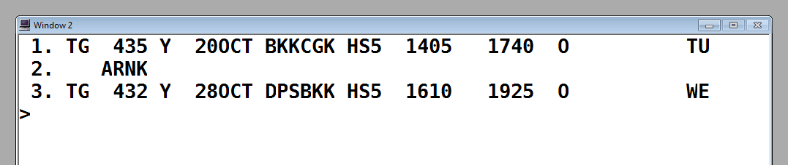

This return journey includes two components.
The outbound component is a non-stop flight from Bangkok to Jakarta. The inbound component is a non-stop flight from Denpasar to Bangkok. Jakarta to Denpasar is a surface sector.

Codeshare flights
This itinerary contains codeshare flights which have Qantas flight numbers but are operated by Emirates (Segments 1 and 4). You will note that the Qantas flight numbers contain four digits. This is a way of identifying codeshare services although this is also clearly advised on this booked itinerary.



When reading this itinerary, you will note the final destination is London Heathrow and on the outbound component, the passenger is having a stopover in Dubai for 4 nights. On the inbound component, the passenger will only transit through Dubai.

Online and interline transfers
The itinerary below is a return journey from Bangkok to San Francisco, flying with Thai Airways and Singapore Airlines.



On the outbound component, the passenger will transit through Hong Kong.
On the inbound component, the passenger will transit through Singapore. Note that flight SQ1 arrives into Singapore at #1200, meaning 12.00pm the next day – 21 November.
The passenger will arrive into Hong Kong on Thai Airways and depart on Singapore Airlines. This is called an interline transfer.
The passenger will return from San Francisco to Singapore and change aircraft, continuing to fly with Singapore Airlines. This is called an online transfer.

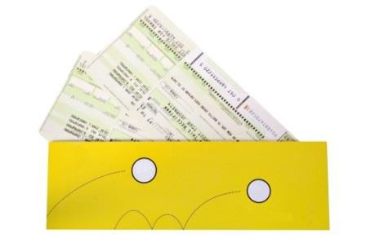Regular airfare rules

Fare rules are the terms and conditions for the fare which are developed by the airlines or IATA. IATA has developed headings and paragraphs to categorise airfare rules and these can be accessed using a CRS. Promotional airfares have airfare rules that must be accessed by the agent and explained to the client. This is explained in the unit Construct and ticket promotional international airfares.
Regular fares are fully flexible. This means that they can be changed at any time and if unused, are fully refundable. It also means that there are no payment deadlines and the agent can hold the booking for the client to consider. The only restriction is that payment is required (and the ticket must be issued) prior to departure.
Regular airfares are also not ‘seasonal’, meaning that the fares will be the same every day of the year, with no high or low season price fluctuations.
Despite this considerable flexibility, there are some restrictions that apply. The agent must ensure:
  - All required checks are completed when constructing the airfare
  - The itinerary meets the requirements of the Global Indicator for the airfare they are accessing and calculating
  - The client is aware that although changes are permitted free of charge, the changes are subject to seat availability on the requested flight
  - Business and first class passengers are aware that not all aircraft have multiple classes of service. In the event that the itinerary is changed and the passenger is now on a flight without business or first class seats, they will not be compensated
  - Clients are aware that although the airlines do not charge any penalties for amendments or cancellation, the enterprise may impose service fees for providing assistance to clients to make these changes.

Booking classes
A booking class is a letter of the alphabet that is allocated to a fare. When calculating promotional airfares, airlines allocate a booking class to represent each of their different airfares. Regular airfares have IATA allocated booking classes that are called primary codes. The IATA allocated primary codes for regular fares are F=First Class, J or C=Business Class and Y=Economy class.

Availability in Galileo
When an availability screen is displayed in the CRS, the information is displayed in order beginning with first class, then business class, premium economy and economy class. All booking classes on flights can be seen in each availability screen, assuming the operating aircraft offers all classes of service. For example, if there is no F shown on a line in the display, there will not be a first class service offered on that flight.
When reading an availability screen, remember that the airline will only show a maximum of nine seats for each booking class. The airline controls this information and can change their allocation at any time to control the number of seats available at each price level.

The following screen shows the seats available on a Qantas flight from Los Angeles to Melbourne. This screen is called an Availability screen and the entries will be included later on how to display this information.

FRI 26JUL LOS ANGELES /MELBOURNE *QANTAS
1 LAX MEL 26/2330*0820 QF 94 F9 A9 J9 C9 D4 I3 W9 R6 T0 Y8 B7 H8 K3 M0 L0 VC SC NC QC OC
The screen above shows that on Qantas flight QF94, there are four classes of travel and the number of seats available for each:

Class of travel | Booking classes | Number of seats | Other information
First class | F and A | 9 seats for each | 9 means 9 or more
Business class | J and C | 9 seats for each | 9 means 9 or more
 | D | 4 seats
 | I | 3 seats
Premium economy | W | 9 seats
 | R | 6 seats
 | T | 0 | No seats left
Economy class  (some examples only) | Y | 8 seats
 | K | 3 seats
 | M and L | 0 | No seats left
 | V, S, N, Q and O | C | No seats and waitlist closed
In this unit we are interested in regular airfares only (F, J/C and Y), however it is useful to understand the reason for so many letters (booking classes) appearing in an Availability screen.

Accessing airfares in Galileo
When using a CRS, there are entries that an agent can use to access information on the airfares that they are considering. The standardised IATA codes and abbreviations are used.
Galileo entries will now be introduced in this topic to demonstrate how information is accessed.
Entries and screen shots will be introduced and described throughout this unit to demonstrate how to:
  - Access and interpret fare displays
  - Access and interpret mileage information
  - Conduct IATA fare construction checks
  - Check seat availability for the client itinerary
  - Create itineraries and bookings.

Galileo Fare Displays One way airfares Example 1:
Below is an example, using a screen shot from Galileo which is displayed after inputting the following entry:

FDHANMEL20OCT-OW/YY: NUC
Here is a breakdown of the information entered:
  - FD Fare Display
  - HAN from Hanoi
  - MEL to Melbourne
  - 20OCT Departing 20th of October (this part of the entry is optional)
  - OW One Way fares only
  - YY Display IATA fares for all airlines
  - NUC Display the fares in NUCs.

This is an entry that the agent will use to ask Galileo to only display the regular, one way fares from Hanoi to Melbourne, based on a departing Hanoi on the 20th of October. The date does not have to be included in the entry as fares are the same every day of the year.

The information displayed in Galileo is as follows:


Towards the top of the screen you will see that it says **ADDITIONAL TAXES/FEES MAY APPLY**. This is a reminder that the information display is the published IATA fare and does not include taxes and surcharges which cannot be calculated until later when the itinerary is constructed.
Here is an explanation of how to interpret this information, reading across each column displayed:
  - The fare on Line 1 is economy class, Line 2 is business class and Line 3 is the first class airfare
  - The ‘CX’ above this column is an abbreviation for carrier. The letter YY appears on each Line as this is what was requested and confirms that the fares are applicable to all IATA carriers
  - FARE / NUC - The fares are displayed in price order and in NUC. For example, the fare on Line 1 is NUC2600.00
  - FARE BASIS - The code in this column indicates the primary booking class for each class of travel, followed by the letters ‘IF’, meaning ‘IATA fare’
  - C indicates the booking class. This letter is the primary code for the class of travel. This information relates to seat availability and will be discussed later
  - AP refers to Advance Purchase. If the airfare must be booked a certain number of days before departure, a number will appear in this column. For all regular fares, the column is blank, indicating that there are no advance purchase restrictions
  - MIN/MAX refers to Minimum and Maximum stay requirements. For all regular fares, this column is blank, indicating that there are no minimum or maximum stay restrictions
  - SEASONS refers to seasonality and when the passenger can use the fare. For all regular fares, this column is blank, indicating that there are no seasonal date restrictions
  - MR - Mileage system or Routing fare – the method being used to construct the fare. All regular fares will show the letter M in this column, indicating that the mileage system is used when calculating the fare
  - GI - Global Indicator – EH indicating that the applicable Global Indicator is Eastern Hemisphere.

Other information on Fare Display screens

MPM 668 EH
  - Maximum Permitted Mileage. If the fare between Hanoi and Melbourne is to be constructed using the mileage system, the passenger cannot travel more than 668 miles on the journey without being surcharged
  - EH – Eastern Hemisphere (the only applicable Global Indicator).

Identify and confirm availability of flights to meet client requirements
Refer to 5.3.

Ensure fare construction complies with operational requirements
Refer to 2.3.

Calculate fare costs
Refer to 2.4.

Construct and check accuracy and completeness of air itineraries
Refer to 2.5.

Work Projects
It is a requirement of this Unit you complete Work Projects as advised by your Trainer. You must submit documentation, suitable evidence or other relevant proof of completion of the project to your Trainer by the agreed date.

  - List three client needs or preferences to identify what they want

  - a Access an airline website and complete the screens for an international destination.
Save a copy of each screen and print this

  - 2b Research the internet for Central reservation System companies and identify where (city, country) they are located and what other services they may provide. List 4, but try to identify others that are not listed in this manual

  - a Provide three examples of open jaw journeys where the outward point of arrival is not the same

6.3b Provide three examples of open jaw journeys where the outward point of departure is not the same

  - c Break down the following information.

FRI 26JUL LOS ANGELES /MELBOURNE *QANTAS

1 LAX MEL 26/2330*0820 QF 94 F9 A9 J9 C9 D4 I3 W9 R6 T0 Y8 B7 H8 K3 M0 L0 VC SC NC QC OC

  - a Using the world map of time zones identify what time it is in the following countries Midday London, UK Rio de Janeiro, Brazil
11am Perth Australia Tokyo, Japan

4pm Mexico City, Mexico Auckland New Zealand

2am Cape Town, South Africa Moscow, Russia

  - b Using the internet research three major international airports and identify the following:
    - The airport name, city and country
    - Mode of transfer between terminals
    - Number of terminals – domestic and international
    - Distance from city centre

In addition to this research identify the three busiest airports in the world as well as the number of passenger travelling through these airports per year.

  - c Identify the following abbreviations:

    - ARR
    - ETA
    - PAX
    - PNR
    - UM

  - a What is the correct Global Indicator for each of these itineraries?

AKL HKG SHA

LON NYC HNL BNE

JNB PER SYD

FRA LAX MEX

BNE KUL TYO AMS

ATH LON NYC LAX

SYD TYO SIN VIE

MEL LAX BUE

SIN KUL DXB ATH

6.5b Construct a round world fare with a stop in each country in TC1, TC2 and TC 3. Identify the intermediate point and provide costing in US dollars. Identify the carriers being used and their cost.

Summary
Construct fares for open jaw journeys

Identify and confirm needs and preferences of client
- Refer to 1.1
Identify and access appropriate resources to enable processing of client requirements
- Refer 1.2
Identify options that enable open jaw journeys
- Open Jaw itinerary and Journeys
- Regular airfare rules
- Booking classes
- Accessing airfares in Galileo
- Galileo Fare Displays
Identify and confirm availability of flights to meet client requirements
- Refer to 5.3
Ensure fare construction complies with operational requirements
- Refer to 2.3
Calculate mixed fare costs
- Refer to 2.4
Construct and check accuracy and completeness of air itineraries
- Refer to 2.5

Element 7:
Apply the pricing unit concept to fares

Divide fare journey into individual pricing units

Introduction
It is essential that the client is provided with airfare pricing that they fully understand before any payments are made and to ensure that all taxes and surcharges are also included in the final price.

Fare journey can include:
  - Single fare
  - Return fare.
This screen shows that there are multiple options to travel from Bangkok to Sydney via Singapore, flying Singapore Airlines.

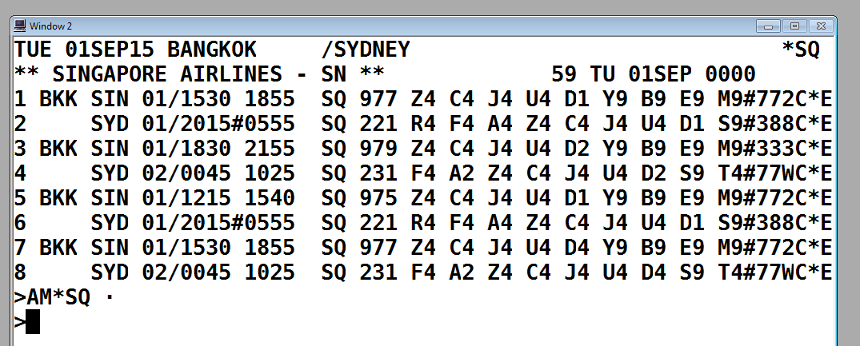
  - If your client is a member of the Qantas Frequent Flyer program, use this entry to see flight options and availability on Qantas only:
    - Entry: A01SEPBKKSYD*QF
This screen shows that there is only one option to fly direct with Qantas for this route. Although this screen provides multiple options, only one direct service is operated by Qantas. The other options are not direct and are codeshare flights which are operated by other carriers.

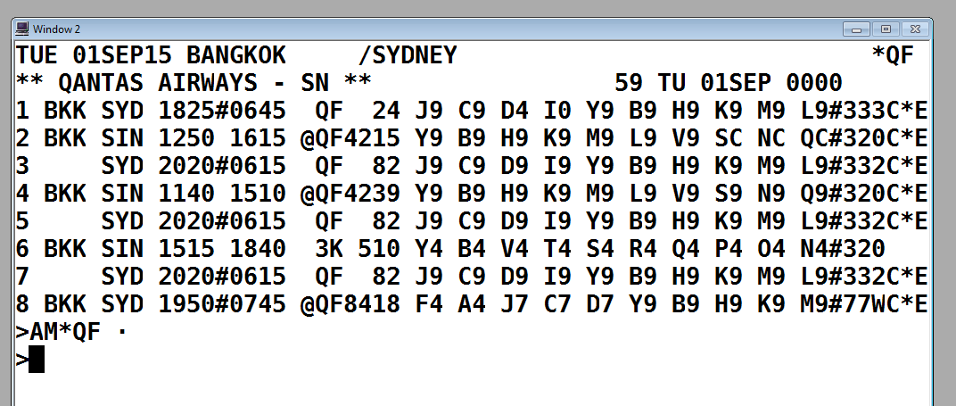

Availability - One way journeys

Using the Availability entry example above, you could continue to book flights and start creating an itinerary. In order to do this, you would need to know which booking class you will need to use. This information is obtained from a fare display which we will consider in a moment.
Imagining that the above flight itinerary was booked from Bangkok to Sydney only (either with Qantas or Singapore Airlines), this would create a one way journey.
The journey from Bangkok to Sydney on Qantas would be a single sector one way journey.
The journey from Bangkok to Sydney, via Singapore, flying Singapore would be a one way journey with two sectors. Singapore would be considered an intermediate point.
If the passenger is only in Singapore for a short time waiting for their next flight, this intermediate point is referred to as a transit.
If the passenger wishes to stay in Singapore for more than 24 hours, Singapore is considered an intermediate stopover flight. This would require the journey to be booked in two segments, using two availability screens. For example:
  - Entry: A01SEPBKKSIN*SQ
  - Entry: A03SEPSINSYD*SQ (Two night stopover in Singapore)

Availability – Return journeys
Continuing with the examples above, imagine that the passenger wishes to return from Sydney one week later.
The Qantas entry would be:
  - Entry: A08SEPSYDBKK*QF
The Singapore Airlines entry would be:
  - Entry: A10SEPSYDBKK*SQ
(Assuming no stopover is required in Singapore):
Although we have not yet considered which booking classes or flights to book, and the entries required for this part of the process, let’s look at the itineraries that could be created for these booking examples:

Qantas itinerary:

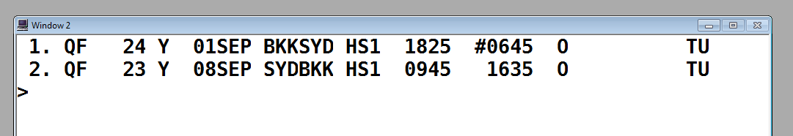

Singapore Airlines itinerary:

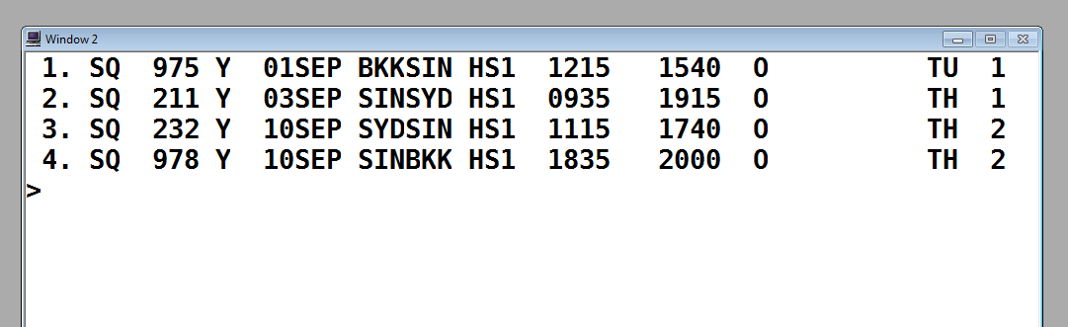
Terminology
Both itinerary examples above are return journeys. Bangkok is the origin and Sydney is the destination.
The Qantas itinerary has a direct, non-stop flight in each direction.
The Singapore Airlines itinerary has an online transfer through Singapore on the outbound component and Singapore is a stopover. On the inbound component, there is also an online transfer through Singapore, and Singapore is a transit point.
In the itineraries above, the booking class Y has been used. As mentioned earlier in Element 2.1, a Fare Display will explain which booking class to use.

Booking classes
Before making either of the bookings above, you would need to thoroughly understand the fares that you are wanting to book and be able to interpret the information from the availability screens.
Remember that a booking class is different to class of service (economy, business, and so on.).
  - Each booking class represents a unique airfare for a specific airline
  - Each airline uses different booking classes and has different prices
  - The number next to the booking class in the availability screen represents how many seats are available for that price
  - To find out information about fares and booking classes, you will need to access information from the CRS fare display.

Calculate lowest combination of fares for given pricing units

Introduction
The lowest priced airfares generally have the most restrictions while the higher priced airfares are generally more flexible.
The construction of promotional international fares is not covered in this unit as this unit relates to constructing regular international fares.

Calculating lowest fare combination
When calculating a client’s lowest combination of fares for given pricing units, it is important to consider the following:
  - Client information and preferences
  - Low cost and full service carriers
  - Airline schedules and flight routes
  - Airline pricing
  - Seat availability.

Creating an itinerary for a one way airfare
This is the process for calculating a fare for a client who wishes to travel one way (OW) from Bangkok (BKK) to Tokyo Narita Airport (NRT) flying with Malaysia Airlines (MH). The client wishes to depart October 14 and have a four night stopover in Kuala Lumpur.

Fare Display
  - FD14OCTBKKNRT-OW/MH

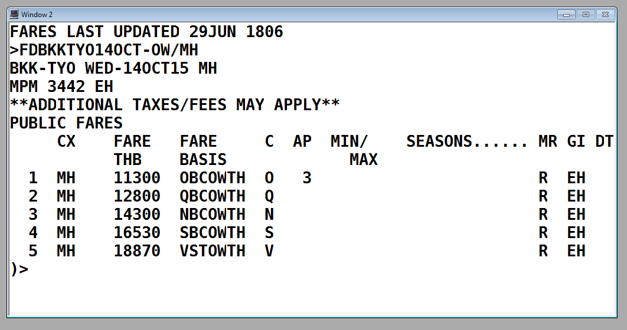

The screen above shows that the cheapest fare needs to be booked in O class and must be booked at least three days prior to departure.

As the client wishes to stopover in Kuala Lumpur, it is recommended to also check the stopover rule (Paragraph 8) to see if stopovers are permitted and if any additional cost applies.

Fare Notes
• FN*1/8

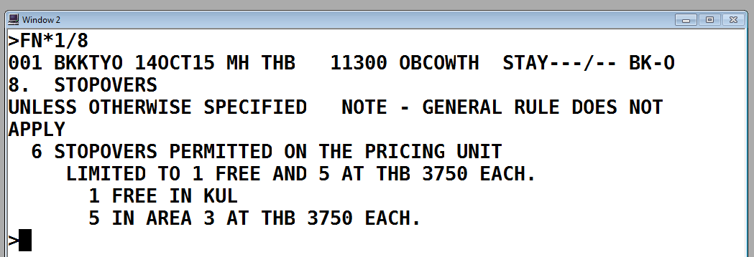

Although this screen is a little confusing to read, it does state that one free stopover is permitted.

Availability
  - A14OCTBKKKUL*MH

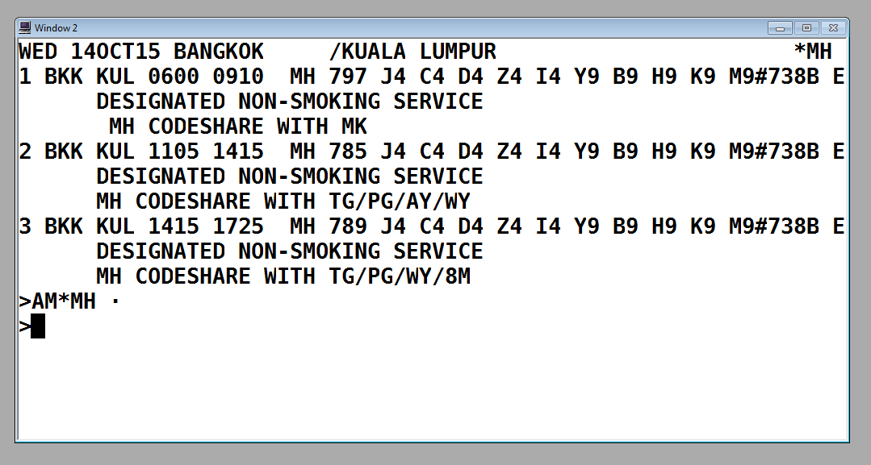

Assuming the client would prefer to fly early in the morning and O class does not appear on the screen, the follow on entry to display all booking classes for Line 1 is:
• A@$1

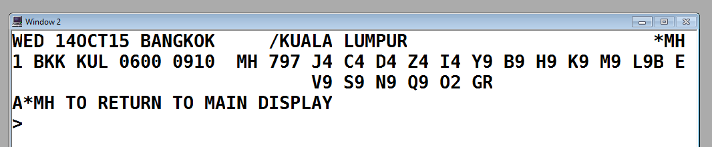

There are two seats remaining on this flight in O class.

Sell seat entry
To book one seat in O class on Line 1 of the above screen, the entry is:
• 01O1
The following screen will display:

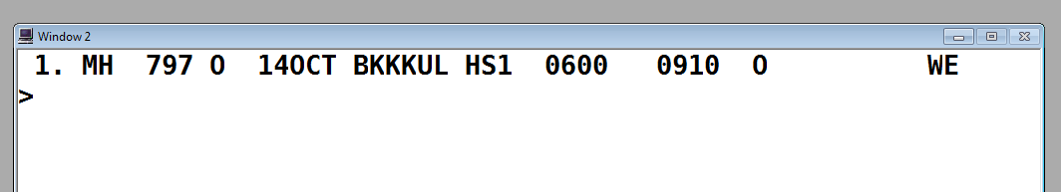
Four days later, the client wishes to fly from KUL to NRT.

Availability
  - A18OCTKULNRT*MH
There is only one flight that day and O class is available.

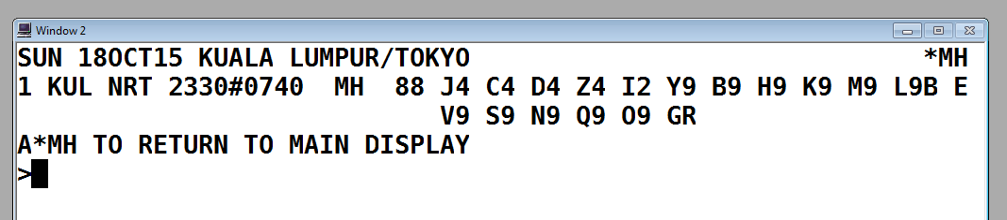

Sell seat entry
To book one seat in O class on Line 1 of the above screen, the entry is:
• 01O1
The following screen will display:

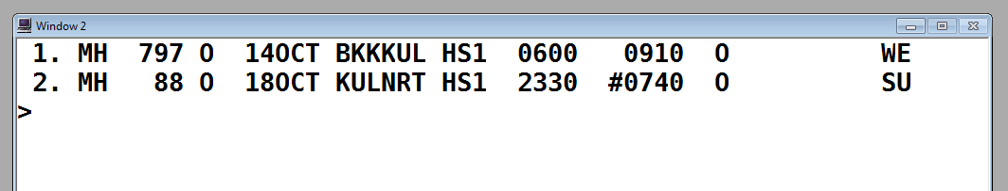



Fare quote
To confirm the fare, the taxes and the TLL, the entry is:

FQ

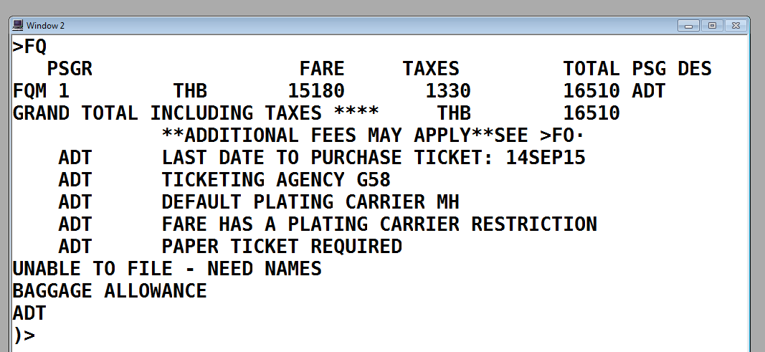
Note that the fare above has been confirmed with an additional surcharge added to the fare.

Creating a return airfare booking in Galileo
This is the process for creating a booking for passengers named Mai and Clara Chen They wish to fly from Manila to Singapore on Philippine Airlines for a 5 night holiday, departing on the 10th of September. They would prefer to fly in the evening.
The agent’s name is John and the travel enterprise is called William Angliss College, based in Manila.

Fare Display
  - FD10SEPMNLSIN-RT/PR

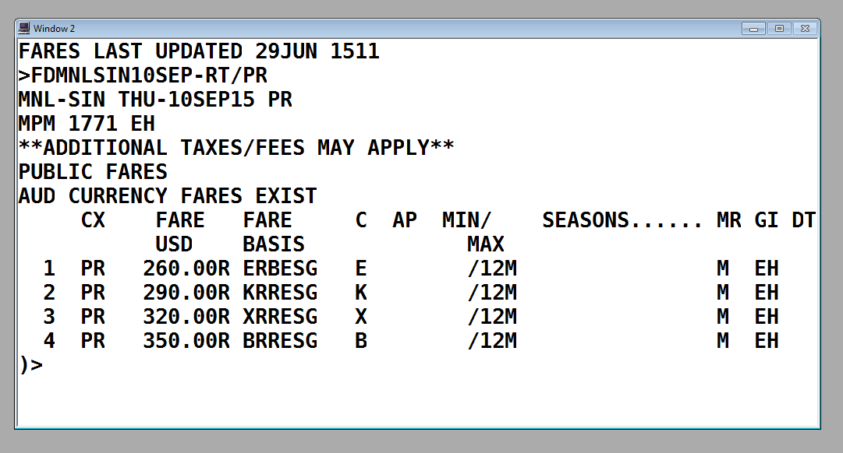

The lowest fare has a fare basis code ERBESG and seats need to be available in E class in order to sell this fare of USD260.00 plus taxes and charges. This fare does not have any minimum or maximum stay requirements.

Availability
  - A10FEBMNLSIN*PR

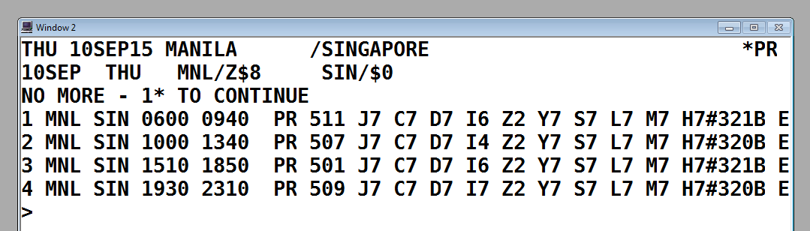
To view availability in E class on line 4 (the evening flight), the follow on entry is:
• A@$4

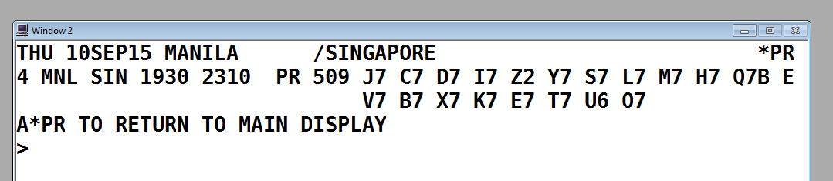

Sell seat entry
To book two seats in E class on Line 4 of the above screen, the entry is:
• 02E4
The following screen will display:

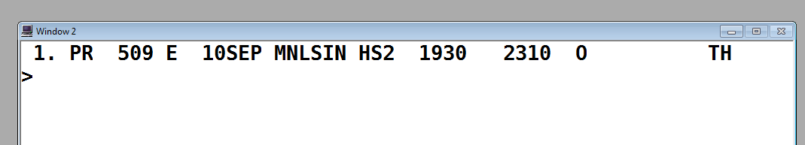



Availability
  - A15FEBSINMNL*PR

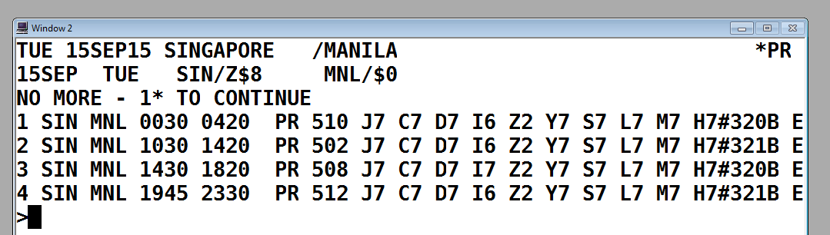
To view availability in E class on line 4 (the evening flight), the follow on entry is:
• A@$4

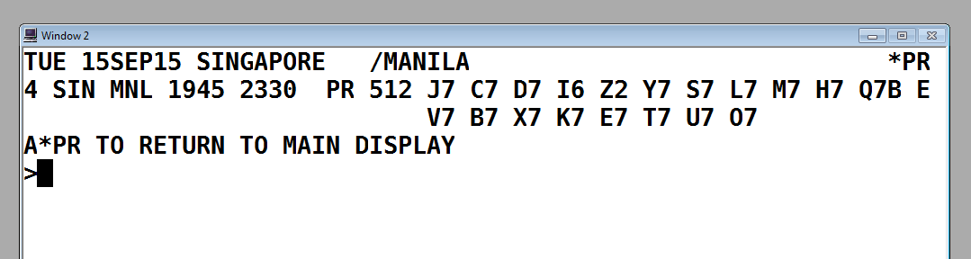

Sell seats
To book two seats in E class on Line 4 of the above screen, the entry is:
• 02E4
The following screen will display

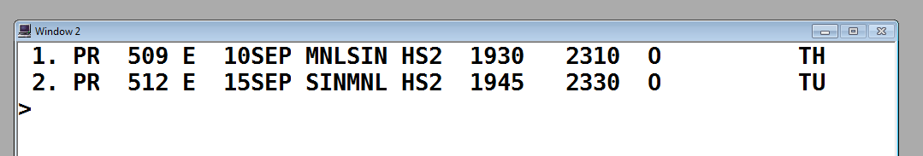



Fare quote
To confirm the expected fare of USD260 and to confirm the taxes and TTL, the entry is:

FQ

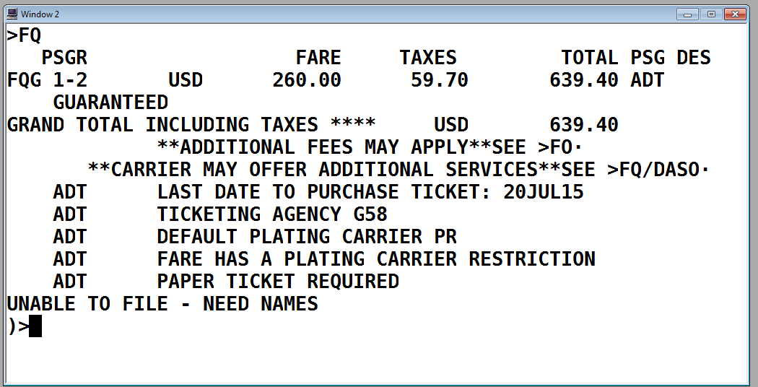
This screen explains:
  - The fare is USD 260.00 plus 59.70 taxes per person
  - The total fare and taxes for both passengers is USD639.40
  - The code ADT indicates both passengers have been quoted adult fares
  - The last date to purchase the ticket (the TTL) is 20 July
  - Please ignore the line stating that paper tickets are required. E-ticketing is now the form of ticketing for all international fares
  - The last line states that the fare cannot be filed (saved) with the itinerary unless names are entered and a booking is created.
This example will continue later in this unit to demonstrate how bookings are created.

Work Projects
It is a requirement of this Unit you complete Work Projects as advised by your Trainer. You must submit documentation, suitable evidence or other relevant proof of completion of the project to your Trainer by the agreed date.

  - Fare journey can include two types of fares, identify the two:

    - Single fare
    - Return fare.

7.2. Research and list five carriers that fly from South East Asia to Australia and illustrate which carrier has the lowest combination of fare

Summary
Apply the pricing unit concept to fares

Divide fare journey into individual pricing units
- Fare journey can include:
- Availability - One way journeys
- Availability – Return journeys
- Booking classes
Calculate lowest combination of fares for given pricing units
- Calculating lowest fare combination
- Creating an itinerary for a one way airfare
- Creating a return airfare booking in Galileo
- Fare quote

Element 8: Maintain client file

Record and update needs and preferences of client

Introduction
Travel enterprises need to maintain and update internal records which contain information related to clients, their travel arrangements and all of the associated financial transactions related to each booking. How this is done will depend on the enterprise and whether or not files are maintained manually, electronically or using a combination of both systems. A client file number is often only allocated (manually or electronically) once a booking has been made and a payment has been received from the client.

Electronic client record systems
Electronic records are maintained using a Client Management System (CMS) and these are used by many enterprises to record client details, booking information, travel arrangements and all the associated financial transactions. This then becomes the client file with an allocated client file number. Each client file number is a unique reference number. A client file number is often only allocated (manually or electronically) once a booking has been made and a deposit received from the client.
The software for the CMS has been developed specifically for the travel industry and records information using industry codes and abbreviations. A CMS can often be used to generate quotations, invoices, receipts and detailed client itineraries. Some systems offer the facility to convert a quotation into an actual booking.
The CMS can usually obtain the booking details from the CRS to generate an itinerary. The agent may choose to add additional information to this itinerary including check-in times, flight durations and details of any other travel arrangements.
A Client Management System is sometimes referred to as a back-office system as it is also used for accounting, marketing and other purposes.

Manual client record systems
Despite the capabilities of a CMS to store information, quite often manual client records or files are also maintained to store documents and notes on each client’s booking. The file may include the agent’s notes from the initial consultation and copies of documents including supplier invoices, passports, booking forms and insurance details. The file may also include a copy of the itinerary, invoice, receipts and any vouchers issued by suppliers.

Many travel enterprises aim to minimise waste associated with unnecessary printing. Guidelines are usually provided to staff so that each agent working for the enterprise will use the CMS and maintain manual client records in the same way.
Most travel agents use one of the following methods to record the detail of the products and services booked, their status and other relevant client detail:
- A totally manual system
- A totally electronic system
- A combination of both – most common.

Client details
Regardless of the system used, for bookings, the following client details must be recorded by the travel agent:
  - Name of the person making the booking or requesting
  - Their contact details i.e. telephone number, mobile, email address etc.
  - The name and address of their company, if applicable
  - The full street address of the passengers
  - The full names of the passenger/s (first name, family name and title)
  - The passenger contact details, telephone, mobile, email and so on
  - Date of birth for any children or infants travelling
  - Source (corporate, past passenger, referral and so on)
  - Detail of all products and services booked.

Products and services
The following detail for products and services booked must include:
  - What products and services have been booked – flight, hotel, car and so on
  - Where has it been booked for – airport, city and so on
  - When has it been booked for – start and end dates
  - Who has it been booked for – names of passengers
  - How was it booked – via an operator, wholesaler, direct, internet and so on
  - Relevant booking/quote reference numbers.
It is also very important to record the status of the product or service i.e. confirmed, on request, waitlisted and so on
In many instances the detail reflected on the documentation will be directly and automatically derived from the electronic client file. In other cases the detail must be manually extracted from the client file and then recorded on the documentation. The specific process is office or enterprise specific.

Vouchers
To ensure accuracy when preparing to issue documentation the following should be checked prior to commencing voucher production.
  - All passenger names match their photo ID/passport
  - All passenger names are correct across all items, products or services
  - All items, products or services have a confirmed status
  - There is date/city continuity for all items, product or services booked
  - There are no unexplained gaps in the itinerary
  - The booking is fully paid.

The information reflected on vouchers and other documentation provided should not include the use of standard travel industry abbreviations, jargon or codes. Everything should be clearly written so that nothing is left open to interpretation.
Ensure when checking documentation that you take particular notice of the names. Typically names and titles are the subject of errors and often they are not immediately apparent. Here are some examples of common errors:
  - Mr Cameron Ryan Mr Ryan Cameron
  - Mrs Chen Ming Wong Mr Chen Meng Wong
  - Master Robert Barri Master. Robert Barry
  - Miss Charlie Khartri Mr Charlie Khartri

Once documentation has been issued, changes requiring a reissue by the airline will incur a fee. If the documentation is being produced ‘in-house’ using the travel agent’s internal automated system, any errors detected on documentation will go back to the source of the information which is usually the client file. Manually produced documents are also subject to errors and therefore once produced, they should be checked very carefully for accuracy.

Record itineraries and airfares quoted

Introduction
It is essential that the enterprise maintains accurate and up to date itineraries and airfares quoted for each booking. The enterprise record will store all of the client’s personal information, details on their current booking and may be linked to past bookings made by the client.

Itineraries and airfares
Itineraries and airfares quoted may include:
  - All types of fares and trips offered by the host enterprise
  - Through fares incorporating add-ones
  - Mixed class fares
  - Round, circle and open jaw trips
  - Fares incorporating intermediate points
  - Fares incorporating intermediate points
  - Fares incorporating sector journeys and side-trips
  - Fares incorporating airport and other taxes.

Fare types:
  - Normal (regular) fares
  - Promotional fares
  - Published fares
  - Net fares
  - Concession fares
  - Child fares, infant fares, unaccompanied minors
  - Calculating child and infant fares
  - Other concessions
  - Mileage and routing fares.

Itinerary types
When creating an itinerary for a client, you will need to determine what type of fare you need to access in order to calculate the cost of their itinerary. As discussed already the general types of itineraries are:
  - One way
  - Return
  - Multi city (which would include Round the world itineraries).
When using a CRS to access fare information, it is possible to specify whether one way or return fares are required.

Confirming airfare conditions
After explaining the itinerary and pricing, ensure that the client is aware of the entire general booking conditions. The most important conditions will relate to inclusions, payments and penalties.
  - Inclusions
Advise the client of the baggage allowance and whether or not on-board entertainment, food and beverages are included in their airfare
  - Payments
Advise the client if full payment is required immediately and what payment methods they can use. If immediate payment is not required, advise the client on the payment due date. It is usual practice to provide this information in writing
  - Penalties
The most restrictive fares may be non- refundable and non-changeable. Other promotional airfares will usually have a penalty fee which applies if the fare is cancelled or amended. Amendment fees should also be explained clearly. Many clients assume that date changes can be made without cost. Date changes may be restricted and are subject to availability. Rerouting (changing cities) is often not permitted or incurs higher fees
Most tickets are also non-transferable, meaning that name changes are not permitted so only the passenger originally booked can use the ticket (they cannot give it to someone else to use). All tickets require accurate spelling of the passenger name and it cannot be assumed that incorrect spelling can be corrected without incurring fees.

Generate and issue documents to clients

Introduction
Before issuing an air ticket, it is important to ensure that all of the details are accurate. This includes the passenger’s details and also the itinerary, pricing and conditions. This information is usually provided to the client as a written invoice. It is important that the client has read and understood the airfare conditions before the payment is processed and tickets are issued. Each enterprise will have different policies and procedures for doing this although most are quite similar and all aim to ensure accuracy of booking details.

Documents
Documents may also include:
  - Invoices
  - Credit notes
  - Receipts
  - Confirmation letters
  - Itineraries
  - Information packs.

Letters of confirmation
Confirmation of a passenger booking should be forwarded as soon as possible after the booking has been made. Although the details of the booking will be discussed in detail at the time of reservation it is important that a passenger receives written confirmation of all the details of their booking. This provides a safety check that all details are as anticipated. It also provides an opportunity for the travel consultant to give out information regarding the rules and conditions of the booking and any visa requirements and offer the passengers travel insurance. Often during the interview and booking process the passengers are all too busy being excited about their holiday so they do not always listen to the finer points of the booking requirements. A confirmation letter will provide this.

Verify ticketing details
Remember that the name on the air ticket must match exactly the name on the form of photo identification or passport to be used. It is important to check titles and any ages of infants or children.
Commonly, the following errors may be detected:
  - The family name is incorrectly spelt e.g. Barry and Barrie
  - The first name is a nick name and not a registered name
  - The title does not match the passport e.g. Mr and Dr
  - The ages are incorrect e.g. booked as infant and age is a child
  - The name is a married name however the passport or photo ID is in the person’s maiden name.

In addition to the passenger name detail, the following should also be verified and collected if not on file:
  - Home address and email address for delivery of air documentation
  - Telephone contact numbers e.g. home, business, mobile and if possible, contact numbers at destination/s.
Before issuing air tickets it is important to review the itinerary to ensure that it makes sense.

Verify itinerary
Check the following:
  - Date of departure – are the day, month and year correct?
  - Check the time of departure – should it be 0600 and not 1800?
  - Date and sector continuity – are there any gaps? Can they be explained?
  - Connecting times – is there sufficient connecting time between flights?
  - Airports – has the flight been booked to/from the correct airport? E.g. Clark International or Ninoy Aquino International, Manila Philippines?
  - Taxes – have they all been included?

Where the booking has been made using a GDS, the system will generally highlight, at the time of booking, any date and segment continuity issues and things such as insufficient connecting time. However assuming that there are none of these issues, or the system has been overridden at time of booking, the GDS will allow you to end the booking. It is your responsibility to check that the dates, times, boarding and off points are correct and in line with the passenger requirements.
Where the booking has been made online, via an airline website or via an airline travel agents website (e.g.: Zuji, Webjet etc.), you will be issuing the ticket at the time of booking and will therefore not have a second opportunity to get it right. All the checks therefore must be done at the time of the booking and prior to purchasing and paying for the ticket.
In particular, make sure that the conditions of the airfare in relation to amendments or cancellation are understood by the client before you go ahead and issue the air ticket. Consider providing the detail of the conditions of the fare to the client in writing e.g. via an email.
Many discounted airfares are non-refundable and cannot have changes made, within various time frames, depending on the fare rules.

Confirming itinerary details
It is important to provide all relevant details to the client using language and terms that they will understand. Remember that passengers are not always familiar with ‘travel jargon’ which includes terms, codes and formats that are specific to the travel industry. For example, it may be appropriate to convert time from the 24 hour clock to 12 hour time, showing AM and PM to distinguish between morning and evening.
Ensure that you explain that the departure and arrival times are the local times for each city shown on the itinerary. When crossing through different time zones, this information may be confusing for clients. It is also suggested that the itinerary could include the duration of each

flight as this can help the client to understand itineraries with departure and arrival times which seem illogical due to changes in time zones.
For example the client’s flight itinerary may read as follows, however what the agent would say is expanded:



An agent might say:

“You are confirmed to fly on Tuesday the 1st of September with Qantas Airways in economy class on flight QF24. The flight departs Bangkok at 6.25pm and arrives into Sydney at 6.45am the next morning. You will stay in Sydney for 6 nights before returning to Bangkok on Tuesday the 8th of September on Qantas flight QF23, departing at 9.45am and arriving at 4.35pm.”

It is not necessary to explain that the booking is made in Y class but it is recommended to mention the class of service, particularly for business and first class itineraries.
When verbally explaining the itinerary, it is also a good opportunity to reconfirm the airline, dates, times and stopovers. Ask the client if they understand and if they have any questions. Do not assume that they understand.

Activity:
View the online itinerary on the following page. In pairs practice confirming the details with the client as per the above listed example.

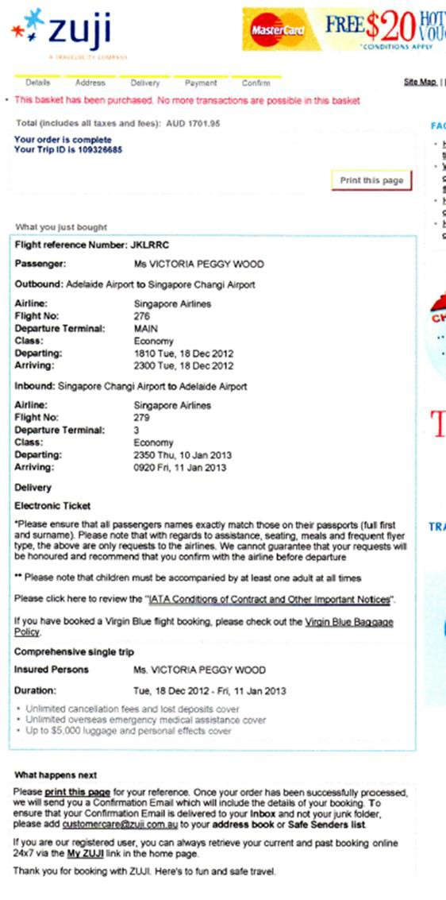

Issuing airline tickets
To issue airline tickets, an agency must be accredited by the airline and IATA (International Air Transportation Association). This accreditation then permits the agency to hold ticket stock and issue tickets.
Accredited agencies may earn commission on the reservations made and ticketed.
E-ticket stock is provided to accredited travel agents by BSP (Billing and Settlement Plan). There are a number of ways to issue e-tickets:
  - Issue at time of booking using an online airline travel agents website
  - Issue via a CRS/GDS using the ticketing facility
  - Issue via the airline e.g. a group.

Remember when using an online airline travel agent website, in order to secure the seat for your passenger, the booking must be paid for in full at the time of reservation. Once the payment has been processed (almost instantly) the airline will auto generate the e-ticket and associated conditions of carriage and so on to the email address entered at the time that the booking is made. Generally this will be the travel agents email address.
When a booking is ticketed via an airline travel agent website, no actual ticket is issued. The passengers will instead receive an itinerary which details the flight details, the fare and taxes, the fare conditions and personal details.
In the example that follows, the e-tickets have been generated via an online Agents website and reflect the following:
  - Full names of all the passengers
  - Their airline loyalty member numbers
  - The itinerary and flight details
  - The airfare and the taxes
  - The payment method.

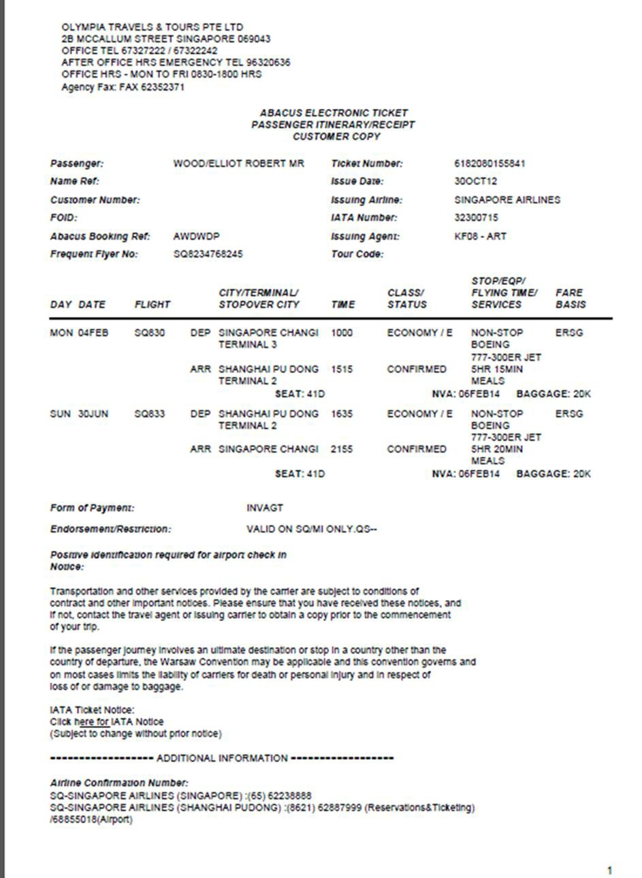

Issuing an e-ticket using a CRS/GDS
Amadeus, Galileo and Sabre all offer an e-ticketing facility. In order to use this functionality you need to ensure that the following requirements are met:
  - Agency activated for e-ticketing
  - Airline/s approval for e-ticketing
  - BSP advised of Airline approval for e- ticketing
  - Electronic tickets assigned
  - Terminal linked to a printer (not a ticket printer)
  - Appropriate carrier and/or GDS e-ticket training provided
  - Your booking has been created in the applicable GDS.

The applicable ticket number/s are generated and recorded in the booking, by passenger. The associated paper work that is generated by this process is minimal and is only for audit purposes i.e. BSP remittance and agent records.
The passenger is provided with an itinerary and e-ticket receipt which reflects their booking reference number, name, flight details, fare and taxes paid. They may or may not be required to produce this when they check-in. What is critical is that the photo ID produced at check-in, matches exactly the name in the booking and therefore the ticket.
In the example below, the e-tickets have been issued using a CRS and the itinerary reflects all the flight and passenger data together with the ticket numbers and payment information.

Example of an e-ticket issued via a travel agent using a GDS

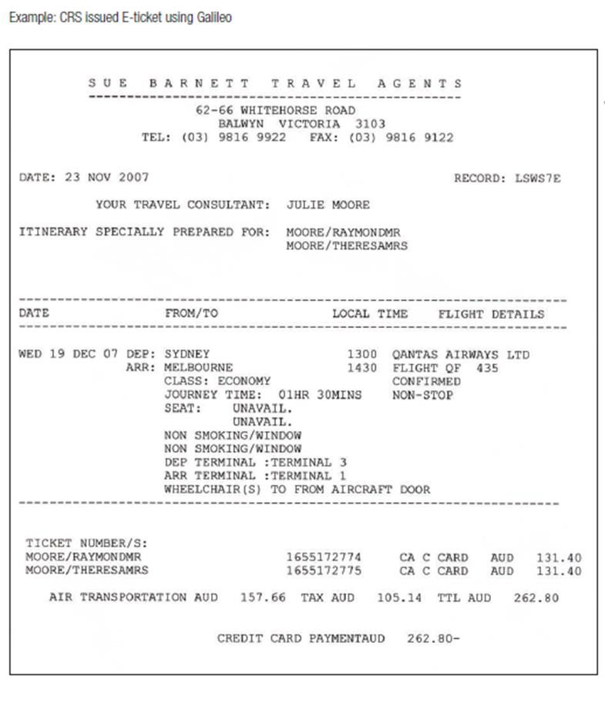

General ticketing overview
  - One ticket per passenger is required
  - One coupon per flight is required – a separate flight coupon is required for each change of carrier and for each portion of the journey where a change of flight or a stopover is involved
  - Where the itinerary consists of more than 4 flights, conjunction tickets must be issued and must be of the same form code and completed in numeric order
  - Flight coupons are issued in date and segment sequence
  - Tickets cannot be transferred from the named ticketed passenger to anyone else
  - Only IATA approved currency codes are to be used e.g. SGD, USD.

You will come across various hard and soft copy formats for e- tickets depending on how they were issued and by whom.
In terms of the client, they simply receive a hard copy (print out) or soft copy of the actual electronically issued air ticket. All the relevant details in relation to the air booking and the ticket issued are held in the passenger PNR and are sent electronically to the airline. The information can be displayed in the GDS if necessary.
When the passenger checks in for their flight, the check-in person will access the airline system and retrieve all the passenger booking details including the e-ticket details. The passenger must of course be in possession of photo identification which matches the name in the booking, failing which they will be denied boarding.

Preparing an invoice
A travel enterprise invoice is usually created using a standard pro-forma which would include the enterprise details such as name, logo and contact details. Each enterprise may use a different format but the included information is usually the same. A printed invoice provides a permanent record of the details of the costs involved in the booking. Invoices usually include the following information:

Details of all travel arrangements booked
Airfare details should include the name of the airline, dates, destinations and the class of travel. Some enterprises include minimal detail and advise the client to read their itinerary for full details. Other enterprises include all itinerary details in the invoice.

Pricing
Pricing for airfares is usually shown as a per person cost. Some agents will show the airfare and taxes separately and others will combine them together.

Service / transaction fees
Travel agencies generally charge service fees in addition to the costs of the airfare and taxes. The amount of the service fees will be advised by the agency that you work for.

Airfare conditions
The relevant conditions would usually include fees involved with any cancellations or amendments. Regular fares are fully flexible, which means that the airlines will not impose fees if the ticket is cancelled or amended. However, the enterprise may charge service fees for changing the itinerary, reissuing or refunding tickets. It is important that the relevant airfare conditions and fees are summarised and explained in a way that is clear to the client.

Penalty fees
The penalties for amendment and/or cancellation will vary and you should check the fare rule or fare sheet to ensure that both you and the passenger are aware of the penalties arising from any of the following changes.
  - Changes before departure and before ticketing
  - Changes before departure and after ticketing
  - Changes after departure
  - Cancellation before departure and after ticketing
  - Cancellation after departure
  - Re-issue and/or revalidation fees.

It is general office routine to carefully check the conditions of an airfare before making a booking and providing a price to the passenger. Consistent exposure to the various fares and their associated conditions will, in time, result in familiarity with the basic conditions governing a fare.
There is often however an interval between providing the quote or making the booking and when the air ticket is issued. It is during this interval that things may change e.g. a fare is withdrawn or has expired. The flight itinerary must therefore be checked prior to proceeding to issue the air ticket to ensure that the fare remains valid and that the flights, class etc. comply with the fare conditions.

Payment details
The invoice should clearly state the last day that the client can pay for the airfare. It should also explain the different payment methods available and if any additional fees apply for payment by credit card.

Record and process changes to bookings

Introduction
It is important to ensure that both the agency and client telephone numbers are recorded in their reservation. This ensures that the airline can contact the client directly if necessary and also advise the agency of any changes to the booking.

Changes to booking
Changes to bookings may include:
  - Changed arrangements
  - Cancellations, including the processing of refunds and issuing of credit notes
  - Verifying alterations with carriers
  - Confirming alterations with clients and issuing appropriate confirmations and amended documents.
Airfare conditions and penalty fees were discussed in the previous pages for 8.3. Refer back to these notes when discussing changes and communicating this to the client.

Confirming booking with client
Confirmation from the client to proceed with the booking will be given either face to face, via the telephone or email. Once the passenger has agreed that the booking is accurate and the itinerary is suitable for them, the agent would make arrangements to confirm all the details in writing.
Whenever possible, it is preferable to provide both written and verbal information for the client. This will ensure that the client has the best possible opportunity to understand the itinerary and airfare before proceeding.

This is an example of a Tiger Airways booking confirmation with reference R7H8VZ.

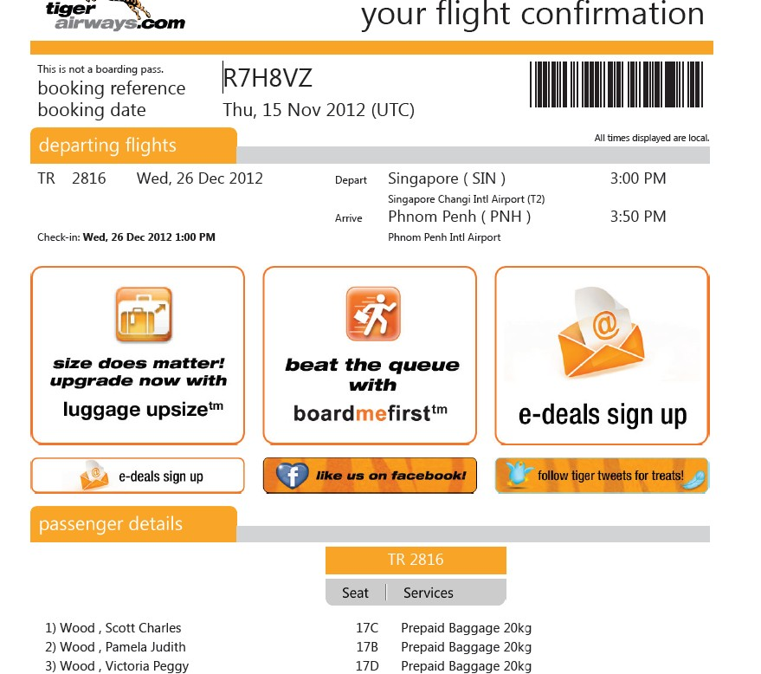

Additional details to be added:
This table includes examples of other information that can be added to a PNR:

Galileo entry | Explanation
SI.P3/CHML | Request a child meal for passenger 3.
SI.P2/BSCT | Request a bassinet for passenger 2 to hold the infant.
SI.YY*CTC SINH 64646357635 | Advising a passenger home contact number to all airlines in the booking.
After any additional information is added to a PNR, the agent must again enter the Received field and End and Retrieve the booking.
  - Entry: R.JOHN
  - Entry: ER
Status codes
When a flight itinerary is being created, the HS code in each flight display indicates that seats are available and are temporarily being held. When a PNR is entered, this code should convert to HK, indicating the seats are now held in the passengers’ names and the airline has been advised.
It is always important to check that the flights have a HK status code. There are a range of other codes that also exist. These codes are standard across the airline and travel industry and are used in all CRS. Here are some examples of other status codes:

Status | Computer Code
Confirmed | HK
Confirmed from Waitlist | KL
Pending need (not confirmed – awaiting airline notification) | PN
Holding Waitlist (not confirmed) | HL
Time change has occurred | TK
Flights are cancelled (if TTL is missed) | HX
Flights are unavailable (no longer operating) | UN

Record, up-date and receipt payments made by client

Introduction
Each enterprise will have policies and procedures relating to accepted payment methods, particularly for credit card and cheque payments. It is important for an agent to be familiar with these procedures before providing information to a client on the payment options. It is also important to follow enterprise policies as incorrect procedures may result in a financial loss to the enterprise.

Updating maintaining internal records
It is essential that the enterprise maintains accurate and up to date financial records for each booking. The client record will store all of the client’s personal information and details on their current booking and may be linked to past bookings made by the client. Record keeping software used by a travel enterprise is designed to be both an accounting system and client database. To ensure accuracy, all information on payments received should be recorded immediately.
If the client has paid in full for their travel arrangements, you may now update their client records and order their airline ticket/s. If only part payment is received, do not issue airline tickets until the final payment has been received and receipted.

Payments
Payments may include:
  - Credit card
  - Cash
  - Personal, business and travellers cheque
  - Direct debit, such as electronic funds transfer
  - Invoice/account
  - Telephone
  - E-mail or other electronic transmission.

Cash payments
When accepting payment by cash, an agent needs to follow all enterprise procedures which may include:
  - Count out and state aloud the amount the client is paying. Some enterprises will require two different staff members to count large amounts of cash to ensure accuracy
  - Issue a receipt for the client
  - Put the cash tended on top of the cash drawer
  - Calculate any change using the register or other means
  - Take the change from the cash drawer
  - Count the change back to the client
  - Place the money tended which is on top of the cash drawer into the drawer and close the till
  - Store large amounts of cash in a safe or immediately deposit it at the bank.

Direct deposits
Some enterprises encourage their clients to deposit money directly into their bank account. This means that both the enterprise and client do not need to be concerned with the security issues related to handling large amounts of cash. It also means that the client does not need to come into the agency to make payment. This is preferable for some clients who do not live or work nearby. It is very important to check the enterprise’s bank account to ensure that the money is in the account before receipting the payment and issuing the tickets.

Cheque payment
Some fare rules require that tickets be issued on the spot (instant issue fares) or within a few days of booking. In this instance payment by cheque would not be encouraged, as once a ticket is issued all cancellation penalties would apply. If for some reason the passengers cheque ‘bounced’ and was not cleared into your account you would effectively have a ticket that the passenger has not paid for and would be liable for all amendment fees associated with the cancellation of the ticket.
Always check with your manager before accepting payment by personal cheque from a passenger.
Bank cheques however are considered to be the same as cash. You may accept a bank cheque in all the same circumstances you would accept cash.

EFTPOS transactions
A common method of payment is using an EFTPOS machine for credit card and debit card transactions. EFTPOS is electronic funds transfer at point of sale and is a most common and preferred method of payment for all transactions today as it enables immediate cash transfer into the vendors account. The agent will need to swipe the client’s card through an EFTPOS machine to process the transaction. The receipt provided will go into the cash register as you would with cash and is balanced at the end of the day, following enterprise procedures.
Credit card EFTPOS transactions usually incur fees for the agency. These fees are generally passed on to the client as a small percentage surcharge and may vary for each type of card. It is very important that the client is made aware of this before and at the time of payment.
Outlining this on the invoice is recommended.

Credit card payment directly to airline
In some circumstances, credit card details can be provided to airlines for direct payment for an airfare. This can be done through the CRS for some carriers. It is important to check with the enterprise to see if this is permitted. Some enterprises prefer to accept all payments directly and not provide client credit card details directly to the airline. In this case, payment will be processed through the EFTPOS machine. Credit card payment using an EFTPOS machine usually attracts some sort of surcharge from the bank and you should ensure your client is aware of this.

Work Projects
It is a requirement of this Unit you complete Work Projects as advised by your Trainer. You must submit documentation, suitable evidence or other relevant proof of completion of the project to your Trainer by the agreed date.

8.1a What is a CMS and what is its purpose?

8.1b What methods are used for recording client details and travel arrangements?

  - c Identify the errors with the following names regarding vouchers and other documentation.

Mr John Johnson Mr John Jonson
Mrs Nadia Kloppenberg Ms Nadia Kleoppenberg
Miss Charlie Davidson Miss Charlie Davison
Hassan Abbas Darwish Hasan Abbas Darwish
Hasan Khalil Al Mutawa Hasan Khallil Al Mutawa
Dr Sharon Anne Lily Lim Dr Sharon Ann Lim 8.2a Identify three itineraries and airfares which may be quoted

  - b What are the three most important conditions relating to airfare conditions?

  - a List three documents you could generate and issue to a client

  - b Identify three details you must check when verifying itinerary

  - a List three reasons you may be required to make changes to bookings

  - b Why should you provide both written and verbal information for the client regarding their requests or booking details?

  - a What does EFTPOS stand for?

8.5b How is a bank cheque different to a personal cheque?

Summary
Maintain client file

Record and update needs and preferences of client
- Electronic client record systems
- Manual client record systems
- Client details
- Products and services
Record itineraries and airfares quoted
- Itineraries and airfares
- Fare types:
- Itinerary types
- Confirming airfare conditions
Generate and issue documents to clients
- Documents
- Letters of confirmation
- Verify ticketing details
- Verify itinerary
- Confirming itinerary details
- Issuing an e-ticket using a CRS/GDS
- General ticketing overview
- Preparing an invoice
Record and process changes to bookings
- Changes to booking
- Confirming booking with client
- Status codes
Record, up-date and proved a receipt of payments made by clients
- Updating maintaining internal records
- Payments
- Cash payments
- Direct deposits
- Cheque payment
- EFTPOS transactions
- Credit card payment directly to airline

Presentation of written work

Introduction
It is important for students to present carefully prepared written work. Written presentation in industry must be professional in appearance and accurate in content. If students develop good writing skills whilst studying, they are able to easily transfer those skills to the workplace.

Style



  - Plan ahead
Students should write in a style that is simple and concise. Short sentences and paragraphs are easier to read and understand. It helps to write a plan and at least one draft of the written work so that the final product will be well organised. The points presented will then follow a logical sequence and be relevant. Students should frequently refer to the question asked, to keep ‘on track’. Teachers recognise and are critical of work that does not answer the question, or is ‘padded’ with irrelevant material. In summary, remember to:

  - Be clear and concise
  - Answer the question
  - Proofread the final draft.

Presenting Written Work

Types of written work
Students may be asked to write:
  - Short and long reports
  - Essays
  - Records of interviews
  - Questionnaires
  - Business letters
  - Resumes.

Format
All written work should be presented on A4 paper, single-sided with a left-hand margin. If work is word-processed, one-and-a-half or double spacing should be used. Handwritten work must be legible and should also be well spaced to allow for ease of reading. New paragraphs should not be indented but should be separated by a space. Pages must be numbered. If headings are also to be numbered, students should use a logical and sequential system of numbering.

Cover Sheet
All written work should be submitted with a cover sheet stapled to the front that contains:
  - The student’s name and student number
  - The name of the class/unit
  - The due date of the work
  - The title of the work
  - The teacher’s name
  - A signed declaration that the work does not involve plagiarism.

Keeping a Copy
Students must keep a copy of the written work in case it is lost. This rarely happens but it can be disastrous if a copy has not been kept.

Inclusive language
This means language that includes every section of the population. For instance, if a student were to write ‘A nurse is responsible for the patients in her care at all times’ it would be implying that all nurses are female and would be excluding male nurses.
Examples of appropriate language are shown on the right:

Mankind
Humankind
Barman/maid
Bar attendant
Host/hostess
Host
Waiter/waitress
Waiter or waiting staff

Recommended reading
CRS Training Manuals

General information on IATA - www.iata.org

Individual airline websites

Information on Coordinated Universal Time (UTC) - http://www.timeanddate.com/time/aboututc.html

Passenger Air Tariff - http://www.passengerairtariff.com/

Trainee evaluation sheet

Apply advanced airfare rules and procedures
The following statements are about the competency you have just completed.

Please tick the appropriate box | Agree | Don’t Know | Do Not Agree | Does Not Apply
There was too much in this competency to cover without rushing.
Most of the competency seemed relevant to me.
The competency was at the right level for me.
I got enough help from my trainer.
The amount of activities was sufficient.
The competency allowed me to use my own initiative.
My training was well-organised.
My trainer had time to answer my questions.
I understood how I was going to be assessed.
I was given enough time to practice.
My trainer feedback was useful.
Enough equipment was available and it worked well.
The activities were too hard for me.

The best things about this unit were:

The worst things about this unit were:

The things you should change in this unit are:

Trainee self-assessment checklist
As an indicator to your Trainer/Assessor of your readiness for assessment in this unit please complete the following and hand to your Trainer/Assessor.

Apply advanced airfare rules and procedures

 |  | Yes | No*
Element 1: Confirm client requirements for all purchases
1.1 | Identify and confirm needs and preferences of client
1.2 | Identify and access appropriate resources to enable processing of client requirements
Element 2: Construct mixed class fares
2.1 | Identify and confirm availability of mixed class combinations
2.2 | Match choice of mixed class fare to identified needs of client
2.3 | Ensure fare construction complies with operational requirements
2.4 | Calculate mixed fare costs
2.5 | Construct and check accuracy and completeness of air itineraries
Element 3: Construct airfares incorporating add-ons
3.1 | Identify and interpret available and applicable add-on flights
3.2 | Ensure fare construction complies with operational requirements
3.3 | Calculate through fare costs including add-ons
3.4 | Construct and check accuracy and completeness of air itineraries
Element 4: Prepare international pre-paid ticket advices
4.1 | Determine the needs and preferences of client for pre-paid ticket advice (PTA)
4.2 | Select flight and carrier that best meets client needs
4.3 | Process PTA in accordance with operational requirements
4.4 | Issue or forward PTA

 |  | Yes | No*
Element 5: Construct round-the-world and round trip itineraries
5.1 | Identify and confirm needs and preferences of client
5.2 | Identify and access appropriate resources to enable processing of client requirements
5.3 | Identify and confirm availability of flights to meet client requirements
5.4 | Ensure fare construction complies with operational requirements
5.5 | Calculate fare costs
5.6 | Construct and check accuracy and completeness of air itineraries
Element 6: Construct fares for open jaw journeys
6.1 | Identify and confirm needs and preferences of client
6.2 | Identify and access appropriate resources to enable processing of client requirements
6.3 | Identify options that enable open jaw journeys
6.4 | Identify and confirm availability of flights to meet client requirements
6.5 | Ensure fare construction complies with operational requirements
6.6 | Calculate fare costs
6.7 | Construct and check accuracy and completeness of air itineraries
Element 7: Apply the pricing unit concept to fares
7.1 | Divide fare journey into individual pricing units
7.2 | Calculate lowest combination of fares for given pricing units
Element 8: Maintain client file
8.1 | Record and update needs and preferences of client
8.2 | Record itineraries and airfares quoted
8.3 | Generate and issue documents to clients
8.4 | Record and process changes to bookings
8.5 | Record, up-date and receipt payments made by client

Statement by Trainee:
I believe I am ready to be assessed on the following as indicated above:

Signed: | Date:

Note:
For all boxes where a No* is ticked, please provide details of the extra steps or work you need to do to become ready for assessment.



